NATIONAL CAMPING SCHOOL
BOY SCOUTS OF AMERICA
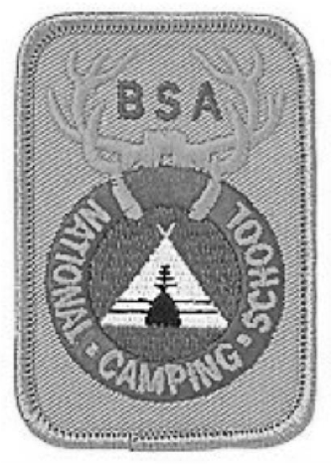
Outdoor Skills/First-Year Camper
Lesson Plan and Resource Manual

* Academic Session

INDEX

Overview and Notes to Presenters | 1 | Reviewing for Firem’n Chit * | 33
DAY 1, BLOCK 1 |  | Tent Talk * | 35
Safety Moment Introduction | 2 | Outdoor Clothing * | 36
Introduction and Philosophy of Outdoor Skills | 3 | DAY 2, BLOCK 3
Outdoor Skills | 5 | Scouting’s Mission, Aims, and Methods * | 37
Basic Ropework Skills 1 | 8 | Lighting a Fire in Wet Weather * | 39
DAY 1, BLOCK 2 |  | The Role of Advancement * | 41
Sequential Programming * | 10 | Camp Stoves * | 42
Putting Skills into Action * | 11 | DAY 3, BLOCK 1
Fusing and Whipping | 12 | Weather-Related - Safety Moment | 43
Outdoor Skills Area * (split session) | 13 | Health and Safety Skills - First Aid * | 44
First-Year Camper Area * (split session) | 15 | Tarps and Patrol Dining Fly | 53
DAY 2, BLOCK 1 |  | Outdoor Skills Merit Badges - Part 1 * Backpacking / Camping / Wilderness Survival (split session) | 54
Buddy System - Safety Moment | 18 | First-Year Camper Program - Part 1 *  (split session) | 73
Outdoor Skills Director: Staﬀ * (split session) | 19 | DAY 3, BLOCK 2
First-Year Camper Director: Staﬀ *(split session) 22 |  | Square Lashing | 77
Basic Ropework Skills 2 | 25 | Fire Without Matches | 78
Popularizing Outdoor Skills at Camp * | 26 | Making Charred Cloth | 79
Basic Ropework Skills 3 | 27 | Map and Compass | 80
DAY 2, BLOCK 2 |  | Measuring Heights and Widths | 82
Outdoor Skills Director Role * (split session) | 28 | Planning, Preparing, and Presenting Activities * 83
First-Year Camper Director Role * (split session) 29 |  | Ropes and Poles | 84
Teaching Totin’ Chip * | 30 | DAY 3, BLOCK 3
Woods Tools 1 | 31 | Floor Lashing | 85
Woods Tools 2 | 32 | Dutch Oven Cooking | 86

DAY 4, BLOCK 1 |  | Anchoring | 147
Fire Safety with Backpacking Stoves - Safety Moment | 89 | Rope Tackle | 148
National Camp Standards * 90 |  | DAY 5, BLOCK 2
Tripod Lashing 92 |  | Planning and Building a Pioneering Project | 149
Chippewa Kitchen 93 |  | Patrol Duty Rosters | 151
Foil Cooking 95 |  | Cub Scout New Adventure Program | 154
DAY 4, BLOCK 2 |  | DAY 5, BLOCK 3
Outdoor Skills Merit Badges - Part 2 * Hiking / Geocaching / Orienteering (split session) 97 |  | Dovetail Notch | 160
First -Year Camper Program - Part 2 *  (split session) 109 |  | Locking a Hitch and Seizing the End of a Line 161
Sloppy Camp 111 |  | Short Splice | 162
Catch the Snapper 112 |  | Finding North at Night | 163
Outdoor Skills Merit Badges - Part 3 * Cooking / Fishing / Pioneering (split session) 113 |  | DAY 6, BLOCK 1
First-Year Camper Program - Part 3 *  (split session) 128 |  | Charcoal Safety - Safety Moment | 165
Shear Lashing 130 |  | Sailmaker’s Whipping | 167
Camping and Hiking in Bear Country * 131 |  | Rolling Hitch | 168
DAY 4, BLOCK 3 |  | No Pots, Pans, or Foil | 169
Snake Race 133 |  | DAY 6, BLOCK 2
Lassoing the Steer 134 |  | Outdoor Ethics | 171
Constrictor Knot 135 |  | DAY 6, BLOCK 3
Lark’s Head 136 |  | Eye Splice | 172
Back Splice 137 |  | S.A.F.E. * | 173
DAY 5, BLOCK 1 |  | Time Bomb and Wall Street | 175
Food Allergies - Safety Moment 139 |  | APPENDIX
Outdoor Hygiene and Sanitation 141 |  | Categorized List of Materials | 176
Predicting the Weather 144 |  | Materials and Videos Day 1 | 180
Cooking Fire Concepts and Configurations * 146 |  | Materials and Videos Day 2 | 181

Materials and Videos Day 3 | 183
Materials and Videos Day 4 | 185
Materials and Videos Day 5 | 188
Materials and Videos Day 6 | 192 | * Academic Material

OVERVIEW AND NOTES TO PRESENTERS
This lesson plan is divided by day, the days into blocks, and the blocks into sessions. Often a session will include more than one skill or topic. During the course of the program, the inclusion of certain skills belonging to some of the larger skill sets have been spread out and interspersed with those from other parts of the outdoor skills spectrum. This has been done on purpose, to add variety, and often relevant to the presentation of various activities.
Interspersed throughout the program are presentations designed specifically for either First-year Camper Directors or Outdoor Skill Directors. These presentations run simultaneously, during which time participants will split into separate groups.

Materials
- There are numerous materials required for the activities presented in this lesson plan. Check to see what can be provided by the host camp and what will need to be secured by other individuals. Check to see that all the required materials are on hand well prior to the start of the school.
- As in any training session, organization of the materials is keynote to assuring success. For added assurance that the presentations will go smoothly, make sure all materials are sorted and arranged by activity and/or when they’ll be needed.

Videos
- The videos can be accessed and projected on a screen or connected to a tv directly from the collection of material found online. They are numbered in order. Alternatively, they can be downloaded directly onto a reliable laptop from YouTube, using the links provided.
- The various how-to skill videos scheduled for viewing throughout the week can be used to smoothly accommodate the Explain and Demonstrate portions of the EDGE method. Though their use is highly recommended, it is the presenter’s prerogative to personally explain and demonstrate the skills themselves.

Activities
- Each activity within the lesson plan includes a link to corresponding materials and descriptions on the Troop Program Resources web pages, most of which additionally feature an illustrative video. Presenters can and should also refer to the guidelines reflected in Planning, Preparing, and Presenting Activities on page 80.

Italics
- Throughout the lesson plan there is text that is in italics. Italicized text should either be read out to the participants or paraphrased by the presenter.
- —> An arrow designates something to which the presenter themselves need to attend.

Reference Materials
- In lieu of hard copy handouts, students will have access to all reference materials through one online link from which they can download the corresponding Word documents or access a PDF file for viewing on their laptop. In the event WiFi is unavailable, the materials will need to be printed up for distribution.

— Day 1 - Block 1 —
Materials
  - three Scout staves
  - three 15-foot braided nylon guylines
  - projector
  - screen
Gathering Period: Hitching Challenge

SAFETY MOMENT INTRODUCTION
One key element of modeling what camp should feel like is the use of Safety Moments throughout the week. NCAP Recommended Practice RP552 suggests that your camp includes a safety moment as part of its daily program to help foster safety awareness and a culture of safety. You’ll notice that we will start our day with a safety moment to get ourselves in the mindset of looking for safety precautions and understanding how to increase the likelihood that our staﬀ and campers have a safe week in your camp.
Safety moments are just that – moments. These are an opportunity for us to pause before an event or outing and talk about the risks associated with the activity or to share some specific information about an event or activity.
—> View Video: Using a Safety Moment in Scouting Activities
Since we will have the same group of staﬀ and participants for this week we will start each day with a Safety Moment. There are five days of instruction. We need five participant volunteers to each lead one Safety Moment each day. This is an opportunity to model NCAP Recommended Practice RP-552.
The safety moments for each day are included in the Reference Materials. Sunday: Buddy System
Monday: Weather Related Safety
Tuesday: Fire Safety with Backpacking Stoves Wednesday: Charcoal Safety
Thursday: Food Allergies
—> Five volunteers are selected.

INTRODUCTION AND PHILOSOPHY OF OUTDOOR SKILLS
(1 hour - Inside)
Objective: Participants will become acquainted with one another, and through discussion and reflection will start defining their personal philosophy regarding outdoor skills.
—> Divide the class into equal-sized patrols and provide a link to the collection of reference material to each participant containing PDF and Word files of both model first-year camper programs, and links to all course activities, resources, and how-to videos.
Welcome: Facilitators and participants introduce themselves and share something about themselves.
Discussion: Baden-Powell stated, “Scouting is a School of the Woods.” What does this mean?
—> After receiving group responses, read the following bullet points:

  - Many fundamental facts of life can be gained by being in nature where Scouts can experience the relevance of life’s basic necessities.
  - In the woods young people can gain an appreciation of our natural world.
  - There’s an allure to nature with all its sights and sounds, awakening the senses and providing a fresh feeling of freedom.
  - Getting out in the woods serves as an enjoyable change of scenes from the humdrum of day to day routines.
  - In the woods, the only distractions are those originating from the beauty of the natural environment.
  - Being out in nature nurtures an appreciation of how awesome our Creator is.
Discussion: We’re here because outdoor skills are an integral part of the Scouting movement. What do young people gain by acquiring and using these skills?
—> After receiving group responses, read the following bullet points:
  - Resourcefulness - Outdoor skills come into play when in the outdoors, Scouts are faced with the necessity of using whatever resources they have on hand.
  - Organization - In the absence of closets, pantries, and cupboards, and often with very limited space while living out of a pack or duﬀel bag, organizational skills are

honed as Scouts necessarily need to know how to keep their personal and group gear well organized.
  - Self Esteem - Using outdoor skills to contribute to the well being of others is an opportunity to exercise servant leadership which is an esteemed quality and its own reward.
  - Self Confidence - Putting acquired outdoor skills into action serves as a source of assuredness and pride in one’s abilities.
  - Self Reliance - Because modern conveniences and materials are limited in the outdoors, Scouts must rely on themselves, using their knowledge and skills, to meet challenges and overcome obstacles.
  - Responsibility - Knowing how to use their outdoor skills provide an incomparable opportunity for Scouts to share the responsibilities that grow out of setting up and maintaining their campsites, preparing and cooking their meals, and attending to all matters concerning health and safety.
—> View Video 00: Character, Leadership, and OUTDOOR SKILLS
—> View Video 01: Large Patrol Raft What’s taking place in this video?
—> After receiving group responses, read the following bullet points:
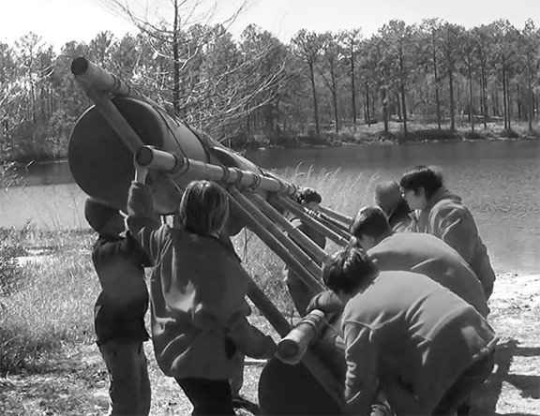
  - Scout engineering
  - Cooperation
  - Teamwork
  - Leadership
  - Involvement
  - Fun

Building a Large Raft

OUTDOOR SKILLS
(1 hour - Inside)
Objective: Through discussion, participants will evaluate Scouting’s wide range of outdoor skills and come to terms with their own readiness to impart these to others.
Discussion: Broadly speaking, what are the general categories of outdoor skills?
‘A’ = Academic (The skill can be acquired through the literature and discussion.) ’T’ = Technical (The skill is acquired through demonstration and application.)
SKILL CATEGORY

SKILL CATEGORY | SKILL | Can Teach | Have Know- ledge | Need Help | A | T
 | General First Aid |  |  |  | A
HEALTH AND | Prevention and Treatment for Blisters |  |  |  | A
SAFETY | Treatment for Cold and Heat Related Injuries |  |  |  | A
SKILLS | Recognizing and Treating Shock |  |  |  | A
 | Lightning Precautions |  |  |  | A
 | Camp and Trail Sanitation |  |  |  | A
WOODS | Proper Care and Use of Knives |  |  |  |  | T
TOOLS | Proper Care and Use of Camp Saws |  |  |  |  | T
SKILLS | Proper Care and Use of Axes |  |  |  |  | T
 | Preparing Tinder and Kindling |  |  |  |  | T
BASIC | Fusing and Whipping |  |  |  |  | T
ROPEWORK | Square Knot, Two Half Hitches, Taut-line Hitch |  |  |  |  | T
SKILLS | Bowline, Sheet Bend, Clove Hitch, Timber Hitch |  |  |  |  | T
 | Using Half Hitches |  |  |  |  | T
 | Round, Square, Tripod, and Floor Lashings |  |  |  |  | T
 | Shear, and Diagonal Lashings |  |  |  |  | T
PIONEERING | Rope Tackle |  |  |  |  | T
SKILLS | Anchors |  |  |  |  | T
 | West Country Whipping |  |  |  |  | T
 | Knowledge and Care of Cordage |  |  |  |  | T
 | Knowledge and Care of Spars |  |  |  |  | T
 | Planning and Building Pioneering Structures |  |  |  |  | T

SKILL CATEGORY | SKILL | Can Teach | Have Know- ledge | Need Help | A | T
 | Building and Feeding a Fire |  |  |  |  | T
FIRE SKILLS | Types of Fires |  |  |  | A
 | Fire Safety |  |  |  | A
 | Extinguishing and Cleanup |  |  |  | A
 | Tents |  |  |  | A
CAMPING | Dining Flies |  |  |  |  | T
SKILLS | Clothing |  |  |  | A
 | Campsites |  |  |  | A
 | Hiking Methods |  |  |  | A
HIKING AND | Gear and Equipment |  |  |  | A
BACKPACKING | Packing |  |  |  | A
SKILLS | What to do if Lost |  |  |  | A
 | Bear Country |  |  |  | A
 | Compass Use |  |  |  |  | T
NAVIGATION | Maps |  |  |  |  | T
SKILLS | Measuring Height and Width |  |  |  |  | T
 | Finding Directions without a Compass |  |  |  |  | T
 | GPS |  |  |  |  | T
 | Menu Planning |  |  |  | A
 | Food Stuﬀ and Pre-Trip Preparation |  |  |  | A
 | Cookware and Utensils |  |  |  | A
 | Cooking Fires |  |  |  | A
COOKING | Stoves |  |  |  |  | T
SKILLS | Foil Cooking |  |  |  |  | T
 | Dutch Oven Cooking |  |  |  |  | T
 | Backcountry Cooking |  |  |  | A
 | Cleanup Procedures |  |  |  | A
 | Cooking without Utensils |  |  |  |  | T

SKILL CATEGORY | SKILL | Can Teach | Have Know- ledge | Need Help | A | T
OUTDOOR | Leave No Trace Principles |  |  |  | A
ETHICS | Leave No Trace Skills |  |  |  | A
SKILLS | Leave No Trace Games |  |  |  |  | T
WILDERNESS | Shelter |  |  |  |  | T
SURVIVAL | Signalling |  |  |  | A
SKILLS | Water |  |  |  | A
 | Fire without Matches |  |  |  |  | T

—> After receiving group responses, turn attention to the “Outdoor Skills Questionnaire” reference materials and direct participants to fill it out.
As outdoor skills directors, the more we, ourselves, know about outdoor skills, the better we will be able teach and example these skills to our staﬀ and to the Scouts at camp. Approaches to teaching and performing many outdoor skills can vary. Much of the time we spend this week will be providing the assurance that each of us can eﬀectively present these skills, and gaining complete confidence when it comes to putting them into action.

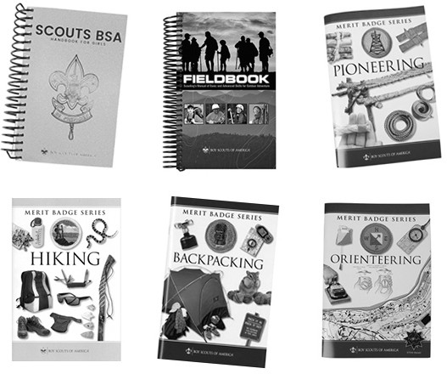

BASIC ROPEWORK SKILLS 1
(2 hours - Inside / Outdoors)

Objective: 1) Through the EDGE method followed by an opportunity to jointly put all the skills into action, participants will become comfortable in their ability to eﬀectively tie and present the square knot, two half hitches, taut-line, clove hitch, and round lashing.
2) Participants will experience sequential programming in action, through their participation in the process.
Class setting: Inside and Outdoors
- projector
- screen
Materials for each participant
- Scout stave
- 3-foot x 1/4-inch braided nylon cord
- 6-foot lashing rope
- 15-foot x 3/16-inch braided nylon guyline
- tent stake
Materials for each patrol
- 3 x 5-foot flag (not U.S. flag)
- two 3-foot cords
- six 6-foot lashing ropes
- four Scout staves
- one mallet
(The following videos can be used to explain and demonstrate each of these knots. As necessary, the process of guiding and enabling commences after each is viewed.)

Square Knot
—> View Video 02: How to Tie a Square Knot (Basic Approach) Activity: Simple Square Knot Relay Race
—> View Video 03: How to Always Tie a Square Knot Right Activity: Visual Square Knot Challenge

Two Half Hitches
—> View Video 04: How to Tie Two Half Hitches

Taut-Line Hitch
—> View Video 05: How to Tie a Taut-Line Hitch
Activity: Taut-Line Hitch Race I (outside weather permitting) -or- Taut-Line Hitch Race III (Inside)

Clove Hitch
—> View Video 06: How to Tie a Clove Hitch Activity: Hitching Race

Round Lashing
—> View Video 07: How to Tie a Round Lashing
—> View Video 08: How to Tie Half Hitches to Finish Many Lashings Activity: Flagpole Race
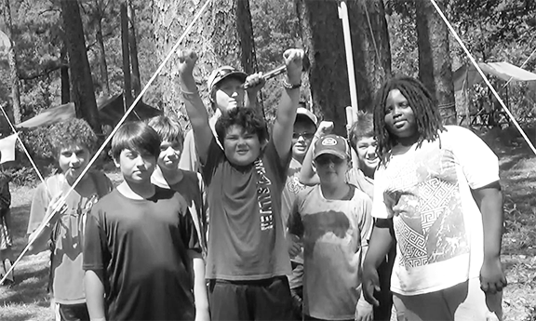
Young Campers are proud of their 15-Foot Scout Stave Flagpole.

— Day 1 - Block 2 —

SEQUENTIAL PROGRAMMING
(15 minutes - Inside)
Objective: Through discussion and reflection, participants will start thinking about sequential programming and how it applies to the acquisition of outdoor skills along with its role in increasing membership and retention throughout Scouting.
Discussion: What is sequential programming, and how does it work?

—> After receiving group responses, read the following explanation and ask further questions:
A sequential approach to program planning is one where gaining specific skills, and then putting them into action, pave the way towards a larger experience that is memorable and rewarding. Each specific skill can be seen as a building block contributing to an increased ability to reach greater accomplishments. Each new skill along the way should itself come with its own rewards.
How were the preceding set of skills and activities an example of sequential programming?
Oﬀ the top of your heads, can you think of other sequences of outdoor skills? (We will be featuring many more during the week.)
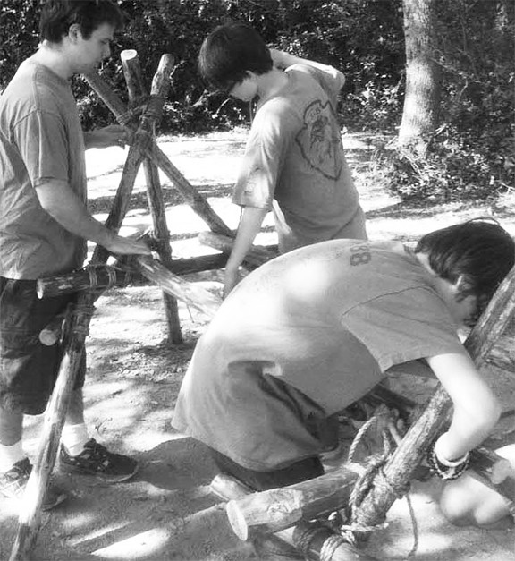
Scouts apply the skills they learned during skills instruction sessions to build a Chippewa Kitchen.

PUTTING SKILLS INTO ACTION
(15 minutes - Inside)

Objective: Through viewing illustrations followed by discussion, participants will further appreciate the positive outcomes resulting from putting outdoor skills into action.
Materials for class
- projector
- screen
—> View Video 09: Putting Skills Into Action
Discussion: Why is putting skills into action so important?
—> After receiving group responses, read: This will be a recurring theme throughout our course. Once Scouts are enabled to use an outdoor skill, they should be given an opportunity to put that skill into action in a way that:
—> (Write these down for all to see and make note of):
- illustrates how the skill is used
- reinforces the ability to utilize the skill
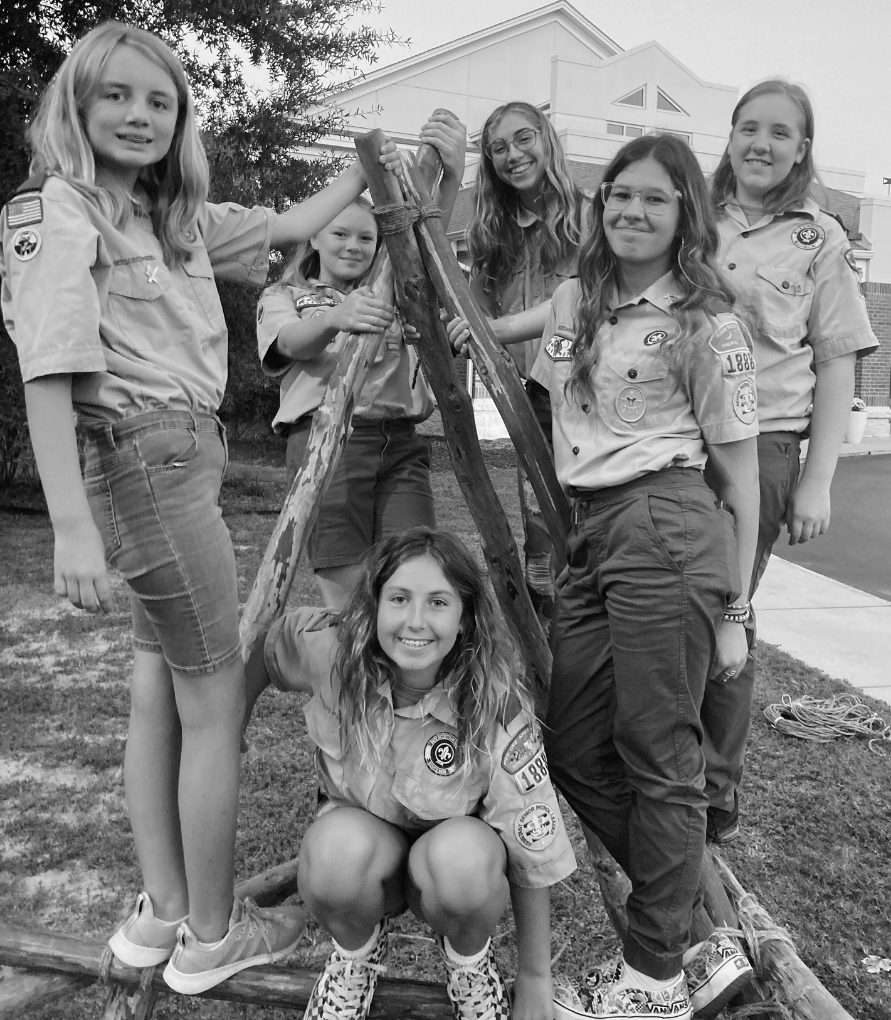
- relies upon the skill in order to complete a challenge or task

—> Emphasize: Ideally, the selected activity that puts the acquired outdoor skill(s) into action is both engaging and fun. (This is a priority!)

Scouts put their skills into action by engaging in the Scout Skill Challenge: Everyone on the Tripod.

FUSING AND WHIPPING
(30 minutes - Inside)
Objective: Through the EDGE method followed by hands on application, participants will become comfortable in their ability to properly fuse synthetic lines and apply the Half Knot (West Country) Whipping.
Materials for each participant
- Scout stave
- 3-foot length of paracord
- lighter
- small wood block for fusing
- small stick
Materials for class
- projector
- screen

Fusing
Each participant fuses the ends of their 3-foot cord using the wood surface and stick to flatten the fused ends so the material is well melded.
The following video can be used to explain and demonstrate the skill. As necessary, the process of guiding and enabling commences after it is viewed.

Whipping
—> View Video 10: How to Tie a Half Knot (West Country) Whipping
This is the method employed by the pioneering staﬀ to whip the ends of the hundreds of lashing ropes they need for building the structures in the pioneering area at the national jamboree.
Participants use the Scout stave to represent the rope and the 3-foot cord to represent the whipping cord and apply the half knot configuration to the stave.
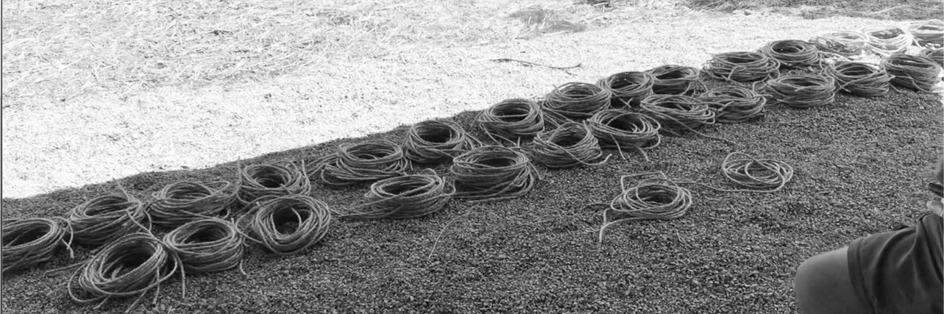
Bundles of Coiled 15-foot Lashing Ropes, Whipped and Ready at the National Jamboree

OUTDOOR SKILLS AREA

(Outdoor Skills Director Split Session)
(45 minutes - Inside)

Objective: Through the exchange of ideas, discussion, and the review of established guidelines, participants will come away with a conception of how to set up the outdoor skills area(s) in their camps.
—> View Video 10-a: A Scout Camp’s Outdoor Skills Area
Discussion: —> Turn attention to “Setting Up the Outdoor Skills Area reference materials and have participants take turns reading a sentence in the two opening paragraphs:
By virtue of what it represents, the outdoor skills area, often referred to as the Scoutcraft area, should impressively example Scouting’s unique and timeless attraction. Here’s where Scouting’s traditions are brought to life, and here’s where some of the the most awesome illustrations of campcraft and Scout engineering can be experienced. It should be situated in a natural setting where it can be readily seen and where units have easy access to it.
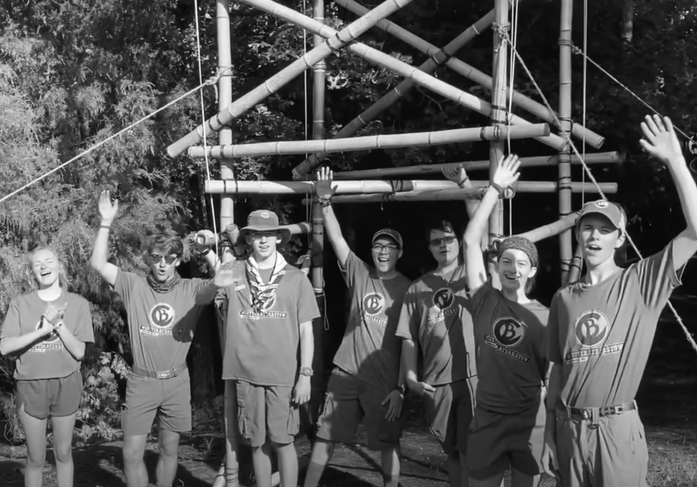
The outdoor skills area should serve as a model of the basic skills that embody Scouting’s quintessential aspect.

This kind of setup should not be diﬃcult to deliver. Presenting an impressive outdoor skills area is actually a very straightforward and simple process. For a conscientious staﬀ, building the site is a cooperative opportunity to put their skills into action. Remember, everything contained in the outdoor skills area should epitomize outdoor skills in
their best and most revealing light.
Are there any comments or questions?

Proud of Their Gateway

Discussion: Go through each of the following bullet points: PREREQUISITES
- Tarp shelters are tight and free from sagging.
- Stakes for tarp shelters are substantial and provide a dependable hold.
- Correct lashings are neatly applied, all knots are correctly tied, and all ropes are properly whipped.

- Uprights, ridge poles, poles for hitching racks, tool racks, and other camp gadgets are appropriately sized and skinned.
- A permanent structure adjacent to or in the vicinity of the area is appropriate for storing materials. Otherwise, suitable shelter should be erected providing weather protection and accessibility.
OUTDOOR SKILLS AREA
- Fire sites are of the proper size and in proximity to a single or double fire bucket holder.
- Trash bag holders are erected and situated conveniently throughout the area.
- There are at least two vertical hitching posts about 6-feet apart.
- At least one hand wash station is set up as a functioning example of an ideal First Class camp gadget.
- There needs to be areas earmarked for outdoor skills instruction and various outdoor skill merit badges. Each of these should have a separate tarp shelter, and since this is the area depicting outdoor skills. it’s most desirable to feature flies, either canvas or nylon, that are erected with metal or wood uprights and ridge poles, and properly secured with guy lines. A table with benches should be situated in the center of each.
- The main outdoor skills area needs to have a flat, open place for Scout skill challenges and troop and patrol competitions. There also needs to be space where pioneering projects can be built.
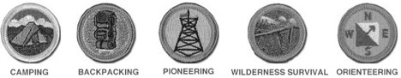
Outdoor Skills Merit Badges

- Definitely consider adding one or more attractions like a:
  - Floating Flagpole flying a special flag,
  - Double A-Frame Monkey Bridge
  - Camp Seesaw
  - Scout Swing
Note: The main outdoor skills area needs to be staﬀed during times when attractions like bridges and playground structures are available. When unsupervised, the area needs to be well closed oﬀ.

FIRST-YEAR CAMPERS AREA

(First-Year Camper Director Split Session)
(45 minutes - Inside)
Objective: Through the exchange of ideas, discussion, and the review of established guidelines, participants will come away with a conception of how to set up the first- year camper area in their camps.
The first-year camper area should be set out with forethought and attention to detail. A substantial portion of a young Scout’s time in camp will be spent in this area, so it’s important that everything used in the first year camper program is organized, accessible and arranged so that each Scout can benefit from their experience with a minimum amount of down time.
Discussion: —> Turn attention to “Setting Up the First-Year Camper Area” reference materials and have participants take turns reading and leading oﬀ a discussion of each bullet point:
- Often, the first-year camper program is located in a completely separate area, with plenty of open space for patrol activities and competitions. It can be in direct proximity to or share the same space as the campwide Scoutcraft area.
- The first-year camper area should have a separate, properly erected patrol fly for each patrol with a table and benches placed underneath. The flies should be secured with correctly-tied and properly-positioned taut-line hitches at the stakes and two half hitches at the grommets. (For a more secure configuration, bowlines and rope tackles can be utilized.)
- A permanent structure adjacent to or in the vicinity of the area is desirable for storing materials. Otherwise, suitable shelter should be erected providing weather protection and accessibility.
- Each patrol should have access to a horizontal hitching rack in proximity to their fly.
- Each patrol should have their own fire site, properly proportioned and in proximity to a single or double fire bucket holder.
- A proper axe yard should be roped off containing solid chopping blocks properly spaced apart at a safe distance.
- There should be a nearby supply of wood for sawing, splitting, and shaving, properly protected from inclement weather.
- A tool rack should be built in proximity to the axe yard.
- A troop flagpole with halyard should be setup in a central position.

- Trash bag holders are erected and situated conveniently throughout the area.
- At least one hand wash station is always desirable as a functioning example of an ideal First Class camp gadget.
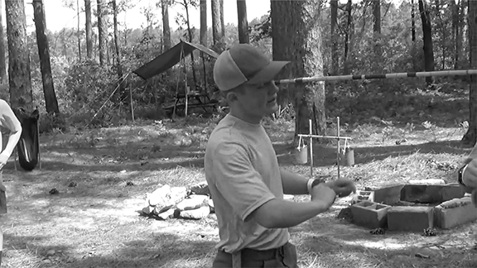
SPL Explaining a Scout Skill Challenge in the First-Year Camper Area

DAY 2

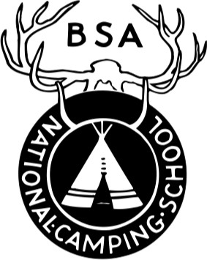

— Day 2 - Block 1 —

Materials
  - one sturdy 5-gallon bucket
  - one Scout stave
  - one playground ball
Gathering Period: (For both Outdoor Skills and First-Year Camper Directors.) Hit the Bucket

BUDDY SYSTEM - SAFETY MOMENT

SUMMARY
In a crowded pool full of raucous Scouts splashing and swimming, the justification for frequent buddy checks appears self-evident. But do Scouts really need to get a friend for a quick trip to the latrine or when they meet with a merit badge counselor?
Simply put, yes. Scouting’s buddy system calls for Scouts to pair up with a friend or two for all activities. This helps ensure safety and accountability, and teaches Scouts to have responsibility for others. The buddy system is a key part of Scouting’s Barriers to Abuse.

GENERAL INFORMATION
Looking out for one another anywhere and everywhere is the keystone to the buddy system. Just because you’re in a populous place doesn’t mean you can’t get overlooked by those around you. Buddies are there to watch you when others may not. They stay nearby to monitor you, alerting a safety team if help is needed.
Adults are not exempt from any these safety measures. Scouters should have buddies during all Scouting activities, too.

- The buddy system should be used at all times, not just for aquatics. Horseback riding, cycling, canvassing the neighborhood during a fundraiser…you name it, you need a buddy.
- It’s recommended that buddies know and be comfortable with each other. No youth should be forced into or made to feel uncomfortable by a buddy assignment.
- It is strongly encouraged to pair Scouts of similar abilities, ages and maturity. Buddy pairs should be no more than two years apart in age and should be single gender. There are no boy-girl buddy pairs in any programs, including Venturing and Sea Scouts.
- A buddy team may consist of three Scouts when necessary, like an odd number in a group.

OUTDOOR SKILLS DIRECTOR: STAFF

(Outdoor Skills Director Split Session)
(1 hour - Outdoors / Inside)
Objective: Through discussion and the review of established guidelines, participants will recognize the vital roles played by the outdoor skills staﬀ.
Discussion: The outdoor skills director is responsible for assuring their staﬀ is qualified, thoroughly trained, and well-prepared to confidently, enthusiastically, and eﬀectively present the part of the outdoor skills program for which they’re responsible.
—> After each question, open a discussion for each of the listed points that follow.
What’s the role of the outdoor skills staﬀ?
The outdoor skills staﬀ serve out of the main outdoor skills area. They
  - assume the role of merit badge counselor for those outdoor skill merit badges oﬀered at camp
  - orchestrate camp-wide outdoor skill challenges
  - supervise the use of main outdoor skill area attractions
What are the outdoor skills staﬀ’s qualifications?
Outdoor skills merit badge counselors should:.
  - be at least 16 years of age.
  - have a love for the subject of the merit badge they will conduct.
  - be willing to devote themselves to completing the training and preparations to be eﬀective merit badge counselors.
What do they need to know?
Outdoor skills merit badge counselors must:
  - be knowledgable about the requirements and content of the merit badge they will conduct.
  - be prepared with the materials needed for the merit badge.
  - know what parts of camp they’ll be utilizing
  - be familiar with eﬀective communication techniques
  - be ready with an interactive lesson plan for their class
What should the staﬀ bear in mind during every skills instruction setting?
During instruction, all staﬀ should remember to:
  - have all necessary materials on hand.
  - be sure everyone in the group can see them along with any materials they will be using during their presentation.

  - be sure everyone in the group can hear what’s being said.
  - make sure everyone is comfortable.
  - feel free to refer to the Scouts BSA Handbook or merit badge pamphlet during the presentation.
  - change the focus of the instruction often to keep things more interesting.
Four Steps in Learning Outdoor Skills Using the EDGE Model
- Explain—The Scout hears an explanation and description.
- Demonstrate—The Scout sees a demonstration. The instructor shows how.
- Guide—The Scout practices the skill. He does it again and again.
- Enable—The Scout may then act as instructor or coach to another person and teach the skill. The Scout can rely upon the skill, use it and put the skill into action.

What are some problems the outdoor skills staﬀ might encounter during a merit badge class? How should these problems be handled?
Problem: Scouts who continually distract the attention of the group with interruptions:
  - Response: Ignoring the disruptions of Scouts who are continually making
unnecessary comments is often the best way to discourage the behavior. If it’s attention they want, they won’t be getting it by being ignored.
  - Response: Continued verbal interruptions should be dealt with in a calm
manner, sharing with the talkative Scout that they need to control themselves because their behavior is making it diﬃcult for you and distracting the group as a whole. This should be done oﬀ to one side, on a one to one basis, while the rest of the group is occupied practicing the skill.
  - Response: Continued disruptions should result in a conversation between
that Scout and the adult in charge.
Problem: Scouts are arguing with one another:
  - Response: Persistent bickering can be dealt with by calmly separating the
Scouts who seem to have diﬃculty getting along. Emphasis should be placed on the sixth point of the Scout Law (a Scout is kind) and on the importance of working together cooperatively as a patrol. Share the fact that a patrol is like a team with a common goal, and should support and help one another.
Problem: Scouts are proceeding at diﬀerent rates in acquiring the presented skills.
  - Not a problem. Those who are learning faster assume the role of servant
leaders and assist those who take longer to gain the skills.

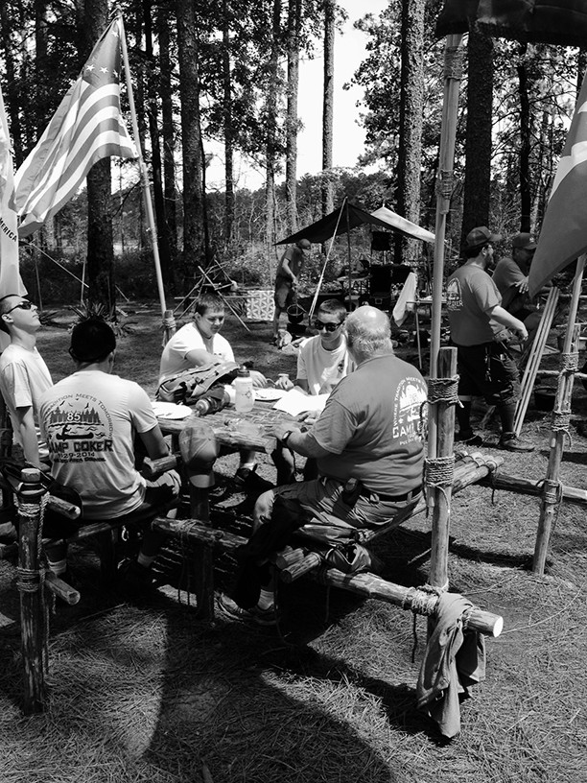
Outdoor Skills Director Staﬀ Training in their Scoutcraft Area

FIRST-YEAR CAMPERS DIRECTOR: STAFF

(First-Year Camper Director Split Session)
(1 hour - Outdoors / Inside)
Objective: Through discussion and the review of established guidelines, participants will recognize the vital roles played by the outdoor skills staﬀ.
Discussion: The outdoor skills/first-year camper director is responsible for assuring their staﬀ is qualified, thoroughly trained, and well-prepared to confidently, enthusiastically,

and eﬀectively present the part of the outdoor skills program for which they’re responsible.
—> After each question, open a discussion for each of the listed points that follow.
What’s the role of the first-year camper staﬀ?
The first-year camper staﬀ delivers the program to the first-year Scouts attending.
- An SPL runs things:
  - oversees the patrol guides
  - assures all materials are available and ready
  - implements the overall schedule
- The patrol guides provide instruction and support:
  - Explain, Demonstrate, Guide, and Enable their patrol to gain the outdoor
skills that are presented
  - rallies their patrol to enthusiastically engage in challenges, competitions,
and games
What are the first-year camper staﬀ’s qualifications?
- The patrol guides for the first-year camper program should:
  - be at least 16 years of age (and at least first class)
  - have a love for outdoor skills.
  - enjoy working with 11 and 12 year olds.
  - be willing to devote themselves to completing the training and
preparations to be eﬀective patrol guides.
- The senior patrol leader of the first-year camper program should:
  - be at least 16 years of age or older (and preferably an Eagle Scout)
  - know how to organize and plan ahead.
  - should work well with Scouts of all ages.
  - be willing to devote themself to completing the preparations to run the
first-year camper program.
What do they need to know?
All first-year camper staﬀ members must:
- be knowledgeable about the requirements pertaining to the skills they will be presenting.
- be adept at explaining and demonstrating each skill.
- know how to enable their patrol members to put the skill into action.
- be familiar with the materials they will use.
- be familiar with the program’s overall agenda.
- be familiar with eﬀective communication techniques.

What should the staﬀ bear in mind during every skills instruction setting?
During instruction, all staﬀ should remember to:
- have all necessary materials on hand.
- be sure everyone in the group can see them along with any materials they will be using during their presentation.
- be sure everyone in the group can hear what’s being said.
- make sure everyone is comfortable.
- feel free to refer to the Scouts BSA Handbook or merit badge pamphlet during the presentation.
- change the focus of the instruction often to keep things more interesting.
Four Steps in Learning Outdoor Skills Using the EDGE Model
- Explain—The Scout hears an explanation and description.
- Demonstrate—The Scout sees a demonstration. The instructor shows how.
- Guide—The Scout practices the skill. He does it again and again.
- Enable—The Scout may then act as instructor or coach to another person and teach the skill. The Scout can rely upon the skill, use it and put the skill into action.

What are some problems the outdoor skills/first/year camper staﬀ might encounter during a skills instruction session? How should these problems be handled?
Problem: Scouts who continually distract the attention of the group with interruptions:
  - Response: Ignoring the disruptions of Scouts who are continually making
unnecessary comments is often the best way to discourage the behavior. If it’s attention they want, they won’t be getting it by being ignored.
  - Response: Continued verbal interruptions should be dealt with in a calm
manner, sharing with the talkative Scout that they need to control themselves because their behavior is making it diﬃcult for you and distracting the group as a whole. This should be done oﬀ to one side, on a one to one basis, while the rest of the group is occupied practicing the skill.
  - Response: Continued disruptions should result in a conversation between
that Scout and the adult in charge.
Problem: Scouts are arguing with one another:
  - Response: Persistent bickering can be dealt with by calmly separating the
Scouts who seem to have diﬃculty getting along. Emphasis should be placed on the sixth point of the Scout Law (a Scout is kind) and on the importance of working together cooperatively as a patrol. Share the fact that a patrol is like a team with a common goal, and should support and help one another.
Problem: Scouts are proceeding at diﬀerent rates in acquiring the presented skills.
  - Not a problem. Those who are learning faster assume the role of servant
leaders and assist those who take longer to gain the skills.
National Camping School 23
First-Year Camper Patrol Guide Providing Guidance to a Member of Their Patrol

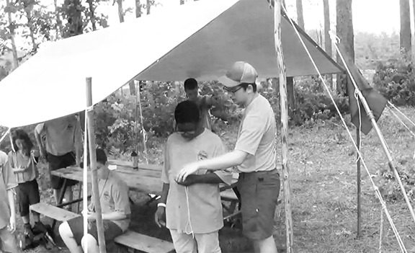

BASIC ROPEWORK SKILLS 2
(30 minutes - Inside)

Objective: Through the EDGE method followed by an opportunity to jointly put both skills into action, participants will become comfortable in their ability to eﬀectively tie and present the sheet bend and bowline.
Materials for each participant
- 6-foot lashing rope
- 3-foot cord
Materials for class
- projector
- screen
(The following videos can be used to explain and demonstrate each of these knots. As necessary, the process of guiding and enabling commences after each is viewed.)

Sheet Bend
—> View Video 11: How to Tie a Sheet Bend

Bowline
—> View Video 12: How to Tie a Bowline Activity: Bowline Sheet Bend Draw

National Camping School 24
A patrol tries their hands at the Bowline Sheet Bend Draw.

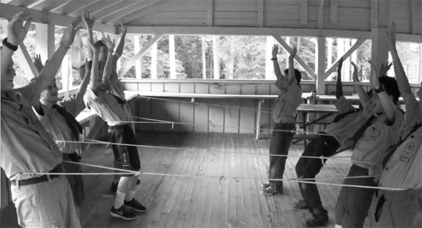

POPULARIZING OUTDOOR SKILLS AT CAMP
(30 Minutes - Inside)

Objective: Through discussion and the review of established ideas, participants will arrive at some ideas regarding how to help make outdoor skills more popular at camp.
Discussion: What, if any, evidence is there that at many camps there’s a general diminished emphasis on outdoor skills? Why is this? As outdoor skills directors, is there anything we can do to increase an overall interest?
—> Divide participants into small groups and allow the groups time to brainstorm on the topic of making outdoor skills popular in camp. At the end of the allotted time, elicit ideas from each group, and note them on a flip chart or whiteboard. Make sure the ideas in the following reference materials are included and discussed.
Discussion: —> Turn attention to “Popularizing Outdoor Skills” reference materials and review each bullet point:

- Present a centrally-located and great-looking outdoor skills area replete with attractive pioneering and campcraft displays for demonstrations, training, and participation.
- Provide specialists who can train unit leaders in colorful and eﬀective methods of instruction.
- Include outdoor skills in camp special events and contests, and encourage every unit to participate in these events.

- Create incentives for individual, patrol, and unit excellence in outdoor skills, with a diﬀerent “skill of the day” contest each day. Oﬀer attractive prizes for first, second, and third place like free goodies at the trading post.
- Create competition in skills with attractive awards or recognition which individual Scouts, patrols, and troops can practice throughout the week. Schedule a time each day to evaluate the eﬀorts of participants. Some examples:
  - Rope Toss Log Lift Solo Challenge
  - Crossing the Alligator Pit Patrol Challenge
  - Hitching Race Solo Challenge
  - Fastest Square Lashing Solo Challenge
  - 15-foot Scout Stave Flagpole Patrol Challenge
  - Scout Stave Launcher for Distance Patrol Challenge
  - Supreme String Burning Race Solo or Patrol Challenge

BASIC ROPEWORK SKILLS 3
(1 hour - Inside / Outdoors)
Objective: Through the EDGE method followed by an opportunity to jointly put both skills into action, participants will become comfortable in their ability to eﬀectively tie and present the timber hitch and sheepshank.
Materials for each participant
- 3-foot cord
- Scout stave
Materials for challenge
- lightweight 10-foot pole for crossbar
- two 10-foot x 2-inch spars for uprights
- two 15-foot lashing ropes
- four stakes
- four 20-foot ropes for guylines
- three 50-foot throwing lines (3/8-inch manila)
- three large stakes
- three 2-feet x 4 to 5-inch logs
- large mallet
Materials for class
- projector
- screen
(The following videos can be used to explain and demonstrate each of these knots. As necessary, the process of guiding and enabling commences after each is viewed.)

Timber Hitch
—> View Video 13: How to Tie a Timber Hitch

Sheepshank
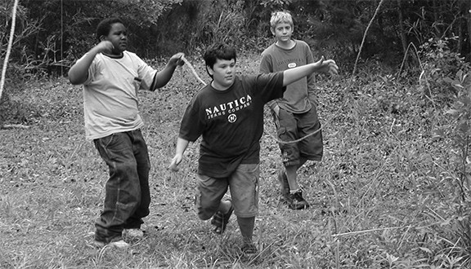
—> View Video 14: How to Tie a Sheep Shank Activity: Rope Toss Log Lift Challenge
The stakes and log are already set out. What is entailed in satisfying this challenge as a troop is: you must put your heads together to set up the 10- foot cross bar using the materials provided. After the cross bar is erected, patrols and troop members are to compete against one another for the best time.)
Scouts Participate in a Rope Toss-Log-Lift Challenge

— Day 2 - Block 2 —

THE ROLE OF THE OUTDOOR SKILLS DIRECTOR

(Outdoor Skills Director Split Session)
(45 minutes - Inside)
Objective: Through discussion and the review of established guidelines, participants will become thoroughly acquainted with the role they play as the outdoor skills director.
Discussion: What’s the outdoor skills director’s role?
—> After receiving group responses, discuss each of the following descriptions:
- Assures the safety of the entire outdoor skills program.
- Oversees the hiring of the outdoor skills staﬀ
- Relating to the campers, when serving in the capacity of the outdoor skills director, they should:
  - establish an atmosphere of structure and discipline
  - teach Scouting’s history and ideals
- Relating to their staﬀ, the outdoor skills director needs to:
train the outdoor skills area staﬀ by:
  - providing training materials and necessary training sessions
  - continually evaluating the entire program and entire outdoor area skills staﬀ
motivate the first-year camper staﬀ and main outdoor skills area staﬀ by:
  - being constantly aware of the group’s morale
  - always sharing information
  - being encouraging and acknowledging jobs well done
  - providing perks (special treats and small tokens of appreciation)
manage the first-year camper staﬀ and main outdoor skills area staﬀ by:
  - assembling the staﬀ each morning before the merit badge classes, to discuss the plan for the day and address any issues
  - observing the staﬀ in action and providing feedback on how they’re doing
- In addition to matters related to their staﬀ, the outdoor skills director should:
  - keep the unit leader the Scouts attending their classes informed about the Scouts’ progress and what’s happening in the program.

THE ROLE OF THE FIRST-YEAR CAMPER DIRECTOR

(First-Year Camper Director Split Session)
(45 minutes - Inside)
Objective: Through discussion and the review of established guidelines, participants will become thoroughly acquainted with the role they play as the outdoor skills director.
Discussion: What’s the first-year camper director’s role?
—> After receiving group responses, discuss each of the following descriptions:
- Assures the safety of the entire first-year camper program.
- Serves as Scoutmaster for the first-year camper troop
- Oversees the hiring of the first-year camper staﬀ
- Relating to the campers, when serving in the capacity of the first-year camper director, they should:
  - establish an atmosphere of structure and discipline
  - teach Scouting’s history and ideals
- Relating to their staﬀ, the first year camper director needs to:
train the first-year camper staﬀ by:
  - providing training materials and necessary training sessions
  - continually evaluating the entire program and entire outdoor area skills staﬀ
motivate the first-year camper staﬀ by:
  - being constantly aware of the group’s morale
  - always sharing information
  - being encouraging and acknowledging jobs well done
  - providing perks (special treats and small tokens of appreciation)
manage the first-year camper staﬀ by:
  - assembling the staﬀ each morning before the first-year camper opening ceremony to discuss the plan for the day and address any issues
  - observing the staﬀ in action and providing feedback on how they’re doing
- In addition to matters related to their staﬀ, the first-year camper director should:
  - keep the unit leader of the first-year campers informed about the progress of their Scouts and what’s happening in the program.

TEACHING “TOTIN’ CHIP”
(30 minutes - Inside)
Objective: Through discussion and the review of material in the Scouts BSA Handbook, participants will become well-versed in what each Scout should know before using woods tools.
Discussion: What do Scouts need to know about knives?
—> After receiving group responses, as necessary, review each bullet point.
  - sizes and styles of knives
  - care of a pocket knife
  - opening and closing (hands on, demonstrated by each Scout)
  - passing to another person (hands on, demonstrated by each Scout)
  - cutting (hands on, demonstrated by each Scout)
  - sharpening (hands on, demonstrated by each Scout) Discussion: What do Scouts need to know about camp saws?
—> After receiving group responses, as necessary, review each bullet point.
  - types of saws
  - what we use them for
  - sheathing a saw
  - carrying a saw
  - replacing blades
  - passing to another person (hands on, demonstrated by each Scout)
  - leather gloves and protective eyewear
  - always use something raised to support the wood being sawed (hands on, demonstrated by each Scout)
  - position the wood so the part being cut falls away from the rest of the wood
  - let the saw do the work (hands on, demonstrated by each Scout)
  - try to use the whole length of the blade when sawing (hands on, demonstrated by each Scout)
Discussion: What do Scouts need to know about axes?
—> After receiving group responses, as necessary, review each bullet point.
  - types of axes
  - the hand axe (hatchet)
  - what we use it for
  - sharpening a hand axe (hands on, demonstrated by each Scout)
  - carrying a hand axe (hands on, demonstrated by each Scout)
  - passing to another person (hands on, demonstrated by each Scout)
  - protective eyewear
  - the contact method (hands on, demonstrated by each Scout)
  - sheathing a hand axe

WOODS TOOLS 1
(30 minutes - Inside / Outdoors)
Objective: Through the EDGE method followed by an opportunity to put what they know into action, participants will become comfortable in their ability to eﬀectively present camp saw skills.
Materials for each patrol
  - one good quality bow saw (folding saws can be used)
  - one pair of leather gloves
  - protective eyewear
  - one log about 3 to 4 feet long with a 2 to 4-inch butt
  - one short, thick log or block for support
Materials for class
  - projector
  - screen
(The following video can serve to explain and demonstrate the skill. As necessary, the process of guiding and enabling commences after the video is viewed.)

Camp Saw
—> View Video 15: How to Use a Camp Saw Activity: Bow Saw Relay

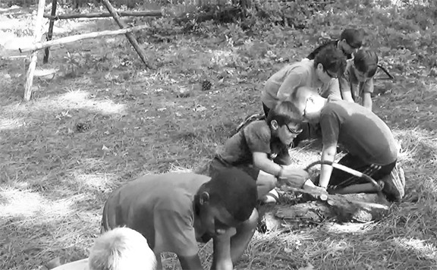
First-Year Campers apply what they learned during a Bow Saw Relay.

WOODS TOOLS 2
(45 minutes - Inside / Outdoors)
Objective: Through the EDGE method followed by an opportunity to put both skills into action, participants will become comfortable in their ability to eﬀectively present the proper use of a hand axe and knife.
Materials for each patrol
  - one sharpened hatchet
  - one pair of leather gloves
  - protective eyewear
  - a chopping block
  - one sharpened knife
Materials for each participant
  - a 9 inch x 1 inch dry stick
Materials for class
  - projector
  - screen
(The following video serves to explain and demonstrate each of these skills. As necessary, the process of guiding and enabling commences after each is viewed.)

Knife and Axe
—> View Video 16: Preparing Tinder and Kindling with an Axe and Knife Activity: Wood Splitting Relay
Discussion: Are there any techniques that can make splitting wood with the contact method easier?
Position the bit of the cutting edge so that it extends about an inch from the tip of the wood.
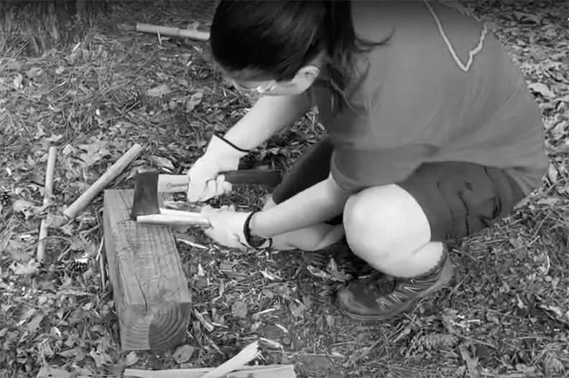
Activity Fuzz Stick Relay (“Variation 2” using a piece of the split wood)
National Camping School 32
Splitting Wood Using the Contact Method

REVIEWING FOR FIREM’N CHIT
(30 minutes - Inside)
Objective: Through discussion and the review of established guidelines, participants will become well-versed in what each Scout should know before lighting fires.

Certification grants a Scout the right to carry matches and build campfires. Scouts must show their Scout leader, or someone designated by their leader, that they understand their responsibility to do the eight requirements.
Discussion: Relate stories about the lack of fire safety, then read out the requirements and elicit a comment from a participant for each:
- I have read and understand use and safety rules from the Scouts BSA Handbook.
- I will build a campfire only when necessary and when I have the necessary permits (regulations vary by locality).
- I will minimize campfire impacts or use existing fire lays consistent with the principles of Leave No Trace. I will check to see that all flammable material is cleared at least 5 feet in all directions from fire (total 10 feet).
- I will safely use and store fire-starting materials.
- I will see that fire is attended to at all times.
- I will make sure that water and/or a shovel is readily available. I will promptly report any wildfire to the proper authorities.
- I will use the cold-out test to make sure the fire is cold out and will make sure the fire lay is cleaned before I leave it.
- I follow the Outdoor Code, the Guide to Safe Scouting, and the principles of Leave No Trace and Tread Lightly!

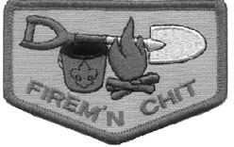

FIRES
(60 minutes - Inside / Outdoors)
Objective: Through the EDGE method followed by an opportunity to put fire building skills into action, participants will become comfortable in their ability to eﬀectively present how to use woods tools to prepare tinder and kindling.
Materials for each patrol
  - two sharp knives
  - one sharpened hatchet
  - one 2-inch x 4-inch x 9-inch piece of pine
  - one ferro rod, steel striker, and two cotton balls -or-
  - fire steel, rock that throws sparks, charred cloth
  - fire ring or pan with one thin cotton string suspended between two upright sticks, 10 inches above the ground
  - one pair of leather gloves
  - protective eyewear
  - a chopping block
Materials for class
  - projector
  - screen

Fire Lay
—> View Video 17: Laying a Fire
Discussion: Comments? What other useful fire lays might be built and when?

Fire Building
—> View Video 18: How to Light and Feed a Fire Discussion: Comments?

After a Fire
—> View Video 19: How to Put Out a Fire
Discussion: It’s good to use the back of your hand to feel whether a fire is cold out. Comments?
Activity: Supreme String Burning Race
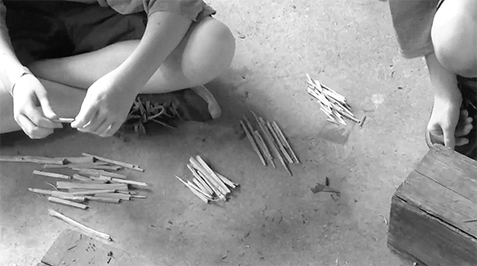
First-Year Campers Sorting Their Kindling

TENT TALK
(15 minutes - Inside)
Objective: Through discussion of the material found in the Scouts BSA Handbook and the camping merit badge pamphlet, participants will review basic information regarding tents.
Discussion: Information on caring for, selecting, pitching, and tents in general can be found in the Scouts BSA Handbook, Fieldbook, and the camping merit badge pamphlet.
Why should we pitch tents well away from streams and lakes? Allows animals to reach the water and lessons our impact on shorelines.
Why should we select tents with muted colors? Reduces the visual impact of our campsites.
Why should we keep tent flaps closed when away from tent? Keeps insects and critters out.
If protecting the floor of a tent with a ground cloth, why should it not stick out from the sides? To keep rain water from collecting on the sides and running under the tent.
After being set up in wet weather, what needs to be done to prevent mildew? Make sure tent is dried out before folding it up or in dry weather set it up again or hang it on a line.
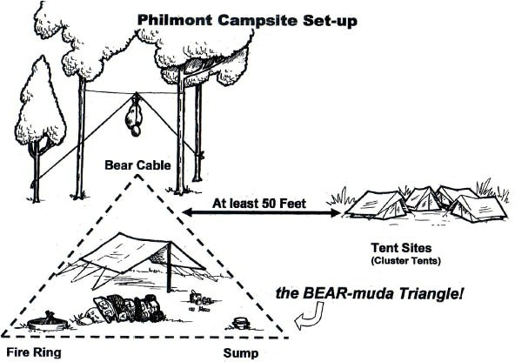
How far from the Bearmuda Triangle should tents be set up? At a minimum of 200 feet.
What can be done to secure tent lines in sand or snow? Use dead man anchors or secure lines to a fixed or heavy object.
At night, what can be done to keep personal items like glasses and flashlight accessible inside the tent? Place flashlight nearby in one boot and glasses and other small items in the other.
What shouldn’t you take into your tent at night? In bear country, anything with a food or chemical smell. Packs can be set outside under a pack cover.

OUTDOOR CLOTHING
(15 minutes - Inside)
Objective: Through discussion of the material found in the Scouts BSA Handbook and the Fieldbook, participants will review basic information regarding outdoor clothing.
Discussion: Extensive information on clothing for the outdoors can be found in the
Fieldbook.
Why is cotton sometimes referred to as the “death fabric”?
- If it becomes wet, it loses any ability to keep you warm.
What’s good about wool?
- It’s durable.
- It insulates even when wet.
What is there to say about synthetics like nylon, polyester and fleece? Can be manufactured in a variety of ways to:
- be lightweight
- have loft for insulation
- wick moisture away from skin
- dry quickly
- shed water
- retain some insulating power even when wet
What is the advantage and disadvantage of goose down?
- High rate of insulating power per ounce, but if it becomes wet, it loses that power.
Why is wearing layers of clothing eﬀective?
- Enables you to adjust your clothing to match your body temperature.
—> Turn attention to “Clothing Lists” reference materials.
What can be done to reduce the amount of moisture that can condense on the inside of rain gear?
- Wear gear that fits loosely enough to allow freedom of movement and allow perspiration to vent neck, cuﬀs and waist.
- Wear rain gear made of breathable synthetic fabrics.
What are the advantages of wearing thin synthetic socks under heavier hiking socks?
- Reduces the chance of blisters
- Wicks moisture away from your skin.

— Day 2 - Block 3 —

SCOUTING’S MISSION, AIMS AND METHODS
(45 minutes - Inside)
Objective: Through discussion reviewing the tenets of the BSA, participants will be able to make a correlation between Scouting’s Mission, Aims and Methods and outdoor skills.
Materials for class
  - projector
  - screen

Mission Statement
Discussion: Read the Mission Statement:
The mission of the Boy Scouts of America is to prepare young people to make ethical and moral choices over their lifetimes by instilling in them the values of the Scout Oath and Law.
Does this have anything to do with outdoor skills?
The answer is, “no.” But, read the following:
Two old time Scouters were having a friendly conversation about the Scouting program. Revealing a little disgust, one stated, “I’m always uncomfortable when I hear about an Eagle Scout who can’t light a fire in the rain.” Looking straight at him, the other Scouter asked. “So what? What does that have to do with the Mission of the Boy Scouts of America?” The first Scouter had to agree that indeed being able to light a fire in the rain really had nothing to do with the Mission. Then after a moment, looking quizzically at the other, the first Scouter commented, “But, while making these ethical and moral choices, perhaps it’s worthwhile to know how to keep yourself and others warm.”
Discussion: In and through the outdoor program, in the midst of imparting a wide range of outdoor skills, the aims of Scouting are always there. These aims should be behind most everything we do in Scouting. What are Scouting’s aims?
—> After receiving group responses, as necessary, review and discuss each of the following aims:
  - Character Development
  - Citizenship Training
  - Personal Fitness
  - Leadership Development
—> View Video 20: Program Feature: Camping
Discussion: What are some of the ways Scout camping provides opportunities to realize each aim?
—> After receiving group responses, as necessary, review each example:

  - accepting responsibility (character development)
  - doing one’s assigned task for the general welfare of the group (character development / citizenship training)
  - pitching in and helping whenever the need arises (character development / citizenship training)
  - assuring that proper attention is given to carry out responsibilities reflected in the duty roster (leadership development)
  - taking care of your personal hygiene (personal fitness)
  - pulling one’s weight during physically demanding activities (personal fitness)
  - practicing the Outdoor Code (citizenship training)
  - obeying the Scout Law (character development)
  - flying the US Flag (citizenship training)
—> View Video 21: Scouting’s Eight Methods
—> Provide a visual display of the eight methods.
Discussion: The outdoor program is one of Scoutings 8 methods to achieve Scouting’s aims. What is unique about the Outdoor Program?
—> After receiving group responses, read the following:
The outdoor program is the one method that encompasses the other seven. How can the other seven be incorporated into this one method where outdoor skills most come into play?
—> After receiving group responses, read the following:

- Outdoor Program - Much of Scouting is designed to take place outdoors.
- Patrols - In the outdoors, the patrol method comes alive as patrol members carry out their assigned tasks, share responsibilities, and pool their resources.
- Ideals - In the outdoors, the ideals serve as the guiding principles where there are repeated opportunities to work with and relate to fellow patrol members.
- Advancement - The outdoors provides the proving ground for all the outdoor advancement-related requirements.
- Adult Association - In the outdoors, adults are provided with numerous opportunities to be positive examples, and when needed, to serve as guiding influences.
- Personal Growth - On outings there are repeated occasions where Scouts can grow in their capacity to benefit others as well as themselves.
- Leadership Development - Because on outings there are ongoing needs to get things done, leadership skills are continually nurtured and put to the test.
- Uniform - During outdoor events, wearing the activity uniform, and on occasion the field uniform, provides a sense of belonging and contributes to a welcome identity.

LIGHTING A FIRE IN WET WEATHER
(15 minutes - Inside)
Objective: By discussing established methods and techniques, participants will review practical approaches to lighting a fire in wet weather.
Discussion: What are some ways Scouts can be prepared to more easily light a fire before it starts raining?
—> After receiving group responses, as necessary go through the following bullet points:
  - Store dry tinder, kindling and fuel under cover before the rain begins.
  - Carry a Bic lighter.
  - Carry waterproof matches.
  - Carry pre-made fire starters in your pack.
    - commercially available fire starters
    - corrugated paper or cotton dipped in melted paraﬃn
    - plastic bag containing cotton balls rolled in Vaseline
    - plastic bag filled with fat wood shavings
    - plastic bag containing a supply of pine needles or bark from cedar or birch

When it’s wet outside, what can be done to get a fire going?
  - If it’s raining, erect a tarp over the fire area, high enough to stand under.
  - If there’s not already a supply of dead fuel wood that’s been rained upon, find dead branches from standing trees.
  - For fuel, split the branches to expose the dry insides.
  - For kindling, split the fuel-sized pieces into pencil-sized pieces.
  - For tinder, shave the pencil-sized pieces into thin strips.
  - Lay the materials on a surface of dry wood to keep it oﬀ the wet ground.

THE ROLE OF ADVANCEMENT
(45 minutes - Inside)
Objective: Through discussion and the review of established rank-related outdoor skills, participants will form conclusions about the connection between advancement and outdoor skills.
Materials for class
- projector
- screen
Discussion: Why does there seem to be such a major focus on advancement throughout Scouting?
—> After receiving group responses, as necessary, review and discuss each of the following:
- Advancement is the outgrowth of most everything we do in Scouting.
- In order to keep a Scout flourishing in the program, they must experience recognition and success. The advancement program provides both.
- Becoming an Eagle Scout serves as a motivator and an end in itself.
- Much of what Scouts do is built around each rank and their requirements. When these requirements aren’t put into action or brought to life, then advancement itself becomes the major focus.
Discussion: The opportunity to go camping is what attracts many young people to become Scouts. What’s the connection between outdoor skills and advancement?
—> Turn attention to the “Rank Related Outdoor Skills” reference materials and go through each rank.
—> View Video 22: Scout Me In: Outdoor Skills!
Discussion: Scouts acquire traditional outdoor skills to gain resourcefulness, self reliance, and have fun in the outdoors. Advancement should be an outgrowth! What does this mean?
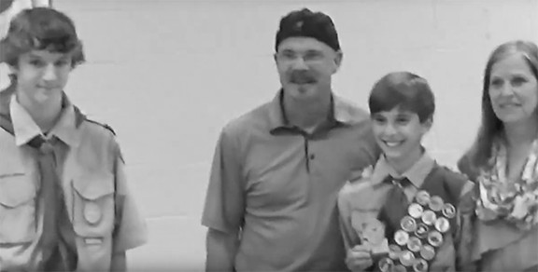
Scouts are recognized during a troop court of honor.

CAMP STOVES
(15 minutes - Inside)
Objective: Through group discussion participants will become acquainted with the most popular stoves used by troops and crews.
Materials for class
- projector
- screen
Discussion: Guidelines for the safe handling of stoves are presented in the Scouts BSA Handbook, Fieldbook, and the Backpacking merit badge pamphlet. Nowadays, what are some of the most common stoves units use on their front country outings?
—> After receiving group responses, as necessary, review the following:
- Various setups of propane cookers
- Coleman 2 Burner Stove (1 for each patrol)
—> View Video 23: Coleman Classic Propane Stove
Discussion: Nowadays what are some of the most popular backpacking stoves used by troops and crews?
—> After receiving group responses, review the following:
- MSR Whisperlite White Gas Stove (regularly used at Philmont for crew cooking)
—> View Video 24: How to Operate an MSR Whisperlite
- JetBoil Canister Stove
—> View Video 25: JetBoil Flash Product Tour
- MSR Pocket Rocket Canister Stove
- Coleman Single Burner Propane Stove
—> Turn attention to “Using Chemical Fuels Safely” reference materials.
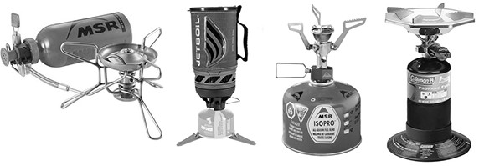

DAY 3

Materials
— Day 3 - Block 1 —

- a designated area measuring 100 feet marked at each end with a tent stake Gathering Period: Find Your Pace

WEATHER-RELATED SAFETY - SAFETY MOMENT

SUMMARY
Robert Baden-Powell once said the definition of the Scout motto Be Prepared is this: “A Scout must prepare himself by previous thinking out and practicing how to act on any accident or emergency so that he is never taken by surprise.” Baden-Powell also advocated that young men spend a lot of time learning in and about the out-of-doors, as he said, “The open-air is the real objective of Scouting and the key to its success.” However, we still need to be aware of our surroundings and their changing conditions, including what is happening with the weather.

GENERAL INFORMATION
Severe weather hazards, such as tornadoes, lightning, hail, flash flooding, and downbursts, can be dangerous. Each requires a basic understanding of what to do so that you can protect yourself and your Scouts. The scale of weather conditions can seem daunting—ranging from high heat with no humidity to torrential downpours with possible flooding. However, some key basic principles can help everyone prepare. Here are a few for you to consider:

- Know the weather forecast before you set out on your trip.
- Prepare for the types of weather hazards that are associated with your destination, such as tornadoes, lightning, snow, torrential rains, and high winds. The BSA’s online Weather Hazards training (available through My.Scouting.org) is a great resource in this area and should be renewed every two years.
- Double-check weather conditions immediately upon arrival to verify forecasts.
- The weather can be integral in becoming lost or injured. If visibility becomes limited, respond quickly to gather the Scouts in your care.
- Inquire about the location of any designated emergency shelters in the area.

You may never encounter a severe weather hazard. Your chances of being hit by lightning in your lifetime are 1 in 700,000, and the chances of your home being destroyed by a tornado (if you live in tornado alley) are 1 in 150,000. By learning and following these key principles, you can move forward with confidence and provide every opportunity to your Scouts to participate in Baden-Powell’s outdoor laboratory.

HEALTH AND SAFETY SKILLS — FIRST AID
(1 hour 15 minutes- Inside)
Objective: Through discussion of the material found in the Scouts BSA Handbook and the first aid merit badge pamphlet, participants will review and become further acquainted with basic, outdoor-related first aid.
Discussion: Point out that these and all academic sections in this lesson plan are presented as discussions. The information is available in the Scouts BSA Handbook, Fieldbook, and corresponding merit badge pamphlets.
Are first aid skills outdoor skills?
—> After receiving group responses, read the following:
First aid skills are largely academic, and acquiring the basic first aid skills required for Tenderfoot through First Class, is primarily a process of gaining the information from the Scouts BSA Handbook and then, whenever possible, practicing each procedure in an imaginary setting where the skills can be put into action. However, in various circumstances, the capacity to call upon outdoor skills, especially relevant to survival, brings to light one’s ability to use one’s resources, which is characteristic of outdoor skills in general.
Some specific preventative measures and treatment procedures have a definite relationship to the outdoors, like:
- Prevention and Treatment for Blisters
- Prevention of, Recognizing, and Treating Dehydration
- Recognizing and Treating Cold and Heat Related Injuries
- Recognizing and Treating Shock
- Lightning Precautions
- Prevention and Treatment of Bites and Stings
—> After receiving group responses, for each of the following questions, as necessary, review the corresponding bullet points:
What are some ways to prevent blisters on the feet?
- Stop walking or hiking at the first signs of irritation and cover the hot spot with some tape to temporarily eliminate the friction on that area.
- Make sure footwear is well-broken in before actual use.
- Wear thin, synthetic socks under heavier hiking socks so the rubbing will be against the thin sock and not directly against the skin.
What are some ways to treat blisters on the feet?
- Cover them with some tape.
- Place a circle of moleskin around them so the surrounding area is raised to the extent the rubbing won’t be felt at the blister site.

- If the blister is painfully large and needs to be popped, do so with a sterilized needle on the side—not the top.
What are the signs of hypothermia?
- Feeling cold and numb
- Incoherent mumbling
- Feeling tired and unable to think straight
- Shivering uncontrollably
- Becoming irritable
- Stumbling and falling
- Losing consciousness
How can hypothermia be treated?
- Move the person to a shelter.
- Replace wet clothing with warm dry clothing.
- Wrap them in sleeping bag, blankets, jackets
- Give warn liquids (NO beverages that contain caﬀein!)
- Wrap water bottles filled with warm water and place under armpits and against groin.
What are some signs of frostbite?
- Complaints that the feet, fingers, ears, or nose hurt or feel numb
- Grayish white patches on the skin
How can frostbite be treated?
- Move the person to a shelter.
- Warm cheeks or ears with palm of hand (gloves oﬀ).
- Slip a frostbitten hand under clothing against warm skin.
- Place dry, sterile gauze between fingers or toes and cover with a loose bandage.
- Rewarm the injured area with warm water (not hot) until normal color returns.
What are signs of heat exhaustion?
- Severe lack of energy
- Feeling faint
- Severe sweating
- General weakness
- Headache
- Nausea
- Cool, pale, moist skin
- Rapid pulse

What steps should be taken to treat heat exhaustion?
- Remove excess clothing and lie in a cool shady place with feet raised.
- Fan the body and apply cool, wet cloths.
- Drink some water. Rehydrate.
What are signs of heatstroke? — Medical emergency, call for medical assistance.—
- Hot, sweaty or dry, red skin

- Vomiting
- Confusion and disorientation
- Rapid pulse
- Seizures
- Unconsciousness
- Shallow breathing
What steps should be taken to cool the victim?
- Move person to air conditioned or shady area.
- Loosen tight clothing, cool skin by fanning and applying wet cloths.
- Apply wrapped ice packs under armpits and against neck and groin.
- Immerse person in shallow pool of water.
- If person can drink, give small amounts of cool water.
What are the signs of dehydration?
- Increased to severe thirst
- Dark urine or decrease urine production
- Feeling tired or weak
- Decreased sweating
- Dry skin and lips
- Nausea
- Fainting
- Loss of appetite
- Headache, body aches
- Muscle cramps
- Confusion
- Dizziness
What can be done to treat dehydration?
- Drink fluids.
- Rest
- In hot weather, get to a shaded or air conditioned place.
What can be done to prevent dehydration?
- Drink plenty of water before feeling thirsty.
- Take in enough fluids so urine is clear.
- Avoid caﬀeinated drinks.
What are the signs of shock?
- Restlessness or irritability
- Weakness
- Confusion
- Fear
- Dizziness
- Clammy, cool, pale skin
- Quick, weak pulse
- Shallow, rapid, irregular breathing
- Nausea and vomiting

- Extreme thirst
What is the first aid for shock?
- Call for help.
- Speak to them in a calm voice.
- Try to eliminate the cause(s) of shock by treating hurry cases: severe wounds, control bleeding, restore breathing and circulation.
- Have the person lie down and raise the feet about 12 inches if no back, neck, head injuries, or fractures of the hip, legs or pelvis are suspected.
- Keep the victim warm by surrounding their body with blankets, coats, etc.
What precautions should be taken during a thunder storm?
- If near safe buildings, stay inside until 30 minutes after the last rumble of thunder is heard.
- If out on the water, quickly head to shore if you hear thunder.
- In the backcountry, avoid open fields, hilltops, and ridge tops.
- Spread the group out 100 feet from one another.
- Stay away from tall, isolated trees and other tall objects.
- In a forest, stay near a lower stand of trees.
- Stay away from water, wet items, and metal objects.
- Stay clear of shallow caves and overhanging cliﬀs.
What treatment should be provided if a person is struck by lightening?
- If the person has stopped breathing, administer CPR.
- After assessment, treat injuries.
- Always seek medical attention.
What can be done to reduce the likelihood of tick bites?
- Wear long pants and long-sleeved shirts in woodlands and fields, button the collar and tuck the cuﬀs into your boots or socks.
- Apply a good insect repellent.
- In tick country, check for ticks twice daily.
What’s the recommended method to remove a tick and treat the bite area?
- Use a tweezer to grasp an embedded tick and gently pull all of it out of the skin.
- Wash the area and your hands with soap and water.
- Treat the bitten area with an antibiotic salve.
How do we treat the sting from a bee or hornet?
- Never squeeze the area around the stinger.
- Remove the stinger by scraping it with a knife blade.
- Apply an icepack to reduce pain and swelling.
- If breathing becomes diﬃcult, seek medical attention and treat for anaphylactic shock by administering epinephrine.
What should we do for a spider bite?
- See a doctor a.s.a.p. if symptoms show up such as swelling, redness, pain, diﬃculty swallowing, nausea, vomiting, muscle pain, or joint pain.
- Wash the bite with soap and water.

- Apply an ice pack.
- Treat for shock.
How to we treat the bite from a nonvenomous snake?
- Same as a puncture wound.
What steps should be taken to treat the bite from a venomous snake?
- Keep the victim calm.
- Wash the wound site.
- Remove any jewelry in the area of the bite before swelling occurs.
- Restrict movement by splinting, if the bite is on an extremity.
- Keep the bite site at the approximate level of the heart.
- Do not:
  - apply ice
  - cut the skin
  - suck out venom
  - apply a tourniquet
- Take steps to get the victim medical help as soon as possible.
- Treat for shock, but don’t elevate the aﬀected limb.

Activity: Play First Aid Base Ball
OUTDOOR SKILLS SECTION FIRST AID BASEBALL QUESTIONS
(Each participant is given only twenty seconds to correctly answer their question or they’re out.)
- What are three ways to prevent blisters on the feet?
  - Stop walking or hiking at the first signs of irritation and cover the hot spot with some tape to temporarily eliminate the friction on that area.
  - Make sure footwear is well-broken in before actual use.
  - Wear thin, synthetic socks under heavier hiking socks so the rubbing will be against the thin sock and not directly against the skin
- What are two ways to treat blisters on the feet?
  - Cover them with some tape.
  - Place a circle of moleskin around them so the surrounding area is raised to the extent the rubbing won’t be felt at the blister site.
  - If the blister is painfully large and needs to be popped, do so with a sterilized needle on the side—not the top.
- What are five signs of hypothermia?
  - Feeling cold and numb
  - Incoherent mumbling
  - Feeling tired and unable to think straight
  - Shivering uncontrollably
  - Becoming irritable

  - Stumbling and falling
  - Losing consciousness
- What are three ways hypothermia can be treated?
  - Move the person to a shelter.
  - Replace wet clothing with warm dry clothing.
  - Wrap them in sleeping bag, blankets, jackets
  - Give warn liquids (NO beverages that contain caﬀein!)
  - Wrap water bottles filled with warm water and place under armpits and against groin.
- What are two signs of frostbite?
  - Complaints that the feet, fingers, ears, or nose hurt or feel numb
  - Grayish white patches on the skin
- What are four ways to treat frostbite?
  - Move the person to a shelter.
  - Warm cheeks or ears with palm of hand (gloves oﬀ).
  - Slip a frostbitten hand under clothing against warm skin.
  - Place dry, sterile gauze between fingers or toes and cover with a loose bandage.
  - Rewarm the injured area with warm water (not hot) until normal color returns.
- What are five signs of heat exhaustion?
  - Severe lack of energy
  - Feeling faint
  - Severe sweating
  - General weakness
  - Headache
  - Nausea
  - Cool, pale, moist skin
  - Rapid pulse
- What three steps should be taken to treat heat exhaustion?
  - Remove excess clothing and lie in cool shady place with feet raised.
  - Fan the body and apply cool, wet cloths.
  - Drink some water. Rehydrate.
- What are five signs of heatstroke?
  - Hot, sweaty or dry, red skin
  - Vomiting
  - Confusion and disorientation
  - Rapid pulse
  - Seizures
  - Unconsciousness
  - Shallow breathing
- What are six signs of dehydration?
  - Increased to severe thirst
  - Dark urine or decreased urine production

  - Feeling tired or weak
  - Decreased sweating
  - Dry skin and lips
  - Nausea
  - Fainting
  - Loss of appetite
  - Headache, body aches
  - Muscle cramps
  - Confusion
  - Dizziness
- What three things can be done to treat dehydration?
  - Drink fluids.
  - Rest.
  - In hot weather, get to a shaded or air conditioned place.
- What three things can be done to prevent dehydration?
  - Drink plenty of water before feeling thirsty.
  - Take in enough fluids so urine is clear.
  - Avoid caﬀeinated drinks.
- What are five signs of shock?
  - Restlessness or irritability
  - Weakness
  - Confusion
  - Fear
  - Dizziness
  - Clammy, cool, pale skin
  - Quick, weak pulse
  - Shallow, rapid, irregular breathing
  - Nausea and vomiting
  - Extreme thirst
- What are four things that can serve as first aid for shock?
  - Call for help.
  - Speak to them in a calm voice.
  - Try to eliminate the cause(s) of shock by treating hurry cases: severe wounds, control bleeding, restore breathing and circulation.
  - Have the person lie down and raise the feet about 12 inches if no back, neck, head injuries, or fractures of the hip, legs or pelvis are suspected.
  - Keep the victim warm by surrounding their body with blankets, coats, etc.

- What are three things to do if a person is struck by lightening?
  - If the person has stopped breathing, administer CPR.
  - After assessment, treat injuries.
  - Always seek medical attention.
- What are three things that can be done to reduce the likelihood of tick bites?

  - Wear long pants and long-sleeved shirts in woodlands and fields, button the collar and tuck the cuﬀs into your boots or socks.
  - Apply a good insect repellent.
  - In tick country, check for ticks twice daily.
- What are three things to do for removing a tick and treating the bite area?
  - Use a tweezer to grasp an embedded tick and gently pull all of it out of the skin.
  - Wash the area and your hands with soap and water.
  - Treat the bitten area with an antibiotic salve.
- What are three things to do for a bee or hornet sting?
  - Never squeeze the area around the stinger.
  - Remove the stinger by scraping it with a knife blade.
  - Apply an icepack to reduce pain and swelling.
  - If breathing becomes diﬃcult, seek medical attention and treat for anaphylactic shock by administering epinephrine.
- What are three things to do for a spider bite?
  - See a doctor a.s.a.p. if symptoms show up such as swelling, redness, pain, diﬃculty swallowing, nausea, vomiting, muscle pain, or joint pain.
  - Wash the bite with soap and water.
  - Apply an ice pack.
  - Treat for shock.
- How to we treat the bite from a nonvenomous snake?
  - Same as a puncture wound.
- What are five steps to take to treat the bite from a venomous snake?
  - Keep the victim calm.
  - Wash the wound site.
  - Remove any jewelry in the area of the bite before swelling occurs.
  - Restrict movement by splinting, if the bite is on an extremity.
  - Keep the bite site at the approximate level of the heart.
  - Take steps to get the victim medical help as soon as possible.
  - Treat for shock, but don’t elevate the aﬀected limb.
- What are three things we shouldn’t do to treat a bite from a venomous snake?
  - apply ice
  - cut the skin
  - suck out venom
  - apply a tourniquet

When basic first aid is included in conjunction with your outdoor skills program, in addition to merely imparting the information, there should be the inclusion of first aid games and first aid relays.
—> Point out that featured in Troop Program Resources, there are several First Aid Skill Activities. Also, the First Aid Module in the Scouts BSA Resident Camp First-Year

Camper Program, contains a series of involving games and activities that reinforce what’s presented in the Scouts BSA Handbook.
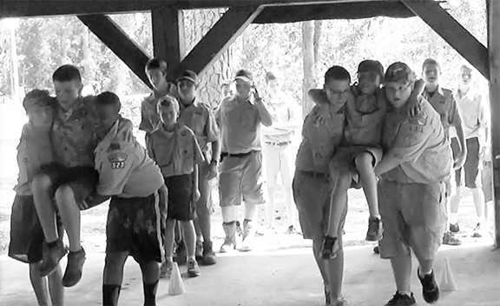
First Aid Carry Relay at Scout Camp

TARPS AND PATROL DINING FLY
(45 minutes - Inside / Outdoors)
Objective: Through group discussion and the viewing of an explanatory video, participants will gain information pertaining to tarps and patrol flies, and then, by employing the skills presented during previous sessions, will pool their resources and quickly erect a basic patrol fly.
Materials for each patrol
  - one tarp with grommets and ridge line attached
  - four 15-foot guylines
  - four Scout staves
  - four 6-foot lashing ropes
  - six stakes
  - one mallet
Materials for class
  - projector
  - screen
—> View Video 26: Tarps and Patrol Dining Fly Discussion: So, why patrol dining flies?
—> After receiving group responses, as necessary, review the following:
  - In addition to serving to keep gear and patrol members dry, a patrol’s dining fly is at the center of the patrol site, under which they stay intact as they meet and eat together. “My ideal camp is where everyone is cheery and busy, where the patrols are kept intact under all circumstances, and where every patrol leader and Scout takes a genuine pride in his camp and his gadgets.” — Lord Baden-Powell.
  - Having their own dining fly gives patrols a sense of autonomy.
What skills are put into action and reinforced when erecting a dining fly in an open field?
  - two half hitches (or bowline)
  - taut-line hitch
  - round lashing
  - mensuration (position of stakes and angles of guylines)
  - clove hitch over an open-ended pole
  - half hitches
  - teamwork, organization and cooperation
—> View Video 27: Dining Fly Race Demonstration Activity: Dining Fly Race

OUTDOOR SKILLS MERIT BADGES PART 1

(Outdoor Skills Director Split Session)
BACKPACKING / CAMPING / WILDERNESS SURVIVAL
(1 hour - Inside)
Objective: Through familiarization and discussion, the outdoor skills director will prepare themselves to train their staﬀ and assure the merit badge classes in their section are exemplary.
Discussion: —> Turn attention to “Backpacking Merit Badge,” “Camping Merit Badge,” and “Wilderness Survival Merit Badge” reference pages. and review each one.
Note:
- Answers are in red.
- Requirements in parenthesis cannot ordinarily be completed in a Scouts BSA residential camp setting.
- Pamphlet Printings - Backpacking: 2017, Camping: 2019, Wilderness Survival: 2012
Let’s review each requirement that can be completed at camp and discuss any special points that need further consideration. These reference pages can be shared as an aid to members of your staﬀ.

BACKPACKING MERIT BADGE
(Pamphlet Printing 2017)
- Discuss the prevention of and treatment for the health concerns that could occur while backpacking, including hypothermia, heat reactions, frostbite, dehydration, insect stings, tick bites, snakebite, and blisters. (Refer to “Health and Safety Skills reference pages”)
- Do the following:
  - List 10 items that are essential to be carried on any backpacking trek and explain why each item is necessary. (page 39 in pamphlet)
    - Pocket Knife
    - First-Aid Kit
    - Extra Clothing
    - Rain Gear
    - Water
    - Flashlight
    - Trail Food
    - Fire Starters
    - Sun Protection
    - Map and Compass
  - Describe 10 ways you can limit the weight and bulk to be carried in your pack without jeopardizing your health or safety. (page 54 in pamphlet)
    - Do a shakedown before each trip to “shake out” everything you won’t need.
    - Divide crew gear so that each Scout carries a fair share.

    - Gradually replace your heavier equipment with lighter items.
    - Choose lightweight hiking boots over stiﬀ, heavy footwear.
    - Prepare one-pot meals featuring pasta, powdered sauce mixes, and other ingredients that are dry, easy to pack, and not very heavy.
    - Match cookware with menus.
    - Get used to the hiking clothes that will be worn repeatedly throughout the trip.
    - Share personal items that will be enough for more than just one person.
    - Carefully consider not bringing anything that is not essential.
    - Review your gear after the trip to figure what you might have done without.
- Do the following:
  - Define limits on the number of backpackers appropriate for a trek crew. (page 15 in pamphlet)
    - The size of the group influences the impact on the land, on the group’s safety, and on the quality of the wilderness experience.
    - Philmont Scout Ranch recommends seven to twelve individuals on a trek—the best number for sharing gear, food and chores.
  - Describe how a trek crew should be organized. (page 16 in pamphlet)
    - Make up a duty roster so that everyone has an equal chance to cook, clean up after meals, manage food storage, and take care of other camp tasks.
  - Tell how you would minimize risk on a backpacking trek. (page 19 in pamphlet)
    - Get in shape.
    - Adjust clothing layers to match changing weather.
    - Drink plenty of water.
    - Take care of gear.
    - Communicate with the crew regarding concerns or diﬃculties.
    - Train in first-aid and deal appropriately with health issues and injuries.
    - Watch where you step.
  - Explain the purpose of an emergency response plan. (page 15 in pamphlet)
    - An emergency response plan provides the crew with important information to use if it encounters backcountry diﬃculties.
- Do the following:
  - Describe the importance of using Leave No Trace principles while backpacking, and at least five ways you can lessen the crew’s impact on the environment. (page 59 in pamphlet)
    - The principles of Leave No Trace help us live up to the responsibility of caring for the environment.
    - Travel and camp on durable surfaces.
    - Dispose of waste properly.
    - Leave what you find.
    - Minimize campfire impacts.
    - Respect wildlife.
  - Describe proper methods of handling human and other wastes while on a backpacking trek. Describe the importance of and means to assure personal cleanliness while on a backpacking trek. (pages 61-62 in pamphlet)
    - Select a wash site at least 200 feet away from water sources.

    - Use a strainer to remove food particles out of dishwater and put the particles in a plastic bag with other bits of leftover food.
    - Urinate on rocks or bare ground away from trails, camps, and other gathering places.
    - Dig a cathole or pack out solid waste, checking with the land management agency for the preferred method.
  - Tell what factors are important in choosing a campsite. (page 60 in pamphlet)
    - Whenever possible, choose an established campsite.
    - Camp at least 200 feet from lakes or streams.
    - Keep campsites small and conduct activities where vegetation is absent.
- Do the following:
  - Demonstrate two ways to treat water and tell why water treatment is essential.
(pages 81-82 in pamphlet)
    - Boiling
    - Chemical Treatment
    - Filtering
    - Water from natural sources may contain invisible microorganisms such as protozoa, bacteria, and viruses that can cause illness.
  - Explain to your counselor the importance of staying well-hydrated during a trek.
(page 23 in pamphlet)
    - Staying well-hydrated is essential to every bodily function. Heat exhaustion, heat stroke, and hypothermia may all be caused in part by dehydration.
- Do the following:
  - Demonstrate that you can read topographic maps. (pages 67-69 in pamphlet)
  - While on a trek, use a map and compass to establish your position on the ground at three diﬀerent locations OR use a GPS receiver to establish your position on a topographic map and on the ground at three diﬀerent locations. (pages 71-72 in pamphlet)
  - Explain how to stay found, and what to do if you get lost. (page 73 in pamphlet)
    - Make a trip plan and leave it with those at base camp.
    - Carry a topographic map and refer to it frequently.
    - Continuously try to match up points on the map with features around you.
    - If you cannot determine your position, don’t panic.
    - Use the map and think about the way you came.
    - If you think you are lost, stay put and make yourself comfortable.
    - Erect a shelter. Build a safe campfire.
    - Three blasts of a whistle a minute a part can help a search party find you.
    - Be patient.
- Tell how to properly prepare for and deal with inclement weather. (pages 24 and 86, in pamphlet)
- Keep your eye on the sky.
- In a thunder storm:
  - Get oﬀ a mountain top before lightning begins. Find a low spot.
  - Do not stand in open areas or near lightning targets.
  - Remove and keep your distance from any metallic frame packs.

  - Avoid outcroppings, overhands, and flood zones.
  - Squat down on the balls of your feet. Make yourself a small target.
  - If possible, take shelter in a steel-framed building or hard-topped motor
vehicle without touching metal parts.
  - Stay away from objects using electrical power.
  - If boating, get to land immediately.
- Do the following:
  - Explain the advantages and disadvantages of the diﬀerent types of backpacking stoves using at least three diﬀerent types of fuel. (page 51 in pamphlet)
    - White-Gas Stoves - eﬃcient in cold weather, fuel is highly volatile.
    - Canister Stoves - safety and convenience, loses eﬃciency as the temperature drops.
    - Alcohol Stoves - transportable and easy to use, does not produce as much heat as white-gas and canister stoves.
  - Demonstrate that you know how to operate a backpacking stove safely and to handle fuel safely.
    - Refer to “Using Chemical Fuels Safely” reference page.
  - Prepare at least three meals using a stove and fuel you can carry in a backpack.
(pages 75-80 in pamphlet)
  - Demonstrate that you know how to keep cooking and eating gear clean and sanitary, and that you practice proper methods for food storage while on a backpacking trek.
    - Dishwashing system (page 62 in pamphlet)
    - Backcountry Food Handling and Storage (page 83 in pamphlet)
- Do the following:
  - Write a plan that includes a schedule for a patrol/crew backpacking hike of at least 2 miles.
  - Conduct a prehike inspection of the patrol and its equipment. (page 55 in pamphlet)
  - Show that you know how to properly pack your personal gear and your share of the crew’s gear and food. (page 56 in pamphlet)
  - Show you can properly shoulder your pack and adjust it for proper wear. (page 57 in pamphlet)
  - While using the plan you developed for requirement 9a, carry your fully loaded pack to complete a hike of at least 2 miles.
(10.) Using Leave No Trace principles, participate in at least three backpacking treks of at least three days each and at least 15 miles each, and using at least two diﬀerent campsites on each trek. Carry everything you will need throughout the trek.
(11.) Do the following:
- Write a plan for a backpacking trek of at least five days using at least three diﬀerent campsites and covering at least 30 miles. Your plan must include a description of and route to the trek area, covering at least 30 miles and utilizing at least three diﬀerent campsites. While on the trek, complete
- Using Leave No Trace principles, take the trek as planned in 11a that is at least 5 full days, and, while on the trek, complete at least one service project approved by your merit badge counselor.
- Keep a daily journal during the trek that includes a day-by-day description of your activities, including notes about what worked well and thoughts about improvements that could be made for the next trek.

- Do the following:

CAMPING MERIT BADGE
(Pamphlet Printing 2019)

  - Explain to your counselor the most likely hazards you may encounter while participating in camping activities and what you should do to anticipate, help prevent, mitigate, and respond to these hazards. (pages15-18 in pamphlet) (Refer to “Health and Safety Skills reference pages”)
    - Complete Tenderfoot through First Class first-aid requirements and First-Aid merit badge.
    - Managing Risk
      - Stay in good physical shape.
      - Know where you are going and what to expect.
      - Adjust clothing layers to match changing conditions.
      - Drink plenty of water.
      - Protect yourself from:
        - exposure to the sun.
        - biting insects.
        - poisonous plants.
    - Altitude Sickness AMS (Acute Mountain Sickness) (Page 17 in pamphlet)
      - Preventive Measures
        - Climb high, sleep low.
        - Drink plenty of fluids.
        - Ascend gradually.
      - Symptoms
        - Headache
        - Nausea
        - Tiredness
        - Loss of motivation
      - Treatment
        - Descend to a lower elevation
        - Rest, fluid, and food.
    - Hyperventilation (Page 18 in pamphlet)
      - Preventive Measures
        - Addressing causes of stress and anxiety
      - Symptoms
        - Quick, shallow breathing
        - Light-headedness
        - Feeling faint
        - Tingling or numbness in fingers and toes
      - Treatment
        - Relax and slow breathing
        - Remove causes of anxiety by moving or talking through the situation.
    - Allergic Reactions (Page 18 in pamphlet)
      - Preventive Measures for Food Allergies

        - Create a safe environment by eliminating the food a Scout is allergic to.
      - Preventive Measures for Asthma or Allergies to Bee Stings and Other
Agents
        - Group leaders should be informed regarding individual conditions and treatment procedures.
        - Scouts should share treatment procedures and treatment kits with group leaders.
  - Discuss with your counselor why it is important to be aware of weather conditions before and during your camping activities. Tell how you can prepare should the weather turn bad during your campouts. (pages 57-58 in pamphlet)
    - Weather conditions dictate what measures need to be taken in order to assure everyone’s comfort and safety.
    - When the weather turns bad:
      - Take steps to keep warm and dry and be on the lookout for signs of
hypothermia.
      - Secure your camp.
      - When setting up camp, the first thing that goes up are patrol flies to shelter
gear while tents are pitched.
      - Heat a pot of water and prepare hot drinks, soup, etc.
      - Be patient and accepting.
    - In an electric storm:
      - Avoid open fields, hilltops, and ridge tops.
      - If possible, spread the group out 100 feet from one another.
      - Stay away from tall, isolated trees and other tall objects.
      - If camping in an open area, set up in a valley or other low area, but avoid
flood prone areas.
      - Stay away from water, wet items, and metal objects.
  - Show that you know first-aid for and how to prevent injuries or illnesses that could occur while camping, including hypothermia, frostbite, heat reactions, dehydration, altitude sickness, insect stings, tick bites, snakebite, blisters,
and hyperventilation. (Refer to “Health and Safety Skills reference pages”)
- Learn the Leave No Trace principles and the Outdoor Code and explain what they mean. Write a personal and group plan for implementing these principles on your next outing. (pages 19-21 in pamphlet)
- Leave No Trace Principles
  - Plan ahead and prepare.
    - Know the regulations and special concerns for the area you’ll visit.
    - Prepare for extreme weather hazards and emergencies.
    - Schedule your trip to avoid times of high use.
    - Visit in small groups where possible. Consider splitting into smaller groups.
    - Repackage food to minimize waste.
    - Use a compass to minimize the use of marking paint, rock cairns or flagging.
  - Travel and camp on durable surfaces.

    - Durable surfaces include established trails and campsites, rock, gravel, dry grasses or snow.
    - Protect areas near water by camping at least 200 feet from lakes and streams.
    - Good campsites are found, not made. Altering a site is not necessary.
    - In popular areas, use existing trails and campsites. Walk single file in the middle of the trail, even when it is wet or muddy. Keep campsites small. Focus activities in areas where vegetation is absent. In pristine areas, spread out to prevent the creation of campsites and trails. Avoid places where impacts are just beginning.
  - Dispose of waste properly (pack it in, pack it out).
    - Inspect your campsite and rest areas for trash and spilled foods. Pack out all trash, spilled foods, and litter.
    - Deposit all waste in catholes dug 6 to 8 inches deep at least 200 feet from water camp, and trails. Cover and disguise the cathole when finished.
    - Where necessary, pack out toilet paper and hygiene products.
    - To wash yourself or dishes, carry water at least 200 feet away from streams or lakes, and use small amounts of biodegradable soap. Scatter strained dishwater.
  - Leave what you find.
    - Preserve what you find; examine but do not touch cultural and historic structures and artifacts.
    - Leave rocks, plants, and other natural objects as you find them.
    - Do not build structures or furniture, or dig trenches.
  - Minimize campfire impacts.
    - Campfires can cause lasting impacts to the backcountry. Use a lightweight stove for cooking and enjoy a candle lantern for light.
    - Where fires are permitted, use established fire rings, fire pans, or mound fires.
    - Keep fires small. Only use sticks from the ground that can be broken by hand.
    - Burn all wood and coals to ash. Put out campfires completely then scatter cool ashes.
  - Respect wildlife.
    - Observe wildlife from a distance. Do not approach them.
    - Never feed animals. Feeding them damages their health, alters natural behaviors, and exposes them to predators and other dangers.
    - Protect wildlife and your food by storing rations and trash securely.
    - Avoid wildlife during sensitive times: mating, nesting, raising young, and during winter.
  - Be considerate of other visitors.
    - Respect other visitors privacy and property.
    - Be courteous. Yield to other users on the trail.
    - Camp away from trails and other visitors.
    - Let nature’s sounds prevail. Keep the noise down.

- The Outdoor Code reminds Scouts of the importance of caring for the environment. The code’s ideals have special meaning whenever you are camping, hiking, or taking part in other outdoor activities.
  - As an American, I will do my best to:
    - Be clean in my outdoor manners,
    - Be careful with fire,
    - Be considerate in the outdoors, and
    - Be conservation-minded.
- Make a written plan* for an overnight trek (page 24 in pamphlet) and show how to get to your camping spot by using a topographical map (page 47 in pamphlet) and one of the following:
  - A compass
  - A GPS receiver**
  - A smartphone with a GPS app
*To complete this requirement, you may use the Scout Planning Worksheet at https:// filestore.scouting.org/filestore/boyscouts/pdf/512-505-2016-Scout-Planning-Worksheet.pdf
**If a GPS-equipped device is not available, explain how to use one to get to your camping spot.
- Do the following:
  - Make a duty roster showing how your patrol is organized for an actual overnight campout. List assignments for each member. (pages 28-29 in pamphlet) Refer to troopleader.scouting.org/patrol-duty-roster
  - Help a Scout patrol or a Webelos Scout unit in your area prepare for an actual campout, including creating the duty roster, menu planning (pages 25-28 in pamphlet), equipment needs, general planning, and setting up camp.
    - Equipment Needs (pages 30-33 in pamphlet)
      - Scout Basic Essentials (page 31 in pamphlet)
        - Pocketknife
        - First-aid Kit
        - Extra Clothing and Rain Gear
        - Water Bottle
        - Flashlight
        - Trail Food
        - Matches and Fire Starters
        - Sun Protection
        - Map and Compass
      - Personal Overnight Camping Gear (page 32 in pamphlet)
        - Clothing for the Season
        - Backpack
        - Rain Cover for Backpack
        - Sleeping Bag
        - Ground Cloth and Sleeping Pad
        - Eating Kit: Spoon, Bowl, Cup
        - Cleanup Kit (Personal Hygiene)
        - Personal Extras (Optional)
      - Group Overnight Camping Gear (page 32 in pamphlet)

        - Tents
        - Dining Fly
        - Nylon Cord (50 Feet)
        - Backpacking Stoves and Fuel (for backpacking overnighters, Coleman 2-burner type for front country overnighters)
        - Patrol Cook Kit
        - Patrol Cleanup Kit (Mealtime)
        - Repair Kit
        - Group Extras
    - General Planning (pages 49-50 in pamphlet)
      - Selecting a Campsite
      - Safety
      - Size
      - Terrain
      - Privacy
      - Permission
      - Water
    - Setting Up Camp (page 51 in pamphlet)
      - Set up Dining Fly first.
      - Pitch your tents. (page 37 in pamphlet)
        - Choose a level site that drains well
        - Remove stones and sticks but try not to disturb the ground cover
      - Establish a plan for personal sanitation. (page 52 in pamphlet)
- Do the following:
  - Prepare a list of clothing you would need for overnight campouts in both warm and cold weather. Explain the term “layering.” (page 33 in pamphlet)
    - For Warm Weather Camping
      - T-shirt or lightweight short-sleeved shirt
      - Hiking shorts
      - Underwear
      - Socks
      - Lightweight long-sleeved shirt
      - Lightweight long pants
      - Sweater or jacket
      - Brimmed hat
      - Bandannas
      - Rain gear
    - For Cold Weather Camping
      - Long-sleeved shirt
      - Fleece or wool long pants
      - Fleece or wool sweater
      - Polypropylene long underwear
      - Wool or synthetic blend socks
      - Warm, hooded parka or jacket
      - Fleece or wool stocking hat

      - Fleece or wool mittens or gloves with water-resistant shells
      - Fleece or wool scarf
      - Rain gear
    - Layering enables you to add or subtract layers of clothing, depending on how hot or cold you feel.
  - Discuss footwear for diﬀerent kinds of conditions and how the right footwear is important for protecting your feet. (page 34 in pamphlet)
    - When walking in the backcountry or over rough terrain, hiking boots can provide comfort and support for feet and ankles.
    - Around camp, a pair of lightweight shoes can keep your feet comfortable and protected.
    - All footwear for camping should fit well and be properly broken in.
  - Explain the proper care and storage of camping equipment (clothing, footwear, bedding).
    - A place for everything, and everything in its place.
    - Organize clothing by placing it in separate storage bags according to type.
    - Have a separate bag for clothes ready for washing.
    - Clean footwear after the trip.
    - Treat footwear with a boot dressing or waterproofing agent according to manufacturer’s recommendations.
    - Don’t ever try to dry footwear by placing it too close to a fire.
    - Remove sleeping bags from their stuﬀ sack between trips.
    - Store a sleeping bag by hanging it in a closet or by placing it in a large laundry bag.
  - List the outdoor essentials necessary for any campout, and explain why each item is needed. (page 31 in pamphlet)
    - Pocketknife - the all-purpose tool for the out-of-doors
    - First-aid Kit - Carrying a few first-aid items in a self-sealing plastic bag will allow you to treat minor injuries and provide initial care if more serious injuries arise.
    - Extra Clothing and Rain Gear - enables you to deal with extremes of weather
—heat, cold, or storm
    - Water Bottle - it is always important to drink plenty of fluids
    - Flashlight - helps you see in the dark
    - Trail Food - helps keep you going
    - Matches and Fire Starters - Be prepared to light a fire even in wet weather.
    - Sun Protection - Protect yourself from sunburn.
    - Map and Compass - Use them to find your way through unfamiliar areas.
  - Present yourself to your Scoutmaster with your pack for inspection. Be correctly clothed and equipped for an overnight campout.
- Do the following:
  - Describe the features of four types of tents, when and where they could be used, and how to care for tents. Working with another Scout, pitch a tent.
    - Tent Types (pages 38-39 in pamphlet)

      - Tarps are most always used to set up a dining fly, but can be erected in many ways as a tent. With no floor and incomplete enclosure, they oﬀer less protection from insects wind, and rain.
      - The common A-Frame tents gets its name from its shape, comes in a wide
range of sizes and is fine for general use.
      - Dome tents have a dome shape. They can be spacious oﬀering lots of
headroom, stability and wind resistance. Usually larger than A-Frames, they can weigh more.
      - Hybrids come in a variety of shapes and can combine the features of A-
Frames and Domes.
      - Wall Tents are large and most always for long term, front country camping.
    - Tent Care (page 40 in pamphlet)
      - Take oﬀ your boots before crawling into a tent.
      - Apply seam sealer to new tents.
      - Try to avoid extended exposure to sunlight which can harm most tent
fabrics.
      - Clean the tent’s interior of litter and debris by sweeping, or if it’s small,
shaking it out.
      - Stow a tent in its storage sack by first putting in the collapsed poles and
then, starting with a corner, stuﬃng the rest.
      - Allow a tent to dry completely before storage.
  - Discuss the importance of camp sanitation and tell why water treatment is essential. Then demonstrate two ways to treat water.
    - Camp Sanitation (page 52 in pamphlet)
      - Sanitation is essential for both health and environmental reasons.
      - Where there are outhouses, use them.
      - Wash hands with soap and water or use a waterless hand cleanser when
you are done.
      - Catholes - Dig a hole 6 to 8 inches deep at least 200 feet from campsites
and trails. Fill it with earth when you’re done and replace ground cover.
      - Latrines - A large group can lesson the impact by digging a shallow trench
3 to 4 feet long, using a shovel to sprinkle a layer of soil into the trench after each use.
  - Describe the factors to be considered in deciding where to pitch your tent. (pages 19, 39, 49, 51 in pamphlet)
    - Pitch your tent on durable surfaces at least 200 feet from lakes and streams.
    - Choose a level site that drains well.
    - Don’t pitch a tent under dead trees or limbs that might fall in a storm.
    - Stay out of gullies that could fill with flash floods.
    - Stay away from lone trees and other likely targets for lightning.
    - Camp some distance away from game trails.
    - Pitch tents at least 200 feet away from cooking area and from where food will be stored.
  - Tell the diﬀerence between internal- and external-frame packs. Discuss the advantages and disadvantages of each. (page 36 in pamphlet)

    - Internal-frame packs have an internal frame, and external-frame packs have an external frame.
    - Internal-Frame Pack Advantages
      - Streamlined
      - Body-hugging fit
      - Easier to keep your balance
      - Fits better into canoes
    - Internal-Frame Pack Disadvantages
      - Less outside pockets
      - Hotter on the back
    - External-Frame Pack Advantages
      - Cooler on open trails
      - Easier to keep gear organized
      - Preferable for heavier loads
    - External-Frame Pack Disadvantages
      - More cumbersome on narrow trails
      - Less comfortable fit
  - Discuss the types of sleeping bags and what kind would be suitable for diﬀerent conditions. Explain the proper care of your sleeping bag and how to keep it dry. Make a comfortable ground bed. (pages 34-35 in pamphlet)
    - Kinds of Sleeping Bags
      - Down sleeping bags are lightweight and suitable for cold weather, but
don’t insulate when wet.
      - Synthetic filled sleeping bags can keep you warm even when wet.
    - Keeping Sleeping Bags Dry
      - Stuﬀ your sleeping bag into a plastic bag inside its stuﬀ sack.
    - Care of Sleeping Bags
      - Remove sleeping bags from their stuﬀ sack between trips.
      - Store sleeping bags by hanging therm in a closet or by placing them in a
large laundry bag.
- Prepare for an overnight campout with your patrol by doing the following:
  - Make a checklist of personal and patrol gear that will be needed.
  - Pack your own gear and your share of the patrol equipment and food for proper carrying. Show that your pack is right for quickly getting what is needed first, and that it has been assembled properly for comfort, weight, balance, size, and neatness. (page 45 in pamphlet)
    - Arrange soft items in your pack so they will cushion your back.
    - Keep items that need to be accessed quickly or easily near the top or in outside pockets.
      - rain gear
      - first-aid kit
      - flashlight
      - trail food
    - Depending on pack, stow sleeping bag inside an internal-frame pack or strapped to the frame of an external-frame pack.

    - Make sure any items strapped to the outside don’t swing around or fall oﬀ.
- Do the following:
  - Explain the safety procedures for: using a propane or butane/propane stove, using a liquid fuel stove, proper storage of extra fuel.
    - Using Stoves Safely (page 43 in pamphlet)
      - Read and understand the manufacturers instructions before lighting any
stove.
      - Make sure the stove is on level ground before use.
      - Never use a stove inside or near a tent.
      - Don’t overload a stove with more weight than it can safely accommodate.
      - Never leave a burning stove unattended.
      - Always let a stove cool completely before you put it away.
      - Don’t open the fuel cap of a hot stove or attempt to refuel a hot stove.
      - Store liquid fuel in well-marked metal fuel bottles designed specifically for
that use.
      - Keep fuel bottles away from sources of heat, even if they are empty.
      - Don’t store fuel containers inside your dwelling.
  - Discuss the advantages and disadvantages of diﬀerent types of lightweight cooking stoves. (page 42 in pamphlet)
    - White Gas Stoves
      - Advantages
        - works eﬃciently in cold weather
        - most often can accommodate larger crew-sized pots
        - white gas is readily available and inexpensive
        - fuel containers come in convenient sizes
      - Disadvantages
        - some need to be preheated
        - more complicated to operate and maintain
    - Cartridge Stoves
      - Advantages
        - easy and convenient to use
      - Disadvantages
        - usually cannot accommodate larger pots
        - lose eﬃciency in colder weather
        - requires specific types of fuel canisters
  - Prepare a camp menu. Explain how the menu would diﬀer from a menu for a backpacking or float trip. (page 25 in pamphlet) Give recipes and make a food list for your patrol. Plan two breakfasts, three lunches, and two suppers. (page 27 in pamphlet) Discuss how to protect your food against bad weather, animals, and contamination. (page 26 in pamphlet)
    - Menus can be more elaborate and take longer to cook on front-country outings, when weight is not a problem, and where a cooler with ice is possible.
    - For backcountry trips, use dehydrated and dry ingredients.
    - On those occasions when engaged in activities away from the campsite, menus should be planned to make meal preparation easy and quick.

    - Repackage food in resealable plastic bags to reduce clutter and weight. On a piece of tape attached to each bag, write the contents and for which meal it will be used.
    - Generally speaking, select foods that will not spoil.
    - Meats and dairy products must be kept cold during storage. Once removed from protective wrappers, these items must be kept separate from other food. Uneaten cooked meat must be kept cold.
    - Pack all food safely away from animals and inclement weather.
  - While camping in the outdoors, cook at least one breakfast, one lunch, and one dinner for your patrol from the meals you have planned for requirement 8c. At least one of those meals must be a trail meal requiring the use of a lightweight stove.
- Show experience in camping by doing the following:
  - Camp a total of at least 20 nights at designated Scouting activities or events. One long-term camping experience of up to six consecutive nights may be applied toward this requirement. Sleep each night under the sky or in a tent you have pitched. If the camp provides a tent that has already been pitched, you need not pitch your own tent.
  - On any of these camping experiences, you must do TWO of the following, only with proper preparation and under qualified supervision.
- Hike up a mountain, gaining at least 1,000 vertical feet.
- Backpack, snowshoe, or cross-country ski for at least 4 miles.
- Take a bike trip of at least 15 miles or at least four hours.
- take a non-motorized trip on the water for at least four hours or 5 miles.
- Plan and carry out an overnight snow camping experience.
- Rappel down a rappel route of 30 feet or more.
  - On any of these camping experiences, perform a conservation project approved by the landowner or land managing agency. This can be done alone or with others.
- Discuss how the things you did to earn this badge have taught you about personal health and safety, survival, public health, conservation, and good citizenship. In your discussion, tell how Scout spirit and the Scout Oath and Scout Law apply to camping and outdoor ethics. (page 61 in pamphlet)
- Patrols work together sharing responsibilities
- Patrols put their energy into practicing outdoor skills and solving problems.
- Campers increase their understanding and the need to remain aware of their personal health and safety.
- Scouts practice good citizenship by caring for the land and contributing to the welfare of the group.
- During the camping trip, Scout spirit is continuously manifested in abiding by the Scout Oath and Law in all things you do.

WILDERNESS SURVIVAL MERIT BADGE
(Pamphlet Printing 2012)
- Do the following:
  - Explain to your counselor the hazards you are most likely to encounter while participating in wilderness survival activities, and what you should do to anticipate, help prevent, mitigate, or lessen these hazards. (pages 9-10 in pamphlet)
    - Not planning ahead or failing to prepare a trip plan
      - Match skill and fitness levels of the participants.
      - Get permission from land owners.
      - Research the terrain, elevation ranges, trails, campsites, and typical
weather conditions.
      - Know where you’re going and what to expect.
    - Not having good leadership in your group
      - Include a mature, conscientious adult at least 21 years old who is
prepared to assume responsibility for the group’s safety. One additional adult, at least 18 must accompany the group.
    - Being in poor physical condition or not eating enough or eating the wrong kind of foods
      - Keep fit and train for the trip.
      - Plan nutritious menus and eat healthily.
    - Wearing the wrong clothing or footwear, and being poorly equipped
      - Have the proper and appropriate equipment and protective clothing to suit
the weather and environmental conditions of the trip.
    - Becoming too tired, too cold, too hot, or too thirsty
      - Don’t overtax the body
      - Get proper rest.
      - Adjust clothing layers to match weather conditions.
      - Drink plenty of water.
    - Encountering unexpected changes in the weather or unexpected terrain
      - Keep an eye on weather conditions.
      - Refer to topographical maps and current trail maps for the area.
  - Show that you know first aid for and how to prevent injuries or illnesses that could occur in backcountry settings, including hypothermia, heat reactions, frostbite, dehydration, blisters, insect stings, tick bites, and snakebites. (pages 51-59 in pamphlet) (Refer to “Health and Safety Skills reference pages”)
- From memory, list the seven priorities for survival in a backcountry or wilderness location. Explain the importance of each one with your counselor.
- STOP: Stop, Think, Observe, Plan: The first thing to do is to stop yourself, stay positive and begin to take charge of the situation. (page 21 in pamphlet)
- Provide First Aid: Treat life-threatening injuries and illnesses immediately. (page 22 in pamphlet)
- Seek Shelter: Give the body shelter to maintain its ideal temperature without using more energy than necessary, (page 23 in pamphlet)

- Build a Fire: A fire can be important for maintaining body warmth, melting snow for water, drying out clothing, signaling for help, and raising your spirits. (page 29 in pamphlet)
- Signal for Help: Signaling for help can aid rescuers in locating you, and can be important if you or others in your group are injured and can’t be moved. (page 34 in pamphlet)
- Drink Water: You can survive for days without food, but in hot weather, only hours without water. (page 38 in pamphlet)
- Don’t Worry About Food: Keeping warm in cold weather, cool in hot weather, finding shelter, drinking water, and signaling your location are all more important than finding something to eat.
- Discuss ways to avoid panic and maintain a high level of morale when lost, and explain why this is important. (page19 and side columns of 20-21 in pamphlet)
- Whatever is done while panicking will probably make matters worse.
- Keep a positive attitude
- Evaluate the resources with you and around you to determine what can be used to make the most of your situation.
- After securing shelter, building a safe fire can raise your spirits.
- Describe the steps you would take to survive in the following exposure conditions:
  - Cold and snowy (page 41 in pamphlet)
    - Do all you can to keep yourself warm and dry.
    - Take steps to build a shelter and if possible to light a fire.
    - Drink plenty of fluids.
  - Wet (page 42 in pamphlet)
    - Do all you can to keep yourself warm and dry.
    - Consider moving to an open area if the need for signaling arises, marking your steps from where you were.
  - Hot and dry (page 42 in pamphlet)
    - Rest in a high, shady spot during the day.
    - Complete necessary activities in the cool of the evening or early morning.
    - Wear sun protection.
  - Windy (page 42 in pamphlet)
    - Wear a windproof outer layer.
    - Seek shelter on the calm side of a boulder or large tree.
    - Watch for signs of hypothermia.
  - At or on the water (page 43 in pamphlet)
    - Those who fall in the water need to get to dry land, get back into a watercraft, or stay afloat until help arrives.
    - If in cold water near the shore, get out of the water as soon as possible to help avoid hypothermia.
    - If far from shore:
      - get as much of your body out of the water as possible by climbing onto
the capsized craft.
      - with pfd, float with legs drawn up close to your trunk.
      - huddle with others if you are not alone.

    - If the situation involves a life raft, look for storage compartments containing an emergency kit.
    - If stranded on the coastline of an ocean:
      - don’t drink the salt water.
      - stay in the shade to keep from sweating away moisture.
      - try to locate sources of fresh water.
    - If you need to ride out rapids in a river, before swimming to safety or catching a rescue line:
      - go downstream feet first.
      - use a backstroke to maneuver past obstacles.
      - watch for eddies that might protect you.
- Put together a personal survival kit and explain how each item in it could be useful.
(page 13 in pamphlet)
- In addition to the ten Outdoor Essentials:
  - Duct Tape - has a variety of uses.
  - Whistle - can be heard over longer distances and requires less energy than
shouting.
  - Metal Mirror - for signaling.
  - Thin Wire - for repairs.
  - Heavy Duty Garbage Bag - to keep things dry and protected.
  - Fishing Line and Hooks - for making repairs and for fishing.
  - GPS Receiver - can pinpoint your location.
  - Mobile Phone - can be a convenient way to contact emergency response
personnel.
- Using three diﬀerent methods (other than matches), build and light three fires. (page 31 in pamphlet)
- Butane Lighter
- Magnesium Rod
- Ferro Rod
- Flint and Steel
- Bow and Drill
- Do the following:
  - Show five diﬀerent ways to attract attention when lost. (pages 36-37 in pamphlet)
    - Mirrors and Lights
      - flashlight
      - flares
    - Color and Motion
    - Fire and Smoke
    - Ground to Air Signals
    - Shadows
  - Demonstrate how to use a signal mirror. (page 36 in pamphlet)
    - Sight a target through the hole in the mirror’s center or by looking over the mirror’s top edge. Form a “V” with the fingers of your free hand and extending your arm in line with the target, adjust the angle of the mirror until the reflected light illuminates the “V”.

  - Describe from memory five ground-to-air signals and tell what they mean. (page 37 in pamphlet)
    - V = Require Assistance
    - X = Require Medical Assistance
    - N = No
    - Y = Yes
    - —> = Proceeding in this direction
- Improvise a natural shelter. For the purpose of this demonstration, use techniques that have little negative impact on the environment. Spend a night in your shelter. (pages 24-28 in pamphlet)
- Explain how to protect yourself from insects, reptiles, bears, and other animals of the local region. (pages 47-49 in pamphlet)
- For insects:
  - use insect repellent.
  - wear a hat, long sleeves and long pants.
  - tie a bandana around your face or an extra t-shirt to protect your head.
  - wear gloves or socks over your hands.
  - smooth a layer of mud over exposed skin.
  - build a fire and stay close in the smoke.
  - consider moving to higher ground.
- For reptiles:
  - use a hiking stick to poke among stones and brush ahead of you in snake
country.
  - watch where you put your hands as you collect firewood or climb over rocks
and logs.
- For bears:
  - make noise while hiking.
  - set up your sleeping area at least 200 feet from where you will cook and eat.
  - properly store all smellables.
  - clean up and pack out campsite trash and spilled food and food particles.
  - dispose of dishwater at least 200 feet from sleeping area.
  - avoid using scented toiletries.
  - wear separate sleeping clothes to bed.
- Demonstrate three ways to treat water found in the outdoors to prepare it for drinking. (page 38 in pamphlet)
- Boiling
- Chemical Treatment
- Filtering
- Show that you know the proper clothing to wear while in the outdoors during extremely hot and cold weather and during wet conditions. (pages 15-17 in pamphlet)
- For hot weather:
  - wicking underwear
  - lightweight, synthetic long pants and long-sleeved shirt
  - hiking shorts

  - lightweight short-sleeved shirt
  - brimmed hat
  - bandana
  - appropriate footwear
- For cold weather:
  - fleece, wool, or synthetic blend long-sleeved shirt
  - fleece, wool, or synthetic blend long pants
  - fleece or wool sweater
  - polypropylene long underwear
  - wool or synthetic blend socks
  - warm hooded parka or jacket
  - fleece or wool stocking hat
  - fleece or wool mittens or gloves with water resistant shells
  - wool scarf
  - appropriate footwear
- For wet weather:
  - breathable, loosely-fitting rain pants and rain jacket with a hood
- Explain why it usually is not wise to eat edible wild plants or wildlife in a wilderness survival situation. (page 39 in pamphlet)
- In order to avoid intestinal distress and even poisoning, it’s best to leave vegetation alone, unless you are absolutely sure of a plant’s identity and know for certain it’s safe to eat.

FIRST-YEAR CAMPER PROGRAM - PART 1 -

(First-Year Camper Director Split Session)
(1 hour - Inside)
Objective: Participants will continue to formulate plans for an action-based program appropriate for their camp, through discussion, and by becoming familiar with two established models of first-year camper programs, comparing and contrasting the two, and learning more about the value of putting skills into action in ways that are fun.
Materials for class
- projector
- screen
Discussion: What reasons can you think of why camps have a special program for younger Scouts attending camp for the first time?
—> After receiving group responses, read and discuss each of the following:)

- Some units are attracted to attend camp because advancement is high on their priority list and they’re under the impression that the program will be an advancement shortcut.
- Some troops like it because it presents instruction for requirements they aren’t equipped to readily oﬀer themselves.
- Some troops want a program where their new Scouts can gain exposure to a host of basic outdoor skills they don’t feel confident they can present as well.
- The camp appreciates oﬀering a program that helps to open the eyes of new Scouts to what Scouting is all about.
- The camp wants their first-year campers to be in a program that is both loads of fun and specifically designed for them, so they will want to come back in the years to come.
Discussion: It is generally agreed that what we want to avoid is an advancement-based program where the information surrounding the skill is presented, followed by checking oﬀ the requirement in the handbook.
When presenting any kind of material, a key objective is to communicate how and why what’s being taught has RELEVANCE for the learner. A Scout should never learn something just because it’s required of them in order to earn the next rank.
The EDGE method is the framework adopted by the BSA for presenting a skill. What is the EDGE method?
—> After a response is given, as necessary, review the following explanations:

Explain - Instructors should share with the Scouts why one would choose to use the skill and when it can be applied.
Demonstrate - It’s necessary to show the Scouts how it looks to actually do the skill. Guide - The next step is to help the Scouts acquire whatever they need, in order to possess the skill for themselves.
Enable -The Scouts need to be able to rely upon themselves to use the skill and put it into action.
In order to bring the skill to life, after a Scout has been enabled to perform the skill, they need to do be provided an opportunity to put it into action.
—> View Video 28: First Year Campers
Discussion: What are some questions that come to mind regarding a camp’s first-year camper program?
—> Make note of each question, writing them down for display. Responses to each should be made at the appropriate time.
What types of programs are out there and what are some of their features?
—> After receiving group responses, read and discuss each of the following:

Half day program | Sharing Scoutcraft area
Full day program | In a designated first-year camper area
Cooking lunch | In both areas
Orienteering course | Campfire program
Going on an overnighter | Large staﬀ
Taking a 5 mile hike | Small staﬀ
Advancement oriented | Large patrols
Activity oriented | Limited facilities

Discussion: Both these First-Year Camper manuals are filled with a wealth of useful resources. A PDF or Word file for each is available in your collection of reference material.—> Review and discuss each bullet point:

Model 1: “First-Year Camper Program Guide”
- This well-organized approach to conducting a first-year camper program is carried out throughout the morning and afternoon.
- ​

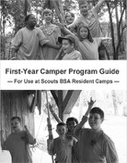
- Each day includes a specific outdoor skill focus—
  - Monday: map and compass
  - Tuesday: Woods Tools
  - Wednesday: Rope Work
  - Thursday: Nature and Fires
  - Friday: 5-mile hike. The nature focus is conducted by
members of the nature staﬀ.
- ​
- Each day begins with a structured, hour-long troop meeting featuring skills instruction and an interpatrol activity pertaining to that day’s outdoor skill focus.
- ​
- The program includes daily lunchtime meal preparation, cooking and cleanup, aﬀording excellent opportunities for newer Scouts to gain basic cooking skills, learn how to share responsibilities and cooperate with one another.
- ​
- The daily program is divided into five periods consisting of swimming, two periods of outdoor skills, first aid, and handicraft. The order in which these are presented varies each day according to patrol.
- ​
- Friday’s 5 mile hike includes organized activity stations relevant to the skills presented throughout the week.
- ​
- There is no overnighter.
- ​
- An opportunity to complete a mile-long orienteering course is provided from Monday through Thursday.
- ​
- For all staﬀ members, in the manual are well-defined schedules, charts, training resources and helpful forms for each aspect of the program. Everything is completely indexed.

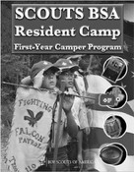
Model 2: “Scouts BSA Resident Camp First- Year Camper Program”
- This well-organized approach incorporates a full day of program.
- The outdoor skills director serves as an inspirational source of Scouting lore. They preside over each day’s opening ceremony and other special ceremonies at designated times, and also conduct a troopwide competition at the end of each day.
- Patrols are divided into groups based on their home troop and/or the rank they’ve reached, but this isn’t a prerequisite for applying the program.
- Each patrol member receives there own Scout stave and
a passport booklet which they keep with them throughout the week.

- The passport is divided into the following modules each of which has its own curriculum and is represented by its own color of beads.:
  - Scout Spirit module
  - Camping and Hiking module
  - First Aid module
  - Swimming module
  - Rope Work module
  - Nature module
  - Totin' Chip and Firem' n Chit module
- One of the essential features of this program is that the patrols proceed at their own pace.
- The curriculum includes a repertoire of activities designed to involve the patrol members as they go through the various modules.
- Each afternoon, before the final first-year camper troop-wide activity, patrols visit the handicraft area, and then participate in rifle shooting, archery, or boating.
- Patrol members receive a bead for each facet of a module they complete. In order to qualify as a graduate of the program, a Scout must receive fifteen or more beads for the week.

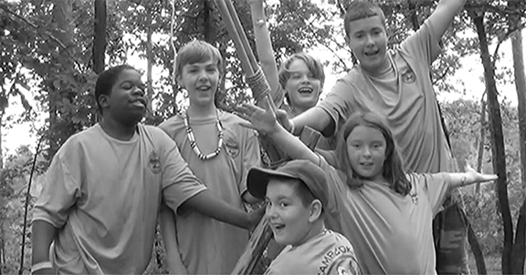
First-year campers deserve opportunities to have fun with the skills they acquire.

— Day 3 - Block 2 —

SQUARE LASHING
(45 minutes - Inside / Outdoors)
Objective: Through the EDGE method followed by an opportunity to put what they learn into action, participants will become comfortable with their ability to eﬀectively tie and present the square lashing.
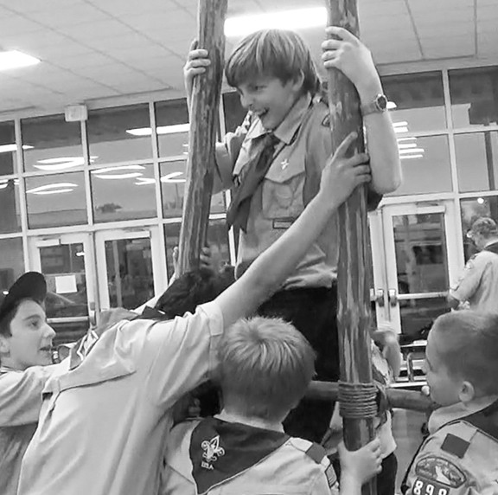
Materials for each participant
- 6-foot x 1/4-inch lashing rope
- Scout stave
Materials for each patrol
- two 8-foot x 4-inch spars
- four 3-foot x 2-inch “rungs,”
- eight 15-foot lashing ropes
Materials for class
- projector
- screen
(The following video can be used to explain and demonstrate the skill. As necessary, the process of guiding and enabling commences after it is viewed.)

Scout Skill Challenge: Ladder Building Event

—> View Video 29: How to Tie a Mark II Square Lashing
Using two staves and a 6-foot lashing rope, participants buddy up and take turns until all are enabled to tie the lashing.
Activity: Ladder Building

FIRE WITHOUT MATCHES
(45 minutes - Inside / Outdoors)
Objective: 1) By watching presentations, participants will learn about the skills entailed in using both a bow and drill and flint and steel to light fires. 2) Participants will apply what they learned about using flint and steel, by catching a spark onto charred cloth, transferring the smoldering material into a tinder bundle, and blowing the tinder into a flame.
Materials for every 3 participants
- piece of flint, quartz or chert that will throw sparks
- hardened, high carbon steel striker
Materials for each participant
- charred cloth
- binder twine
Materials for class
- projector
- screen
Discussion: What are some of the most common methods used to light fires without matches? Go around the room giving each participant a chance to name one.
- Ferro rods
- Lighter
- Hot Spark Kit (Magnesium rod)
- Magnifying glass
- Fire piston
- 9 volt battery and steel wool
- Potassium Permanganate and Glycerin
- Flint and steel
- Fire by friction
Why is flint and steel in a separate class of fire making techniques? It’s been used all over the world for centuries as the primary method for lighting fires.
—> View Video 30: How to Light a Fire by Friction Questions?
—> View Video 31: Flint and Steel for Beginners
—> View Video 32: Making a Fire with Flint and Steel
Activity: Participants will apply what they learned about making a fire with flint and steel, by taking turns sparking some charred cloth, adding the smoldering cloth to a tinder bundle they’ve made from unravelled binder twine, and blowing it until it bursts into flame.
(Note: presenters need to be thoroughly familiar with this procedure before demonstrating the process.)

MAKING CHARRED CLOTH
(15 minutes - Outdoors)
Objective: Through discussion and an illustration, participants will recognize the benefits of using a small can to make charred material.
Materials
- 2-inch x 2-inch squares of 100% cotton cloth or linen
- piece of flint, quartz or chert that will throw sparks
- hardened, high carbon steel striker
- covered, metal container with small hole
- stove
- tongs
Materials for class
- projector
- screen
—> View Video 33: How to Make Char Cloth in Altoids Tin
Demonstration: Several pieces of cotton cloth are placed in the prepared metal container (like an Altoids or shoe polish can) and positioned over the hot flame of a lit stove. When smoke from the hole is no longer issuing from the can, it’s removed from the stove with the tongs.
(Note: presenters need to be familiar with this procedure before demonstrating the process.)
When the fire making materials are already on hand, what are the advantages of flint and steel over fire by friction?
—> After receiving group responses, as necessary, review the following:
- requires less energy
- easier to keep the materials dry
- normally much less time consuming

MAP AND COMPASS
(30 minutes - Inside / Outdoors)
Objective: Through the EDGE method followed by an opportunity to put what they learn into action, participants will become comfortable with their ability to eﬀectively present how to use a compass to face and follow a bearing, orient a map, and use a map to find a bearing.
Materials for each participant
- Silva Starter Compass
- large paper bag
Materials for class
- large US map
- projector
- screen
(The following videos can be used to explain and demonstrate each of these skills. As necessary, the process of guiding and enabling commences after each is viewed.)
—> View Video 34: How to Face a Bearing
—> Weather permitting, go outside and set up a shadow stick to find an east west line, and then proceed with the activities. If the sky is overcast, proceed with this undertaking on subsequent days.
Activity: Compass Facing Activity: Blindfold Compass Walk
—> Return to meeting room.
—> View Video 35: How to Use a Map and Compass
Activity: Participants use the US map to find and face the (approximate) direction of their home address.
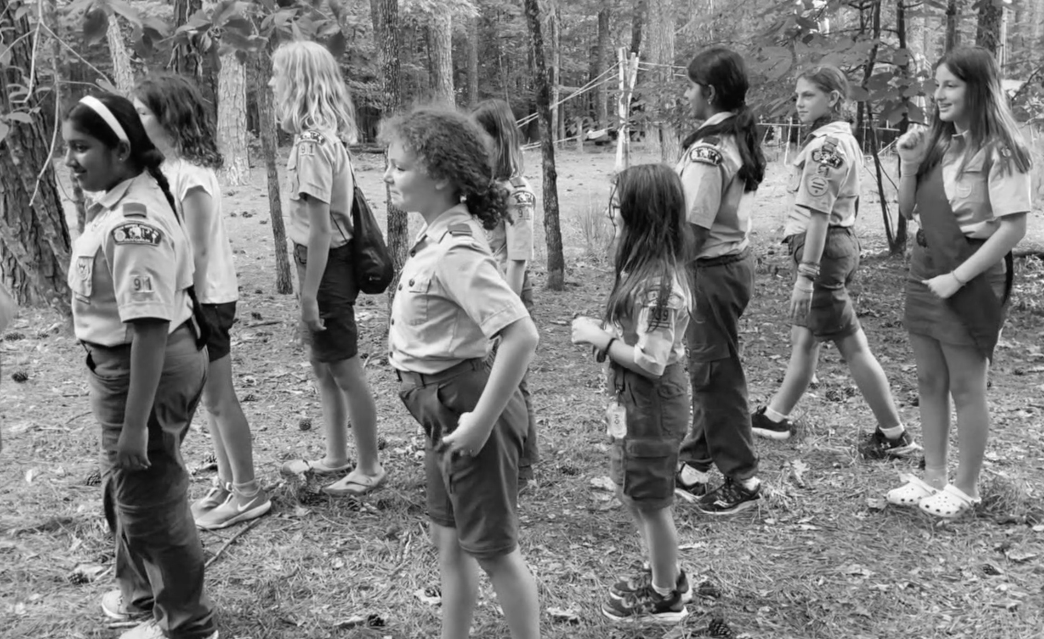
Direction Facing Activity

MEASURING HEIGHTS AND WIDTHS
(1 hour, 30 minutes - Inside / Outdoors)

Objective: Through the EDGE method followed by an opportunity to put what they learn into action, participants will become comfortable with their ability to eﬀectively present how to measure heights and widths in the field. Participants will apply the skills they’ve learned by following a prepared treasure map.
Materials for each patrol
- 4 stakes
- mallet
- compass
Materials for class
- treasure map
- trowel
- projector
- screen
—> View Video 36: How to Measure Heights and Widths
Discussion: This video explained and demonstrated one approach to measuring heights and widths. What is another method presented in the handbook for measuring heights and how is it done? How could you measure the width of a stream if you had a compass? If necessary, describe the Falling Method for measuring heights and the Compass Method for measuring widths as presented in the Navigation section of the Scouts BSA Handbook.
Activity: Have each patrol measure the height of a particular tree using both the Stick Method and the Falling Method.
Activity: Have each patrol measure the width of a determined area using both the Stick Method as described in the video and the Compass Method.
—> Check out the previously arranged shadow stick and confirm the shadow is pointing east. Ask participants to use an analog watch to find south. (Halfway between the hour hand and the 12, when the hour hand is pointing at the sun.)
NOTE: This session requires the creation of a treasure hunt with map and buried “treasure” to be set up prior to the participants’ arrival.

- Creating this treasure hunt requires the creation of a series of clues that lead the Scouts to a buried treasure filled with things they like. (The treasure is literally buried in a waterproof bag filled with goodies.)
- In order to do what the clues say, the Scouts will have to first orient a map and use it to discover the treasure hunt’s starting point.

- From there, they’ll commence acting upon each clue which will require them to face and follow a specific bearing for a given distance before acting upon the next clue. Each new clue requires taking and following a fresh bearing.
- Along the way, they’ll have to calculate the height of an object the correct answer for which will give them the next correct bearing.
- They’ll also have to measure the distance between two points, and rely upon their calculation being correct in order for them to be provided with the next correct clue.
- Finally they’ll follow a bearing to the treasure itself, which they can then dig up and divide amongst themselves.
Discussion: During the treasure hunt, in order to find the treasure, Scouts are required to:
- orient a map
- use the map to find a starting point
- act upon a series of clues requiring them to face and follow various bearings for set
distances
- measure the height of an object
- measure the width between two points
How does this activity transform the use of these skills into a fun adventure?

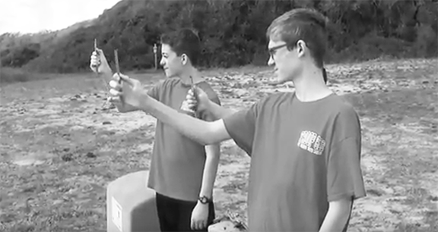
Stick Method for Measuring Heights

PLANNING, PREPARING AND PRESENTING ACTIVITIES
(15 minutes - Inside)
Objective: Through group discussion, participants will gain the understanding that conscientious planning and preparation, along with the proper presentation are necessary for successful Scout activities.
Discussion: What needs to be considered in order to assure the successful presentation of a challenge or game?
—> After receiving group responses, as necessary, review the following:
- PREPARATION – Are all the required materials laid out and the playing area set up?
- AVAILABLE SPACE – Is there a large enough open area to carry out the challenge or game?
- READINESS – If the activity is a challenge, do the Scouts have the necessary skills to complete it successfully?
- TIME – Is there enough time to finish the activity?
- DELIVERY – Do the Scouts understand the activity’s rules and objectives?
- PRESENTATION – Are the staﬀ members conducting the activity primed and ready to deliver a successful presentation so that everything goes smoothly?
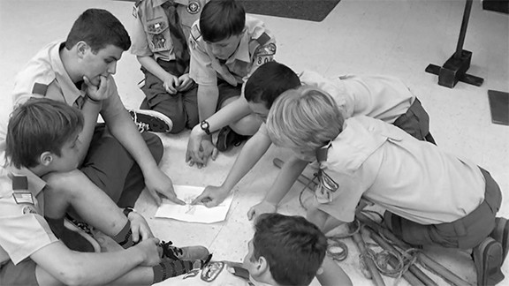

Activity explained, materials made available, a patrol ponders its objectives and plans what needs to be done in order to complete a Scout Skill Challenge.

ROPES AND POLES
(30 minutes - Inside)
Objective: 1) After an illustrative presentation, participants will become acquainted with the specs of basic materials used in Scout pioneering. 2) Through the EDGE method, participants will be able to hank synthetic line, and tie a draw hitch to bind coils of natural fiber rope.
Materials for each participant
  - 15-foot braided nylon guyline
  - 3-foot cord
  - Scout stave
Materials for class
  - Color-coded coils of lashing ropes
  - projector
  - screen
—> View Video 37: Lashing Ropes and Pioneering Spars Questions?
—> View Video 38: How to Tie a Draw Hitch
Using their 3-foot cord, participants apply a draw hitch to the Scout stave. After feeling comfortable doing this, participants coil groupings of lashing ropes and secure the bundle with a tight draw hitch.
Discussion: So, for storage, natural fiber ropes are coiled. This keeps them organized and eliminates kinking. In other words, we don’t hank them. We can and do hank synthetic lines. —> Hold up a guyline that’s been hanked. There are a variety of ways to hank synthetic lines. —> Demonstrate one way.
Participants all hank their 15-foot guyline.
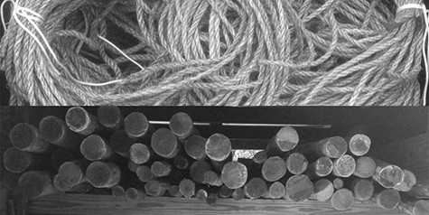

— Day 3 - Block 3 —

FLOOR LASHING
(30 minutes - Inside / Outdoors)
Objective: Through the EDGE method followed by an opportunity to put what they learn into action, participants will become comfortable with their ability to eﬀectively tie and present a double floor lashing.
Materials for every two participants six Scout Staves
two 15-foot lashing ropes
Materials for each patrol two 8-foot x 4-inch spars
six 3-foot x 2-inch floor spars two 20-foot lashing ropes
Materials for class
  - projector
  - screen
(The following video can be used to explain and demonstrate the skill. As necessary, the process of guiding and enabling commences after it is viewed.)
—> View Video 39: How to Tie a Double Floor Lashing
Participants pair up and laying out two Scout staves as platform supports, both lash on four other staves to one of the platform supports with a floor lashing.
Activity: Lift Seat Procession
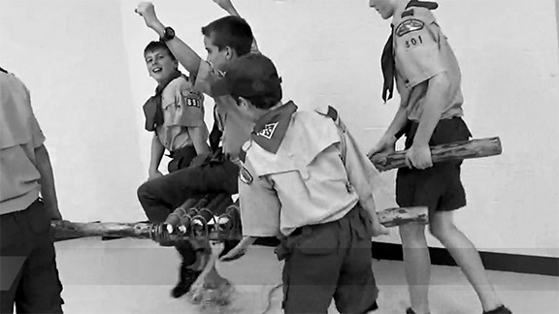
Lift Seat Procession

DUTCH OVEN COOKING
(1 hour, 30 minutes - Outdoors)
Objective: Participants will reinforce their knowledge of dutch oven cooking through discussion and hands on application.
Materials

Ingredients Cooking Items
2 whole Granny Smith apples | one well-seasoned 12-inch dutch oven
2 (8 oz.) cans crescent rolls | one 8 or 10-inch dutch oven
2 sticks butter | Dutch oven lid lifter, charcoal tongs
1-½ cup sugar | 1 charcoal chimney
1 teaspoon vanilla | bag of charcoal
cinnamon | chef’s Tool Kit (with peeler)
1 can (12 oz.) Mountain Dew soda | paper towels
- | cutting board
- | paper bowls and spoons
- | garbage receptacle
- | filled fire buckets
- | prepared fire ring or pit

Discussion: What do we know about dutch ovens and dutch oven cooking?
—> After receiving group responses, as necessary, review the following:
What are the advantages of cooking with cast iron?
    - Even cooking temperature
    - Easy to clean
    - Naturally non-stick when properly seasoned
    - Nearly indestructible
What is the diﬀerence between a camp dutch oven and other kinds?
    - Lip around the lid
    - Legs
    - Bail

—> Review some points regarding cooking with charcoal briquettes.
  - Follow the recipe
  - For 350º, double the size of the oven (12-inch dutch oven = 24 briquettes), divide by 3 then place 2/3 on the top and 1/3 on the bottom ( 16 on top, 8 on bottom) - or - “the rule of 3” size of oven plus 3 for the top, and minus 3 for the bottom (15 on top, 9 on bottom).
  - Place the briquettes in a random ring around the bottom and a checkerboard pattern on the lid.
  - Every briquette will increase or decrease the cooking temperature about 10º.
  - Use a charcoal chimney to ignite briquettes.
  - Brush away ashes as the briquettes burn down.
  - To prevent “hot spots,” every 15 minutes, lift the oven by the bail and rotate 1/4 turn, then rotate the lid 1/4 turn in the opposite direction.
—> Turn attention to “Dutch Oven Apple Dumplings” reference page.
Activity: Patrols prepare the coals and follow the recipe. (The above ingredients yield 16 dumplings.)
While the dumplings are baking, patrols can swap dutch oven recipes and personal cooking stories and accounts.
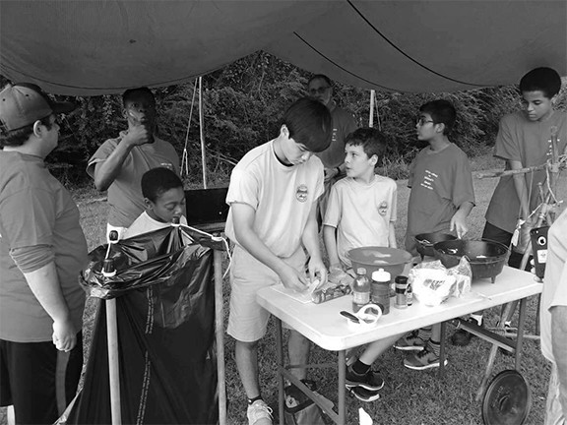
The whole patrol gets involved in preparing Dutch Oven Apple Dumplings.

DAY 4

Materials
— Day 4 - Block 1 —

  - 3-foot length of cord with a small fixed loop on each end for each participant. Gathering Period: Prisoners Escape

FIRE SAFETY WITH BACKPACKING STOVES - SAFETY MOMENT

SUMMARY
Stoves made for the outdoors can extend the range of your travels by giving you a reliable way to safely cook anywhere and in any weather. Typically, backpacking stoves use white gas, kerosene, propane, butane, or isobutane gas as a fuel. Ultralight trekkers also favor alcohol stoves.

GENERAL INFORMATION
Here are some fire safety tips for the proper use of these types of stoves:
- Before attempting to use the stove, review the manufacturer’s instructions for its proper use, the type of fuel, and how to safely light it.
- Never use large pots as a windscreen for your backpacking stove, because enclosing the stove could lead to an explosion. Instead, use a manufacturer’s windscreen that is designed to be attached to the backpacking stove for safe use in windy conditions. Also, do not place the stove inside a large pot, because overheating can occur.
- BSA policy prohibits use of homemade backpacking or alcohol stoves.
- Unleaded gasoline and liquid alcohol fuels (including isopropyl alcohol, denatured ethyl alcohol, and ethanol fuels) are not recommended for use, as noted in BSA policy (see “Resources” below) on the storage, handling, and use of chemical fuels and equipment.
- When transporting fuel for backpacking stoves, use the manufacturer’s recommended containers. Many of the fuel bottles are metal and may have pouring spouts or funnels attached for dispensing. The caps on the fuel bottles should be liquid tight, to prevent leakage.
- In case of burns, make sure your first-aid kit is well kept, and know your local emergency response contacts and/or locations.

NATIONAL CAMP STANDARDS PERTAINING TO OUTDOOR SKILLS
(15 minutes - Inside)
Objective: Participants will become acquainted with the NCAP standards that apply to outdoor skills and first-year camper programs by reviewing a printout of PS-212 and PD-112.

Discussion: —> Turn attention to “NCAP Standards for Outdoor Skills” reference pages and review contents.
The National Camp Accreditation Program (NCAP) standard for SCOUTCRAFT, WOODCRAFT, AND OUTDOOR SKILLS PROGRAM (PS-212) states:
“If oﬀered, Scoutcraft, woodcraft, and outdoor skills activities are led by qualified staﬀ, meet safety standards, use maintained equipment, and provide opportunities for learning, growth, and advancement.”

Specific Requirements of the Standard:
- Equipment used for this program area must be in serviceable condition and is checked to avoid potential injury.
- Appropriate safety equipment, skills training, and supervision are provided in the programs where risk must be managed.
- Pioneering projects where participants are elevated more than 6 feet above the ground are permitted only after review by the council enterprise risk management committee.

INTERPRETATION:
- Scoutcraft, woodcraft, and outdoor skills activities include camping, outdoor cooking, wilderness survival, pioneering, and other Scoutcraft opportunities.
- Prepared staﬀ will oﬀer specific outdoor learning skills as selected by the program leadership.
- Scout camp structures such as monkey bridges, obstacle courses, and pioneering towers are expected to meet safety standards in equipment and supervision comparable to COPE, but are bot subject to COPE standards, do not require COPE inspection, and do not require an on-site COPE Level II Instructor.

VERIFICATION:
  - Observation of procedures in practice

  - If a project has participants elevated over 6 feet above the ground, evidence of council enterprise risk management approval. This approval may be part of the general program design review in Standard PD-112.

The standard under OTHER PROGRAM STAFF QUALIFICATIONS (SQ-412) states: “All camp activity leadership staﬀ is qualified by age and training of acceptable experience to safely lead a quality program. Supporting staﬀ meets age and training requirements as necessary.”

Specific Requirements of the Standard:
- If an outdoor skills program is oﬀered, the outdoor skills director is at least 18 years
of age and holds a valid certificate of training from the Outdoor Skills section of the National Camping School or equivalent skills.
- If a first-year camper program is oﬀered, the first-year camper director is at least 18
years of age and holds a valid certificate of training from the First-Year Camper section of the National Camping School or equivalent skills.

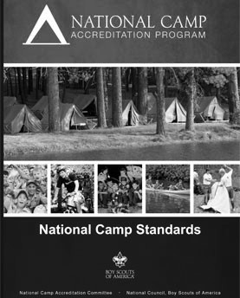
INTERPRETATION:
- Outdoor skills—“Equivalent life skills” may include but are not limited to Scouting experience as a Scouts BSA leader, earning merit badges oﬀered in outdoor skills area, or completion of college courses in outdoor skill topics.

VERIFICATION:
  - Documentation of age
  - Relevant certificates on file (may be submitted with declaration)
  - Authorization for approved alternatives
  - Interviews with camp director and staﬀ leadership
  - Observation of program implementation during assessment

TRIPOD LASHING
(45 minutes - Inside / Outdoors)
Objective: Through the EDGE method followed by an opportunity to put what they learn into action, participants will become comfortable with their ability to eﬀectively tie and present a tripod lashing.
Materials for every 2 participants
  - three Scout staves
  - one 10-foot lashing rope
Materials for each patrol
  - three 8-foot x 4-inch spars
  - three sturdy 6-foot x 3-inch spars
  - six 15-foot lashing ropes
  - one 20-foot lashing rope
Materials for class
  - projector
  - screen
(The following video can be used to explain and demonstrate the skill. As necessary, the process of guiding and enabling commences after it is viewed.)
—> View Video 40: How to Tie a Tripod Lashing (with plain turns)
Using three staves and a 10-foot lashing rope, participants buddy up and take turns until all are enabled to tie the lashing.
Activity: Everyone on the Tripod (Leave tripods assembled.)
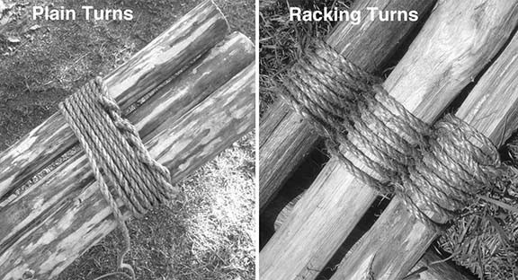

CHIPPEWA KITCHEN
(45 minutes - Inside / Outdoors)
Objective: 1) Participants will use the skills featured in the sessions presenting square, floor and tripod lashing, by building a Double Tripod Chippewa Kitchen. 2) Through discussion, participants will further their understanding of the role sequential programming makes to making the process of imparting outdoor skills more meaningful and fun.
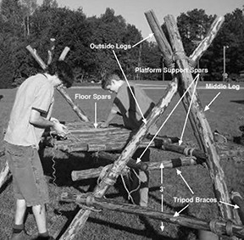
Materials for Kitchen
  - eight 8-foot x 4-inch tripod legs and platform supports
  - six 6-foot x 2-1/2- inch tripod braces
  - twenty 3-foot x 2-inch floor spars
  - sixteen 15-foot x 1/4-inch manila lashing ropes for square lashings
  - two 20-foot x 1/4-inch manila lashing ropes for tripod lashings
  - binder twine for floor lashing
  - piece(s) of burlap, terry cloth, or canvas to cover cooking platform
  - two 5-gallon buckets of mineral soil
Materials for class
  - projector
  - screen
—> View Video 41: Chippewa Kitchen
Discussion: How do we build it? Participants reason out an approach.
—> After receiving group responses, mention that the 6-foot tripod leg braces that will support the platform support spars should each be lashed on 3-feet oﬀ the ground.
Activity: Participants build a Chippewa kitchen. (The tripod(s) from the previous session can be adjusted as necessary and used to expedite the building process.)

Discussion:
—> After receiving group responses for each of the following questions, as necessary, review the corresponding bullet points:
What skills did we use to build our kitchen?
  - square lashings
  - tripod lashings
  - floor lashings
How is this activity a culmination of the sessions corresponding to each of those skills?
  - Each preceding session featured one of the skills used in building the project.
So, what is the total sequence, including the Scout Skill Challenges that led up to and included building the project?
  - square lashing and ladder building / floor lashing and lift seat procession / tripod lashing and everyone on the tripod / building Chippewa kitchen and cooking on it
How did this perfect example of sequential programming make the process of imparting outdoor skills more meaningful and fun?
  - All the skills were tied together
  - After they were presented, each skill was put into action in a way that illustrated how it could be used, and with a challenge, the completion of which relied upon using it.
  - The activities were fun.
  - Skills weren’t just introduced and learned without any rhyme or reason. Instead they were brought to life in a relevant fashion.
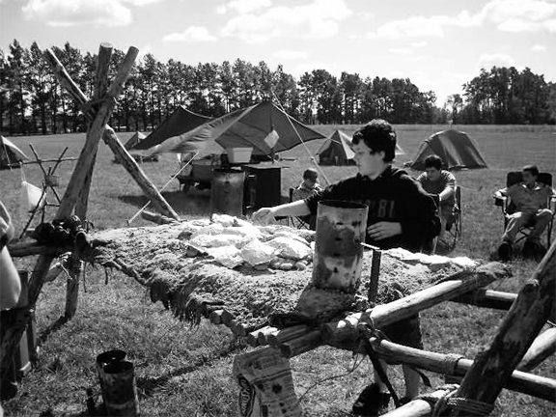
A Scout foil cooks his patrol’s lunch on a Double Tripod Chippewa Kitchen

FOIL COOKING
(1 hour, 30 minutes - Inside / Outdoors)
Objective: Through discussion and active participation, participants will become well- acquainted with foil cooking procedures and techniques.
Materials

Ingredients Cooking Items
1 bag tortilla chips | mixing bowl
16-ounces of canned white meat chicken | charcoal
1/2 cup red enchilada sauce | 2 charcoal chimneys
1 (15-oz.) can chopped fire-roasted tomatoes, drained | tongs
1 cup black beans, drained from can | chef’s tool kit
12-ounces shredded cheddar | cutting board
12-ounces shredded Monterey Jack | garbage receptacle
one banana per person | spoons
1-cup chopped Rolos * | heavy duty aluminum foil
1-cup mini marshmallows * | filled fire buckets
1/4-cup crushed graham crackers * | can opener
caramel syrup | -
* every four persons

Discussion: We’ll start by letting you all complete a little quiz. Let’s see which patrol can score the highest.
—> Turn attention to “Foil Cooking Quiz” reference pages along with paper and pencils.
—> After patrols have completed their work, review the solutions and answers. Patrols will score themselves.
- For their first meal, a patrol is having hamburger patties with potatoes, carrots and onions, cooked in a foil package. There will not be any patrol tables for their use at the campsite.
  - What can be done to make this meal easier to prepare?
  - Besides the chopped meat, potatoes, carrots and onions, what supplies and patrol equipment will they need to bring with them to enhance the meal? (50 points maximum)

Solutions:
  - Prepare patties at home, wrap in wax paper or foil, freeze, and store in freezer bags. (10 points)
  - Wash and dry the potatoes and carrots at home and store in plastic food bags. (10 points)
  - Tear oﬀ enough sheets of heavy duty aluminum foil in the sizes needed (12”x16”) at home and pack with the food. (10 points)
  - Bring all the seasonings: Salt, Pepper, Ketchup, Cream of Mushroom Soup. (2 points each)
  - Bring: Charcoal, Charcoal Chimneys, Fire Bucket, Tongs, Slicing Knife, Heavy Duty Aluminum Foil, Plastic Sheet, Patrol Shovel. (2 points each)

- What is the most important thing to remember when using the drug store wrap to make a foil cooking packet? Answer: Make sure the pouch is air tight. (10 points)
- If everyone in the patrol were to place their own amounts of potatoes, carrots, onion, and cream of mushroom soup, and fold their own packets using the drugstore wrap, how can the cook best keep track of whose foil packet is whose? Answer: Place the packets on the coals positioned in line from left to right and in rows from top to bottom, and assign a number or letter to each packet. (10 points)
- Describe the best way to set up their cooking pit for foil cooking.
  - What is the best size, shape, and design for the pit?
  - What troop and patrol equipment will they require?
  - How could everything be laid out for the most convenience and safety? (100 points maximum) Solutions:
  - Use patrol shovel to dig a rectangular pit down to mineral soil, large enough to fit all the foil packets you will be using, at the same time. (25 points)
  - Put any sod or ground covering on a plastic sheet for replacement when you break camp. (10 points)
  - Surround the sides of the pit with logs, or built up surface dirt. (10 points)
  - Have a Fire Bucket filled with water near by. (10 points)
  - Place the Shovel near by. (10 points)
  - Each patrol will need 1 or 2 Charcoal Chimneys, and their Tongs. (5 points each)
  - Have a complete supply of tinder and small kindling protected in a plastic bag or covered by a plastic sheet, to light chimneys. (15 points)
  - Place, Charcoal, Tongs, Chimneys, and Tinder together, neatly near fire pit. (10 points)
- The head cook for the patrol wants to save time by pre-slicing the potatoes for use in foil cooking. What will they have to do to keep the raw potatoes from turning brown? (10 points) Answer: Store the sliced potatoes in a container of water making sure the water covers the slices.

- What are two good reasons to prepare food using foil cooking? (20 points maximum)
  - Foil Cooking cooks the food in its own juices. (10 points)
  - With Foil Cooking there’s no need to clean any pots, pans, or plates. You just dispose of the foil. (10 points)
Discussion: Why should charcoal chimneys be used to ignite the charcoal?
—> After receiving group responses, as necessary, review the following:
    - Charcoal chimneys are very eﬃcient.
    - Charcoal chimneys need no liquid fuel.
    - No self-starting charcoal is ever needed, (or should ever be used).
—> Turn attention to “Foil Pack Chicken Nachos” and “Rolo Stuﬀed Bananas” reference materials.
Activity: Patrols prepare the coals and follow the recipes for: Chicken Nachos and Rolo Stuﬀed Bananas, foil cooking each recipe on their Chippewa kitchen.

— Day 4 - Block 2 —

OUTDOOR SKILLS MERIT BADGES PART 2

(Outdoor Skills Director Split Session)
HIKING / GEOCACHING / ORIENTEERING
(1 hour - Inside)
Objective: Through familiarization and discussion, the outdoor skills director will prepare themselves to train their staﬀ and assure the merit badge classes in their section are exemplary.
Discussion: —> Turn attention to “Hiking Merit Badge,” “Geocaching Merit Badge,” and “Orienteering Merit Badge” reference pages and review each one.
Note:
  - Answers are in red.
  - Requirements in parenthesis cannot ordinarily be completed in a Scouts BSA residential camp setting.
  - Pamphlet Printings - Hiking: 2017, Geocaching: 2019, Orienteering: 2016
Let’s review each requirement that can be completed at camp and discuss any special points that need further consideration. These reference pages can be share as an aid to members of your staﬀ.

HIKING MERIT BADGE
(Pamphlet Printing 2017)
- Do the following:
  - Explain to your counselor the most likely hazards you may encounter while hiking, and what you should do to anticipate, help prevent, mitigate, and respond to these hazards. (page 45 in pamphlet)
    - Waterborne Parasites
      - Only drink properly-treated water.
    - Trouble with Wildlife
      - Store food out of their reach.
      - Eliminate odors from sleeping areas.
      - Keep campsites spotless.
    - General Mishaps
      - Prepare a Trip Plan (page 24 in pamphlet)
        - Where are you going?
        - When will you return?
        - Who is hiking with you?
        - Why are you going?
        - What are you taking?
      - Watch where you step.
      - Pay attention to what you are doing

      - Take care of gear.
    - Diﬃculties with Physical Demands
      - Stay in good shape.
      - Drink plenty of water.
      - Adjust clothing layers to match changing weather conditions.
  - Show that you know first aid for injuries or illnesses that could occur while hiking, including hypothermia, frostbite, dehydration, heat exhaustion,
heatstroke, sunburn, hyperventilation, altitude sickness, sprained ankle, blisters, insect stings, tick bites, and snakebite. (pages 47-59 in pamphlet) (Refer to “Health and Safety Skills reference pages”)
    - Sunburn (page 54 in pamphlet)
      - Preventive Measures
        - Limiting exposure to the sun
        - Wearing long sleeves and broad-brimmed hat.
        - Use sunscreen with a protective factor (SPF) of at least 15 and apply it often.
      - Treatment
        - Get person under shade. (If no shade available, cover exposed skin with sun-protective clothing.)
        - Apply cool wet cloths to sunburnt areas.
    - Altitude Sickness AMS (Acute Mountain Sickness) (Pages 50-51 in pamphlet)
      - Preventive Measures
        - Drink plenty of fluids.
        - Ascend gradually.
      - Symptoms
        - Headache
        - Nausea
        - Tiredness
        - Loss of motivation
      - Treatment
        - Descend to a lower elevation
        - Rest, fluid, and food.
    - Sprained Ankle (Pages 48-49 in pamphlet)
      - Prevention Measures
        - Watch your step, especially over loose rocks, gravel, other debris and along a steep incline.
        - Stay within the boundaries of the trail and behind any protective railing.
      - Treatment on the trail
        - Leave the boot on.
        - Wrap the ankle, boot and all with an ankle bandage.
- Explain and, where possible, show the points of good hiking practices including proper outdoor ethics, hiking safety in the daytime and at night, courtesy to others, choice of footwear, and proper care of feet and footwear.
- Outdoor Ethics and Hiking (pages 26-29 in pamphlet)

  - Adhere to the Principles of Leave No Trace
  - Plan ahead and prepare.
  - Travel on durable surfaces.
  - Dispose of waste properly.
  - Leave what you find.
  - Minimize campfire impacts.
  - Respect wildlife.
  - Be considerate of other visitors.
- Hiking Safety in the Daytime
  - Walk single file on the left side of the road facing traﬃc.
  - Heed all traﬃc signals.
  - When crossing a country thoroughfare, the whole crew should line up along
the road and all cross at the same time.
  - Don’t carelessly hurdle over large logs obstructing a path.
  - Don’t poke a hiking stick in holes along a path.
- Hiking Safety at Night (Same as daytime)
  - On roadways, wear light-colored clothing or tie a light-colored bandana
around your right arm.
  - Take extra care to keep members of the group together.
- Courtesy to Others
  - Greet people along the way.
  - Lend a hand whenever you can
  - On a mountain trail, give an oncoming crew on the downward side of a
mountain the right of way.
- Choice of Footwear (page 32 in pamphlet)
  - Avoid heavy boots.
  - Short walks on easy terrain: most any kind of shoes
  - Hiking in good weather: lightweight boots with uppers made of nylon or other
tough fabric
  - For added feet and ankle support and resistance against rain and snow:
leather boots
- Care of Footwear (pages 32-33 in pamphlet)
  - Clean footwear after a hike.
  - Do not put footwear too close to a heat source.
  - Treat leather boots with protective ingredients that keep them flexible and
water repellent.
- Care of Feet (page 33 in pamphlet)
  - Gradually break in boots before hiking.
  - Wash feet regularly during a long trek.
  - Treat for blisters at the first sign of a hotspot.
  - Wear socks made for hiking.
  - Wear a smooth, liner sock under a thick outer sock to reduce friction and wick
moisture away from the feet.
  - Cut toenails straight across.

- Explain how hiking is an aerobic activity. Develop a plan for conditioning yourself for 10-mile hikes, and describe how you will increase your fitness for longer hikes. (Pages 31-32 in pamphlet)
- Hiking is an aerobic activity because it increases your rate of breathing and your heartbeat.
- For conditioning, engage in aerobic activities like bicycling, jogging, and sports that require constant motion.
- Increase your fitness by pushing yourself each time to achieve a little more.
(4.) Take the five following hikes, each on a diﬀerent day, and each of continuous miles. These hikes MUST be taken in the following order:
- One 5-mile hike
- Three 10-mile hikes
- One 15-mile hike
You may stop for as many short rest periods as needed, as well as one meal, during each hike, but not for an extended period (example: overnight). Prepare a written hike plan before each hike and share it with your Scoutmaster or a designee. Include map routes, a clothing and equipment list, and a list of items for a trail lunch.*
*The required hikes for this badge may be used in fulfilling hiking requirements for rank advancement. However, these hikes cannot be used to fulfill requirements of other merit badges.
(5.) Take a hike of 20 continuous miles in one day following a hike plan you have prepared. You may stop for as many short rest periods as needed, as well as one meal, but not for an extended period (example: overnight).

(6.) After each of the hikes (or during each hike if on one continuous “trek”) in requirements 4 and 5, write a short reflection of your experience. Give dates and descriptions of routes covered, the weather, and any interesting things you saw. It may include something you learned about yourself, about the outdoors, or about others you were hiking with. Share this with your merit badge counselor.

GEOCACHING MERIT BADGE
(Pamphlet Printing 2019)
- Do the following:
  - Explain to your counselor the most likely hazards you may encounter while participating in geocaching activities, and what you should do to anticipate, help prevent, mitigate, and respond to these hazards. (pages 67-73 in pamphlet)
    - Lightening (page 68 in pamphlet)
      - Avoid open areas and lightening targets
        - trees
        - flagpoles
        - wire fences
      - Avoid contact with anything metal
      - If you are near a mountaintop, get down hill.
      - Take shelter in a steel-framed building or if you can, in a hard-topped
motor vehicle, and avoid touching the metal parts.
      - Avoid water.
      - Avoid any contact with electronic devices.

      - If you cannot find shelter, crouch low with only the soles of your shoes touching the ground and at least 100 feet from your companions.
        - If you have a sleeping pad, use it for insulation by folding it and crouching upon it.
  - Discuss first aid and prevention for the types of injuries or illnesses that could occur while participating in geocaching activities, including cuts, scrapes, snakebite, insect stings, tick bites, exposure to poisonous plants, heat and cold reactions (sunburn, heatstroke, heat exhaustion, hypothermia), and dehydration. (pages 70-73 in pamphlet) (Refer to “Health and Safety Skills reference materials”)
  - Discuss how to properly plan an activity that uses GPS, including using the buddy system, sharing your plan with others, and considering the weather, route, and proper attire. (page 67 in pamphlet)
    - Use the buddy system.
      - You can watch out for each other.
      - You have more eyes to spot your cache.
    - Plan ahead.
      - Know where you are going and what to expect.
      - Let someone know where you are going and when you will return.
    - Watch the weather.
      - Avoid dangerous weather situations.
      - Dress appropriately
      - Take plenty of water.
- Discuss the following with your counselor:
  - Why you should never bury a cache (page 53 in pamphlet)
    - Burying a cache can lead to too many holes being dug while searching for a container, since the accuracy of a GPS receiver never gets you to the exact spot (ground zero).
  - How to use proper geocaching etiquette when hiding or seeking a cache, and how to properly hide, post, maintain, and dismantle a geocache
    - Geocaching Etiquette (page 46 in pamphlet)
      - Always carry a trash bag and remove litter along your route.
      - Follow Leave No Trace guidelines in the natural environment.
      - Be careful not to disturb the area around the cache.
      - Follow all laws and regulations. Never enter private property without
permission.
      - Write an entry in the logbook at the cache.
      - Try to leave something of equal value when you take an item from the
cache.
      - Respect other visitors around the area.
    - The Four Steps to Hiding and Seeking a Cache (page 54 in pamphlet)
      - Research.
        - Are there adequate places to hide your caches without risk to the environment when people are seeking them?
        - Are there too many other caches nearby?
        - Get permission from the land owner or land manager.

      - Safety. Don’t put caches:
        - near busy intersections
        - near railroad tracks
        - on electric utility boxes
        - up high in trees
        - in places overgrown with poisonous plants
      - The Hunt.
        - Make sure geocachers can find your cache.
        - Post a hint online.
        - Can you get a good satellite signal so you’ll be posting accurate coordinates for others to follow?
        - Can your cache be easily identified as a geocache?
      - The Actual Find.
        - Put the logbook in a waterproof bag along with a pencil and a welcome note.
        - Preload the cache with enough prizes for the first few people to find.
        - Cache items should be family oriented (suitable for all ages).
        - Do not include food items.
    - Submitting Your Cache
      - Log on to www.geocaching.com filling out online form on the “Hide & Seek
a Cache” page.
    - Maintaining Your Cache
      - Monitor the online logs that are sent to you.
      - Return to the cache site as often as possible to check the condition of the
container and the cache area.
      - If disturbed, change cache location and the online listing.
    - Dismantling a Cache
      - Remove the cache if it can’t be maintained by yourself or someone who
takes over the responsibilities.
      - Physically remove the cache and all litter that may be around your hiding
spot.
      - Go online and archive your cache listing.
  - The principles of Leave No Trace as they apply to geocaching (pages 31-32 in pamphlet)
    - Plan Ahead and Prepare
    - Travel and Cache on Durable Surfaces
    - Dispose of Waste Properly
    - Leave What You Find
    - Minimize Campfire Impacts (not often relevant to geocaching)
    - Respect Wildlife
    - Be Considerate to Other Visitors
- Explain the following terms used in geocaching: waypoint, log, cache, accuracy, diﬃculty and terrain ratings, attributes, trackable. Choose five additional terms to explain to your counselor. (pages 75-77 in pamphlet)

- Waypoint - A reference point for a physical location on earth defined by a set of coordinates.
- Log - A place for geocachers to write their name and the date they visited a cache, and sometimes to leave comments.
- Cache - (Short for geocache), a container hidden at specific coordinates that includes, at minimum, a logbook for geocachers to sign when they find the cache. Caches often include a “treasure” or items to trade.
- Accuracy - Freedom from error. No civilian GPS receiver has perfect accuracy, and the accuracy may be low due to interference aﬀecting the satellite signals reaching the receiver.
- Diﬃculty - A ranking system from 1 to 5 describing how hard the cache is to find with 1 being the easiest.
- Terrain Ratings - A ranking system from 1 to 5 describing the land features and how how easy or hard the cache is to get to with 1 being the easiest and 5 probably requiring special equipment.
- Attributes - The icons on a cache detail providing helpful information to geocachers who wish to find specific kinds of caches.
- Trackable - Anything with a tracking number or other unique identifier that can be followed as the item travels from cache to cache.
- Explain how the Global Positioning System (GPS) works. (page 11 in pamphlet) Then, using Scouting’s Teaching EDGE, demonstrate to your counselor the use of a GPS unit. (pages 19-21 in pamphlet) Include marking and editing a waypoint, changing field functions, and changing the coordinate system in the unit.
- GPS works by using signals from satellites orbiting Earth to determine specific locations on or near Earth’s surface.
- Marking a Waypoint with a Garmin eTrex®
  - With a clear view of the sky, press the “mark” button which will program the
spot into the GPS unit’s waypoint memory.
- Editing a Waypoint (Page 23 in pamphlet)
  - You can change the numerical designation of a waypoint by highlighting the
number and typing in a name of your choice.
- Changing Field Functions
  - Refer to the manual to learn where specific buttons are like “nav,” “enter,”
“escape” or “back,” “up,” “down,” “left,” and “right,” “mark,” “zoom,” “menu,” and “goto.”
- Going to a Waypoint with a Garmin eTrex® (page 22 in pamphlet)
  - Turn the GPS receiver on using the “power” button on the right side of the
unit.
  - Locate the “enter” button and the “up” and “down” buttons on the left side
used to change the menus and screens.
  - Push the “page” button repeatedly, on the right side of the unit, to get to the
menu page.
  - Press the “down’ button and highlight “waypoints.”
  - Press “enter” and the waypoints page appears.

  - Press “enter” again and the highlight will move to a waypoint (if there are some already recorded in the unit).
  - Press “enter” again and then highlight “goto.”
  - Press “enter” again and the pointer should appear for the waypoint.
- Changing the Coordinate System (page 11 in pamphlet)
  - Most GPS receivers have a simple setting to switch between various
coordinate systems.
- Do the following:
  - Show you know how to use a map and compass and explain why this is important for geocaching. (page 27 in pamphlet)
    - Your batteries may die.
    - You can’t get good satellite reception.
    - You might accidentally program in the wrong coordinates.
  - Explain the similarities and diﬀerences between GPS navigation and standard map-reading skills and describe the benefits of each. (page 28 in pamphlet)
    - Both a GPS receiver and a compass can tell you what direction you need to go.
    - A GPS receiver can provide the coordinates of a spot.
    - A map reveals the best route to take by displaying land’s features providing exact details and a large view of the area.
- Describe to your counselor the four steps to finding your first cache. Then mark and edit a waypoint. (pages 43-46 in pamphlet)
- Research
  - Register for a membership at geocaching.com. Click on “Hide and Seek a
Cache,” enter your zip code and click “search” or “go.”
  - Choose a geocache from the list and click on its name.
  - Enter the coordinates into your GPS device. (The owner’s manual will show
you how to manually enter coordinates into your device.) You will need a map to help you search.
- Safety
  - Let someone know where you are going and when you will return.
  - Use the buddy system.
  - Bring a first aid kit, compass, and extra batteries for your GPS receiver.
  - Bring water, some food, and extra clothing.
  - Be conscious of where you are walking being mindful of potential hazards.
- The Hunt
  - Mark your starting place as a waypoint to guide your return.
  - When you get within 300 feet or so, check the GPS signal strength and
accuracy.
  - As you get closer to the final location, instead of relying on the GPS receiver’s
pointer arrow, concentrate more on the final distance decreasing.
  - Look around for likely hiding spots.
- The Actual Find
  - Sign the cache’s logbook with your name, the date, and some comments.
  - If you exchange an item for trade, it should be of equal or better value.

  - Use the waypoint you created to guide your return.
- With your parent’s permission*, go to www.geocaching.com. Type in your city and state to locate public geocaches in your area. Share with your counselor the posted information about three of those geocaches. Then, pick one of the three and find the cache.
- Do ONE of the following:
  - If a Cache to Eagle® series exists in your council, visit at least three of the locations in the series. Describe the projects that each cache you visit highlights, and explain how the Cache to Eagle® program helps share our Scouting service with the public.
    - Providing exposure to actual examples of the community service rendered by Eagle candidates provides testimonies of Scouting’s positive contribution to society.
  - Create a Scouting-related Travel Bug® that promotes one of the values of Scouting. “Release” your Travel Bug into a public geocache and, with your par- ent’s permission, monitor its progress at www.geocaching.com for 30 days. Keep a log, and share this with your counselor at the end of the 30-day period.
(c.) Setup and hide a public geocache, following the guidelines in the Geocaching merit badge pamphlet. Before doing so, share with your counselor a three-month maintenance plan for the geocache where you are personally responsible for those three months. After setting up the geocache, with your parent’s permission, follow the logs online for 30 days and share them with your counselor. You must archive the geocache when you are no longer maintaining it.
- Explain what Cache In Trash Out (CITO) means, and describe how you have practiced CITO at public geocaches or at a CITO event. Then, either create CITO containers to leave at public caches, or host a CITO event for your unit or for the public.
  - Whatever geocachers bring with them while hiding or hunting for a cache should be carried out with them, in accordance with Leave No Trace.
(9.) Plan a geohunt for a youth group such as your troop or a neighboring pack, at school, or your place of worship. Choose a theme, set up a course with at least four waypoints, teach the players how to use a GPS unit, and play the game. Tell your counselor about your experience, and share the materials you used and developed for this event.
*To fulfill this requirement, you will need to set up a free user account with www.geocaching.com. Before doing so, ask your parent for permission and help.

ORIENTEERING MERIT BADGE
(Pamphlet Printing 2016)

- Show that you know first aid for the types of injuries that could occur while orienteering, including cuts, scratches, blisters, snakebite, insect stings, tick bites, heat and cold reactions (sunburn, heatstroke, heat exhaustion, hypothermia), and dehydration. Explain to your counselor why you should be able to identify poisonous plants and poisonous animals that are found in your area. (pages 64-73 in pamphlet) (Refer to “Health and Safety Skills reference pages”)
  - While orienteering, an orienteer may very well come in contact with poisonous plants and encounter poisonous animals found in the area of the orienteering course. Therefore it is important to know how to identify them.
- Explain what orienteering is. (page 5 in the pamphlet)
  - Orienteering is a cross-country race in which participants use a highly detailed map and a compass to navigate their way between checkpoints along an unfamiliar course.
- Do the following:
- Explain how a compass works. Describe the features of an orienteering compass. (pages 7-9 in pamphlet)
  - The north and south poles exert a pull on magnetized materials. A compass works by combining a compass card showing 16 to 32 compass points, or the 360 degrees of a circle, and a floating, magnetized, metal needle that is colored on the north end.
  - The baseplate (or protractor) compass is used for orienteering. It’s features are:
    - Baseplate of clear plastic
    - Direction-of-Travel Arrow indicating which way to go after taking a bearing
    - Map Scales simplifying measuring distance on a map
    - Bezel (Dial) containing fluid which houses the needle and rotates 360
degrees
    - Orienting Arrow used to establish the direction of travel, when aligned with
the needle
    - Orienting (North-South) Lines used when taking a bearing from a map
- In the field, show how to take a compass bearing and follow it. (page 9 in the pamphlet)
  - Hold the compass in one hand centered on your body. Rotate your body and the compass until the direction-of-travel arrow points in the direction you want to go. Rotate the bezel of the compass until the north of the orienting arrow lines up with the north of the magnetic needle. Determine the bearing by reading the number corresponding to the direction-of travel arrow (on the bezel directly opposite the bearing index).
- Do the following:
- Explain how a topographic map shows terrain features. Point out and name five terrain features on a map and in the field. (pages 11-12 in pamphlet)

  - A topographic map shows terrain features with contour lines and contour intervals.
    - Gentle Slope - The interval between contour lines is wide.
    - Steep Slope - Contour lines are close together.
    - Cliﬀ - Contour lines are almost touching.
    - Mountain Summit - Contour lines create irregular shapes that converge
into one shape smaller than the rest.
    - Valley or Gully - Contour lines form upward “Vs”.
    - Ridge - Contour lines form downward “Vs”.
- Point out and name 10 symbols on a topographic map. (pages 13-15 in pamphlet)
- Explain the meaning of declination. Tell why you must consider declination when using map and compass together. (pages 16-18 in pamphlet)
  - The diﬀerence between true north and magnetic north, measured in degrees, is called declination.
  - If you do not compensate for declination, you will not be able to find the actual direction as related to the north south of the landscape.
- Show a topographic map with magnetic north-south lines.
  - Draw parallel magnetic north-south lines, aligned with the arrow pointing to magnetic north, in the bottom margin, revealing the declination.
  - Orienting maps are drawn with the tops aimed at magnetic north.
- Show how to measure distances on a map using an orienteering compass. (page 20 in the pamphlet)
  - Maps contain distance rulers in their margin, and an orienting compass has a ruler along the edge of the baseplate. Distances can be measured by measuring the distance between points on the map with the ruler and comparing the measurements with the map’s distance rulers.
- Show how to orient a map using a compass. (page 19 in the pamphlet)
  - Line up north with the direction-of-travel arrow. Set the compass on the map with the edge along one of the north-south magnetic lines and the direction-of travel arrow pointing north. Rotate the map and the compass together until the compass needle matches the direction of travel arrow.
- Set up a 100-meter pace course. Determine your walking and running pace for 100 meters. Tell why it is important to pace-count. (pages 23-25 in pamphlet)
Knowing your walking and running pace-count is important for judging distance.
- Do the following:
- Identify 20 international control description symbols. Tell the meaning of each symbol. (pages 36-37 in pamphlet)
- Show a control description sheet and explain the information provided. (page 35 in the pamphlet)
- Explain the following terms and tell when you would use them: attack point, collecting feature, catching feature, aiming oﬀ, contouring, reading ahead, handrail, relocation, rough versus fine orienteering. (pages 38-43 in pamphlet)
  - Attack Point (page 39 in the pamphlet) - An attack point is a large, recognizable feature that is near the control point, serving to determine the exact location for navigation and pacing.

  - Collecting Features (page 39 in the pamphlet) - Noting obvious features along the route, help send you in the right direction towards the next control point.
  - Catching Feature (page 39 in the pamphlet) - Noting a feature that lies beyond the current control point, serves as a landmark warning you that you have passed the control.
  - Aiming Oﬀ (page 40 in the pamphlet) - When a control or attack point is on a linear feature, such as a road, you can aim oﬀ to one side of the straight line heading to the feature. Then, when you reach the feature, if you do not see the control, you’ll know in which direction to turn to find it.
  - Contouring (page 41in the pamphlet) - When there are changes in elevation along the direct route to the next control, if the elevation of the control is roughly the same as where you are standing, it may be easier to follow a route that stays at the same elevation—the contour line.
  - Reading Ahead (page 40 in the pamphlet) - While proceeding to the next control point:
    - Keep a clear mental picture of the terrain you will pass through.
    - Read the map every few seconds.
    - Think beyond your location and plan ahead.
    - Make sure you understand what the map is telling you and do not move
until you are sure.
  - Handrail (page 38 in the pamphlet) - Linear features along the leg of a course like streams, trails, roads, fences, and power lines, lead you in the direction you want to go and provide easier travel, continuous direction, and a more accurate position.
  - Relocation (page 42 in the pamphlet) - If you don’t know where you are, find a definite feature that you can correctly locate.
  - Rough Orienteering (page 43 in the pamphlet) - Moving in broadly defined directions toward a collection point found on the map enables you to cover a lot of ground quickly.
  - Fine Orienteering (page 43 in the pamphlet) - Once you reach the chosen collection point, the primary goal is to accurately determine where you are in relation to the check point using attack points, handrails, and compass bearings.
(7.) Do the following:
- Take part in three orienteering events. One of these must be a cross-country course.
- After each event, write a report with (1) a copy of the master map and control description sheet,
(2) a copy of the route you took on the course, (3) a discussion of how you could improve your time between control points, and (4) a list of your major weaknesses on this course. Describe what you could do to improve.
(8.) Do ONE of the following:
- Set up a cross-country course that is at least 2,000 meters long with at least five control markers. Prepare the master map and control description sheet.
- Set up a score orienteering course with at least 12 control points and a time limit of at least 60 minutes. Set point values for each control. Prepare the master map and control description sheet.
(9.) Act as an oﬃcial during an orienteering event. This may be during the running of the course you set up for requirement 8.
10. Teach orienteering techniques to your patrol, troop, or crew.

FIRST-YEAR CAMPER PROGRAM - PART 2 -

“First-Year Camper Program Guide”

(First-Year Camper Director Split Session)
(1 hour - Inside)
Objective: Participants will continue to formulate plans for creating an action-based program appropriate for their camp, by examining some special features found in the First-Year Camper Program Guide.
Materials for class
- PDF of First-Year Camper Program Guide
- projector
- screen
Review from Day 3 Block 1
—> As a review, go though each of the following:

- This well-organized approach to conducting a first-year camper program is carried out throughout the morning and afternoon.
- ​
- Each day includes a specific outdoor skill focus— Monday: map and compass, Tuesday: Woods Tools, Wednesday: Rope Work, Thursday: Nature and Fires, Friday: 5-mile hike. The nature focus is conducted by members of the nature staﬀ.
- ​
- Each day begins with a structured, hour-long troop meeting featuring skills instruction and an interpatrol activity pertaining to that day’s outdoor skill focus.
- ​
- The program includes daily lunchtime meal preparation, cooking and cleanup, aﬀording excellent opportunities for newer Scouts to gain basic cooking skills, learn how to share responsibilities and cooperate with one another.
- ​
- The daily program is divided into five periods consisting of swimming, two periods of outdoor skills, first aid, and handicraft. The order in which these are presented varies each day according to patrol.
- ​
- Friday’s 5 mile hike includes organized activity stations relevant to the skills presented throughout the week.
- ​
- There is no overnighter.
- ​
- An opportunity to complete a mile-long orienteering course is provided from Monday through Thursday.
- ​
- For all staﬀ members, in the manual are well-defined schedules, charts, training resources and helpful forms for each aspect of the program. Everything is completely indexed.

Discussion: Each of the following is reviewed and then discussed.
—> Project the pdf file onto the screen. Wherever appropriate, individual participants should take turns reading the specified text aloud for the group.
- The First-Year Camper Philosophy: page 8 (Read aloud.)
- Program Operation: page 13, (Point out that there is a daily PLC meeting.)
- Staﬀ Job Descriptions: page 14 (Read the name of each position that is described.)
- A complete chart of the Requirements Covered: page 17 (Scan through the categories.)
- A section on Staﬀ Development: page 19 (Read first sentence of each paragraph.)
- A complete Staﬀ Week Schedule: page 21 (An extensive “to do” list covering everything the outdoor skills staﬀ needs to do, in detail.)
- The Daily Program: page 27 (Read through a couple of days to communicate what is included.)
- Shared Program Elements: page 35 (Read top paragraph)
- Each day provided with its own schedule: e.g. Monday pages 55-70 (—> Scroll through Monday’s pages — Daily Schedule overview with corresponding page numbers for each segment / Pre-Program Staﬀ Meeting / Complete Troop Meeting / Scout Skill content for the day / Post-Program Staﬀ Meeting
- First-Year Camper Program Scout Tracking Sheet: page 129 (One of several forms included in the Appendix)
- Equipment List: page 137 (The materials needed to run the program.)

SLOPPY CAMP
(30 minutes - Outdoors)
Objective: Participants will spot and ultimately correct errors and examples of bad judgement in a poorly setup campsite through observation and drawing upon the outdoor skills they know.
Materials
  - tent
  - groundcloth
  - dining fly with poles, guylines, and stakes
  - firewood
  - plastic sheet
  - glass jar and other trash
  - axe
  - boots
  - trash
Activity: Sloppy Camp As observations are made, participants correct each example of bad judgement and faulty skills. When the campsite area is properly arranged, participants breakdown the camp and store the materials.

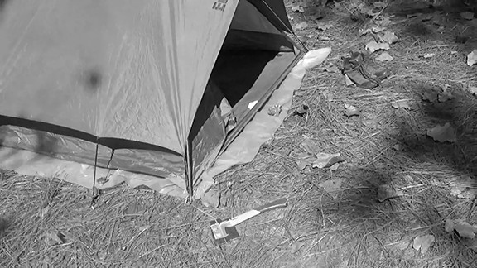
Scene from “Sloppy Camp”

CATCH THE SNAPPER
(30 minutes - Outdoors)
Objective: By pooling their resources and using the materials provided, attendees will review their round lashing and half hitching skills by taking part in a popular Scout Skill Challenge.
Materials for each patrol
  - two rat traps
  - one 2-ounce fishing sinker
  - two 3-foot cords
  - six 6-foot lashing ropes
  - four Scout staves Activity: Catch the Snapper
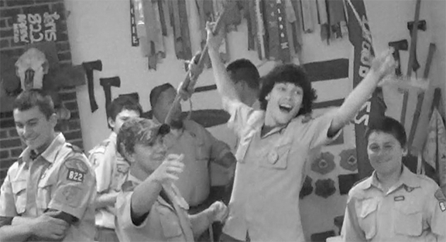
Scouts become jubilant after catching the “snapper.”

OUTDOOR SKILLS MERIT BADGES PART 3

(Outdoor Skills Director Split Session)
COOKING / FISHING / PIONEERING
(1 hour - Inside)
Objective: Through familiarization and discussion, the outdoor skills director will prepare themselves to train their staﬀ and assure the merit badge classes in their section are exemplary.
Discussion: —> Turn attention to “Cooking Merit Badge,” “Fishing Merit Badge,” and “Pioneering Merit Badge” reference pages. and review each one.
Note:
- Answers are in red.
- Requirements in parenthesis cannot ordinarily be completed in a Scouts BSA residential camp setting.
- Pamphlet Printings - Cooking: 2019, Fishing: 2017, Pioneering: 2019
Let’s review each requirement that can be completed at camp and discuss any special points that need further consideration. These reference pages can be shared as an aid to members of your staﬀ.

COOKING MERIT BADGE
(Pamphlet Printing 2019)

- Health and safety. Do the following:
  - Explain to your counselor the most likely hazards you may encounter while participating in cooking activities and what you should do to anticipate, help prevent, mitigate, and respond to these hazards.
    - Safety with Fire and Heat (pages 9-10 in pamphlet)
      - Turn pan handles towards the back of the stove so hot pots and pans will
not accidentally get bumped.
      - Keep items that could easily catch fire away from the stove and fire
source.
      - Never use a wet oven mitt or towel to handle something hot.
      - Keep a charged fire extinguisher nearby and know how to use it. When
cooking over a fire or in coals, keep a filled fire bucket nearby.
      - Wipe oﬀ all grease spills immediately.
      - Never use water on a grease fire. Smother it.
      - If there is an oven fire, close the oven door and turn oﬀ the oven.
      - Wear close-fitting clothes.
      - Be very careful when moving heavy pots of hot liquid.
      - Be cautious of hot grease splatters when frying.
      - Never grab a pot handle without first protecting your hands with a pot
holder or tongs.
      - Do not allow horseplay in the cooking area.

    - Safe Food Storage and Transportation (page 11 in pamphlet)
      - All food must be stored at safe temperatures and cooked at proper
temperatures.
      - Keep in mind the concept of cross contamination.
        - Wash your hands frequently with soap and water.
        - Keep work surfaces clean.
        - Wash produce.
      - Make sure the safety seal on jar lids is intact.
    - Clean (page 13 in pamphlet)
      - Make sure the work area is clean and uncluttered before you begin, and
keep the area clean as you go.
      - Have all ingredients, utensils, pots, and pans ready to go.
      - Use hot, soapy water to wipe up spills from raw foods.
      - At camp, use the three pot method for cleanup.
      - Clean items that will be reused during the cooking process, as you go.
    - Separate (page 13 in pamphlet)
      - Keep raw eggs, meat, poultry, seafood, and their juices away from ready-
to-eat food. At camp, store these food items in separate, sealed containers or plastic bags.
      - Use separate cutting boards for diﬀerent kinds of foods to avoid cross
contamination.
      - Don’t put cooked food in unwashed plates and bowls that previously held
raw food.
      - Don’t use sauce used to marinate raw foods on cooked foods unless it
was subsequently brought to a boil.
    - Cook (page 14 in pamphlet)
      - Use a food thermometer to ensure food has been cooked to a safe
temperature.
    - Chill (pages 15-16 in pamphlet)
      - Indoor Kitchen
        - Do not leave foods requiring refrigeration at room temperature for more than two hours (1 hour if the temperature is above 90 degrees).
        - Freeze any fresh fish, poultry, or ground beef if not used within two days.
        - Freeze whole cuts of meat within five days.
        - Refrigerated, thawed out food should be refrozen or used within two days.
        - Refrigerate leftovers right away.
        - Discard any uneaten leftovers after three days.
        - Foods thawed outside the refrigerator should be cooked immediately.
      - At Camp
        - Before packing a cooler, refrigerate or freeze the food overnight.
        - Whenever possible, use blocks of ice instead of ice cubes.
        - Include an appliance thermometer in the cooler to ensure it maintains a safe temperature of 40 degrees or colder.
        - Insulate the cooler with a blanket or tarp.

        - Use separate coolers for drinks and perishable foods.
      - Tools and Equipment (pages 16-17 in pamphlet)
        - Become acquainted with how to properly and safely use various cooking utensils and special pots.
  - Show that you know first aid for and how to prevent injuries or illnesses that could occur while preparing meals and eating, including burns and scalds, cuts, choking, and allergic reactions.
    - Preventing burns and scalds: refer to “Safety with Fire and Heat” (above).
    - First Aid for Burns and Scalds (pages 63-64 in pamphlet)
    - Preventing Cuts (page 66 in pamphlet)
      - Always use a knife safely.
      - Keep knives and scissors sharp.
      - Safely store sharp items separately from other utensils.
      - Never try to catch a falling knife.
      - Don’t use a knife to open a can.
      - Place items to be cut on a flat surface.
      - Place a damp paper or dish towel under the cutting board to keep it from
slipping.
    - Preventing Choking
      - Try to avoid talking and laughing with food in the mouth.
      - Avoid taking large bites of meat that require thorough chewing
    - First Aid for Choking (page 67 in pamphlet)
      - Have someone call for help.
      - Give five back blows.
      - Perform abdominal thrusts.
      - Repeat the back blows and abdominal thrusts as necessary.
    - Preventing Allergic Reactions and foodborne Illnesses (pages 68-73 in pamphlet)
      - Be aware of any allergies of those for whom you are cooking.
        - Scouts who know they’re susceptible to anaphylaxis should carry emergency kits that contain an injection of epinephrine.
      - Make substitutions in the cooking of those foods of which individuals are
allergic, providing alternatives from the same food group.
      - Follow safe food handling procedures.
      - Use water that comes from trusted sources or has been properly treated.
      - Do not use food from cans that are dented, rusty, showing signs of
swelling or leakage.
      - Follow all injunctions listed under part a. (above).
  - Describe how meat, fish, chicken, eggs, dairy products, and fresh vegetables should be stored, transported, and properly prepared for cooking. Explain how to prevent cross-contamination.
    - Food Storage and Preventing Cross Contamination - Refer to: “Safe Food Storage and Transportation” and “Separate” (above).
  - Discuss with your counselor food allergies, food intolerance, and food-related illnesses and diseases. (pages 68-73 in pamphlet) Explain why someone who handles or prepares food needs to be aware of these concerns.

    - The health of those who will be eating the food depends upon those who handle and cook the food being health conscious and responsible.
  - Discuss with your counselor why reading food labels is important. Explain how to identify common allergens such as peanuts, tree nuts, milk, eggs, wheat, soy, and shellfish.
    - The ingredients listed on packaging labels reveal the inclusion of ingredients that might create an adverse reaction in those who are known to be allergic to those particular allergens.
- Nutrition. Do the following:
  - Using the MyPlate food guide or the current USDA nutrition model, give five examples for EACH of the following food groups, the recommended number of daily servings, and the recommended serving size: (pages 51-56 in pamphlet)
    - Fruits (2 cups per day)
      - Berries
      - Citrus Fruits
      - Melons
      - Pitted Fruits
      - Other Fruits
    - Vegetables (3 cups per day)
      - Dark Green Vegetables
      - Red, Orange, and Yellow Vegetables
      - Beans and Peas
      - Starchy Vegetables
      - Other Vegetables
    - Grains (7 ounces per day)
      - Bread
      - Pasta
      - Oatmeal
      - Rice
      - Grits
    - Proteins (6 ounces per day)
      - Meat and Poultry
      - Seafood
      - Beans and Peas
      - Eggs
      - Nuts and Seeds
    - Dairy (3 cups per day)
      - Milk
      - Yogurt
      - Cheese
      - Puddings
      - Ice Cream
  - Explain why you should limit your intake of oils and sugars. (pages 56-57 in pamphlet)
    - Oils are fattening and should be consumed in small amounts. The empty calories from added sugars are fattening and contain no added nutrition.

  - Determine your daily level of activity and your caloric need based on your activity level. Then, based on the MyPlate food guide, discuss with your counselor an appropriate meal plan for yourself for one day (pages 52, 59 in pamphlet)
  - Discuss your current eating habits with your counselor and what you can do to eat healthier, based on the MyPlate food guide. choosemyplate.gov
  - Discuss the following food label terms: calorie, fat, saturated fat, trans fat, cholesterol, sodium, carbohydrate, dietary fiber, sugar, protein. Explain how to calculate total carbohydrates and nutritional values for two servings, based on the serving size specified on the label. (page 59 in pamphlet)
    - Calorie - caloric needs vary depending on age, sex, and physical activity. 400 or more calories per serving for a single food is high.
    - Fats - especially saturated fat and trans fat should be limited in one’s diet.
    - Cholesterol - should also be limited.
    - Sodium - should also be limited.
    - Carbohydrate - found in the grains group.
    - Dietary fiber - helps in digestion.
    - Sugar - added sugar has no nutritional value and is fattening.
    - Protein - one of the basic food groups.
    - The label reveals nutritional values per serving. For two servings, multiply the specified nutritional values by two.
- Cooking basics. Do the following:
  - Discuss EACH of the following cooking methods. For each one, describe the equipment needed, how temperature control is maintained, and name at least one food that can be cooked using that method: baking, boiling, broiling, pan frying, simmering, steaming, microwaving, grilling, foil cooking, and use of a Dutch oven. (pages 92-93 in pamphlet)
    - Baking - To cook by dry heat. Use a conventional oven, Dutch oven, or foil. Temperature control is maintained with temperature settings, with Dutch ovens, the amount and kind of coals, and with foil, regularly flipping the packets—cakes, meats, lasagna.
    - Boiling - To cook in water or other liquid, hot enough to boil. Use a metal pot or pan and any heat source. Temperature control is maintained by controlling the boiling time—eggs, vegetables.
    - Broiling - To cook meat in front of or directly over an open fire. Use a stick, spit, or grill. Temperature control is maintained by controlling the distance from the fire—poultry, meat, and fish over an open fire.
    - Pan frying - To cook meat in a very hot skillet with a minimum of oil. Use frying pan over a stove or positioned over a cooking fire—meats.
    - Simmer - To cook in liquid just barely at the boiling point. Adjust and monitor the heat source to control the level of simmering—stews, soups.
    - Steaming - To place food on a rack or special device over boiling or simmering water in a covered pan. Adjust and monitor the heat source to control the level of steaming—vegetables.
    - Microwaving - To heat or cook food in a microwave oven. The degree of heat is controlled by using the oven’s time and intensity settings—pizza. (page 22 in pamphlet)

    - Grilling - To cook directly over hot coals by laying the food on a grill. Temperature control is maintained by changing the space between the food and the coals, and by turning the food to cook evenly and keep it from burning
—meats, vegetables.
    - Foil Cooking - To cook food in airtight foil packets over the coals or directly on the coals. Use heavy duty foil. Control the amount of heat and keep foods from burning by turning the packets and by keeping track of the time they’re over or on the coals—meats, vegetables. (pages 34-35, 82-84 in pamphlet)
    - Dutch Oven - To cook foods by placing them in a Dutch oven and applying combinations of top and bottom heat for boiling, simmering, and baking. Use a camp Dutch oven and tools for lid lifting, and improving ease of cooking— breads, deserts, one-pot meals, anything.
  - Discuss the benefits of using a camp stove on an outing vs. a charcoal or wood fire. (page 29 in pamphlet)
    - Camp stoves allow you to prepare meals more quickly in nearly every sort of weather, on almost any terrain, and without relying on available firewood. They leave no marks on the land and do not require a fire ring.
  - Describe for your counselor how to manage your time when preparing a meal, so components for each course are ready to serve at the correct time. (pages 37, 44 in pamphlet)
Note: The meals prepared for Cooking merit badge requirements 4, 5, and 6 will count only toward fulfilling those requirements and will not count toward rank advancement or other merit badges. Meals prepared for rank advancement or other merit badges may not count toward the Cooking merit badge. You must not repeat any menus for meals actually prepared or cooked in requirements 4, 5, and 6.
    - Timing a meal so that everything is served on time in the correct sequence requires planning and organization.
      - Create a timetable, based on how long it takes to prepare each course or
recipe. While the main course is cooking, prepare side dishes that could require less time. (pages 24-25 in pamphlet)
      - Make sure there is enough space to manage the cooking operation.
      - Lay out and prepare all ingredients and cooking implements so they are
readily accessible for use when they will be needed.
      - Make sure all heat sources are ready to use.
      - Follow the recipe(s) so that each step is given the proper attention at the
appropriate time.
- Cooking at home. Using the MyPlate food guide or the current USDA nutrition model, plan menus for three full days of meals (three breakfasts, three lunches, and three dinners) plus one dessert. (page 51 in pamphlet) Your menus should include enough to feed yourself and at least one adult, keeping in mind any special needs (such as food allergies) and how you kept your foods safe and free from cross-contamination. Refer to: “Safe Food Storage and Transportation,” “Separate,” and “Preventing Allergic Reactions and foodborne Illnesses” (above). List the equipment and utensils needed to prepare and serve these meals. Then do the following:
  - Create a shopping list for your meals showing the amount of food needed to prepare and serve each meal, and the cost for each meal. (page 39 in pamphlet)

    - Consider how much of each ingredient you will need to buy.
  - Share and discuss your meal plan and shopping list with your counselor.
(c.) Using at least five of the 10 cooking methods from requirement 3, prepare and serve yourself and at least one adult (parent, family member, guardian, or other responsible adult) one breakfast, one lunch, one dinner, and one dessert from the meals you planned.*
(d.) Time the cooking to have each meal ready to serve at the proper time. Have an adult verify the preparation of the meal to your counselor (as per 3c above).
*The meals for requirement 4 may be prepared on diﬀerent days, and they need not be prepared consecutively. The requirement calls for Scouts to plan, prepare, and serve one breakfast, one lunch, and one dinner to at least one adult; those served need not be the same for all meals.
(e.) After each meal, ask a person you served to evaluate the meal on presentation and taste, then evaluate your own meal. Discuss what you learned with your counselor, including any adjustments that could have improved or enhanced your meals. Tell how planning and preparation help ensure a successful meal.
- Camp cooking. Do the following:
  - Using the My Plate food guide or the current USDA nutrition model, plan five meals for your patrol (or a similar size group of up to eight youth, including you) for a camping trip. (page 51 in pamphlet) Your menus should include enough food for each person, keeping in mind any special needs (such as food allergies) and how you keep your foods safe and free from cross-contamination. Refer to: “Safe Food Storage and Transportation,” “Separate,” and “Preventing Allergic Reactions and foodborne Illnesses” (above). These five meals must include at least one breakfast, one lunch, one dinner, AND at least one snack OR one dessert. List the equipment and utensils needed to prepare and serve these meals.
  - Create a shopping list for your meals showing the amount of food needed to prepare and serve each meal, and the cost for each meal. (page 39 in pamphlet)
    - Consider how much of each ingredient you will need to buy.
  - Share and discuss your meal plan and shopping list with your counselor.
  - In the outdoors, using your menu plans for this requirement, cook two of the five meals you planned using either a lightweight stove or a low-impact fire. Use a diﬀerent cooking method from requirement 3 for each meal. You must also cook a third meal using either a Dutch oven OR a foil pack OR kabobs. Serve all of these meals to your patrol or a group of youth.**
  - In the outdoors, prepare a dessert OR a snack and serve it to your patrol or a group of youth.**
  - After each meal, have those you served evaluate the meal on presentation and taste, and then evaluate your own meal. Discuss what you learned with your counselor, including any adjustments that could have improved or enhanced your meals. Tell how planning and preparation help ensure successful outdoor cooking.
  - Explain to your counselor how you cleaned the equipment, utensils, and the cooking site thoroughly after each meal. Explain how you properly disposed of dishwater and of all garbage. (pages 44-45 in pamphlet)
    - Put a pot of water on to boil prior to serving meal.
    - Clean cooking gear as soon as possible after the meal.
    - Set up a three pot dish washing assembly line

      - Goop receptacle: scrape any excess food (there shouldn’t be any) into the receptacle with a goop scraper.
      - First Pot: hot water with a few drops of biodegradable soap.
      - Second Pot: Clear rinse water (can be hot or warm).
      - Third Pot: Water with a sanitizing tablet or a few drops of bleach (can be
cold or hot).
      - Plastic Sheet: drying area (place a stick under the sheet so pots and
dishes can lean against it to better foster air drying.
    - Strain dish water over a sump hole screen and collect any food bits, or strain into a pot, collect any food bits, and fling the wash water at least 200 feet away from camp or any any water source.
    - Pack out all food scraps.
    - Pack out all trash and garbage.
  - Discuss how you followed the Outdoor Code and no-trace principles when preparing your meals.
    - All leftover food and food scraps are packed out.
    - All garbage and trash are packed out
    - All cooking fires are built in existing fire rings or on a protective layer of mineral soil with no semblance of a fire remaining.
    - All wash water disposed of in a conservation-minded fashion.
- Trail and backpacking meals. Do the following:
  - Using the MyPlate food guide or the current USDA nutrition model, plan a menu for trail hiking or backpacking that includes one breakfast, one lunch, one dinner, and one snack. (page 51 in pamphlet) These meals must not require refrigeration and are to be consumed by three to five people (including you). Be sure to keep in mind any special needs (such as food allergies) and how you will keep your foods safe and free from cross-contamination. Refer to: “Safe Food Storage and Transportation,” “Separate,” and “Preventing Allergic Reactions and foodborne Illnesses” (above). List the equipment and utensils needed to prepare and serve these meals.
  - Create a shopping list for your meals, showing the amount of food needed to prepare and serve each meal, and the cost for each meal. (page 39 in pamphlet)
    - Consider how much of each ingredient you will need to buy.
  - Share and discuss your meal plan and shopping list with your counselor. Your plan must include how to repackage foods for your hike or backpacking trip to eliminate as much bulk, weight, and garbage as possible. (page 41 in pamphlet)
    - Measure out the food for the trip and take only the amount needed.
    - Consolidate dry ingredients for convenience and to reduce the amount of litter you will generate.
    - Label all packages corresponding to the meal they’re for, noting the ingredients.
    - Separate the packages by meal and day.
  - While on a trail hike or backpacking trip, prepare and serve two meals and a snack from the menu planned for this requirement. At least one of those meals must be cooked over a fire, or an approved trail stove (with proper supervision).**

  - After each meal, have those you served evaluate the meal on presentation and taste, then evaluate your own meal. Discuss what you learned with your counselor, including any adjustments that could have improved or enhanced your meals. Tell how planning and preparation help ensure successful trail hiking or backpacking meals.
  - Discuss how you followed the Outdoor Code and no-trace principles during your outing. Explain to your counselor how you cleaned any equipment, utensils, and the cooking site after each meal. Explain how you properly disposed of any dishwater and packed out all garbage.
    - All leftover food and food scraps are packed out.
    - All garbage and trash are packed out
    - All cooking fires are built in existing fire rings or on a protective layer of mineral soil with no semblance of a fire remaining.
    - All wash water disposed of in a conservation-minded fashion.
- Food-related careers. Find out about three career opportunities in cooking. Select one and find out the education, training, and experience required for this profession. Discuss this with your counselor, and explain why this profession might interest you. (pages 75-79 in pamphlet)
- Production and Manufacturing Professionals (page 77 in pamphlet)
- Research and Development (page 77 in pamphlet)
- Food and Beverage Service Professionals (page 78 in pamphlet)
- Food and Medicine Professionals (page 78 in pamphlet)
- Government, Public Health, and Nonprofit Professionals (page 78 in pamphlet)
**Where local regulations do not allow you to build a fire, the counselor may adjust the requirement to meet the law. The meals in requirements 5 and 6 may be prepared for diﬀerent trips and need not be prepared consecutively. Scouts working on this badge in summer camp should take into consideration foods that can be obtained at the camp commissary.

FISHING MERIT BADGE
(Pamphlet Printing 2017)

- Do the following:
  - Explain to your counselor the most likely hazards you may encounter while participating in fishing activities, and what you should do to anticipate, help prevent, mitigate, and respond to these hazards.
    - Take all precautions to avoid unexpected outcomes. (page 69 in pamphlet)
      - Always fish with a buddy.
      - Leave behind a trip plan.
    - Always take special care while wading in order to minimize the chance of slipping and falling. (page 69 in pamphlet)
    - Boating can be dangerous. (page 70 in pamphlet)
      - Check the weather forecast.
      - Perform a safety check before getting under way.
    - Take special care in canoes that can tip over and provide very limited space.
(pages 70-71 in pamphlet)
      - Don’t stand up.
      - Paddle to shore before landing a large fish.
      - Cast from the bow while a stern paddler controls the canoe.
      - Lash gear to the thwarts.
    - Take steps to avoid near-drowning accidents. (page 71 in pamphlet)
      - If your boat capsizes, stay with the boat.
      - Follow the BSA’s Safe Swim Defense plan.
      - Follow the BSA’s Safety Afloat plan.
  - Discuss the prevention of and treatment for the following health concerns that could occur while fishing, including cuts and scratches, puncture wounds, insect bites, hypothermia, dehydration, heat exhaustion, heatstroke, and sunburn. (pages 72-74 in pamphlet) (Refer to “Health and Safety Skills reference pages”)
  - Explain how to remove a hook that has lodged in your arm. (page 75 in pamphlet) First cut the line.
    - If the barb is embedded:
      - Tie a piece of strong string to the bend of the hook.
      - Press down on the hook’s shank to free the barb.
      - Maintain pressure on the shank and jerk firmly on the string in the direction
the hook entered.
    - If the barb has gone through and come out above the skin:
      - Cut the barbed end with wire cutters.
      - Back the hook’s shank out through the entry wound.
  - Name and explain five safety practices you should always follow while fishing. (see 1a.)
    - Always fish with a buddy and leave behind a trip plan.
    - Always be extra careful when wading.
    - Always check the weather when boating.
    - Always take special care when canoeing.
    - Always follow the BSA Safe Swim Defense and Safety Afloat plans.

- Discuss the diﬀerences between two types of fishing outfits. Point out and identify the parts of several types of rods and reels. (pages 39-43 in pamphlet) Explain how and when each would be used. Review with your counselor how to care for this equipment.
- Spinning Tackle (page 42 in pamphlet). Open-faced spinning reels have a fixed spool, a bail, and a rotating head which winds the line engaged by the bail around the spool. The drag adjustment is built into the spool. The reel is mounted below the rod and the line guides are larger than on other rods. Spinning is the process of retrieving a lure after a cast to resemble the movement of a food source swimming through the water.
- Bait Casting (page 40 in pamphlet). Conventional reels or bait-casting reels have a free spool which rotates freely as line is cast or released. A lever is used to place the reel in gear, keeping the spool from turning and enabling the fisherman to retrieve line. A star drag is located between the handle and the side of the reel. The reel is mounted on top of the rod which has smaller line guides. Bait casting is often used for bottom fishing or often when the line is not being continuously retrieved to resemble a swimming bait.
- Reels should be kept well lubricated. All gear should be cleaned.
- Demonstrate the proper use of two diﬀerent types of fishing equipment.
- Demonstrate how to tie the following knots: improved clinch knot (page 45 in pamphlet), Palomar knot (page 46 in pamphlet), uni knot (page 46 in pamphlet), uni to uni knot (page 46 in pamphlet), and arbor knot (page 45 in pamphlet). Explain how and when each knot is used.
- Improved Clinch Knot - The universal knot for tying a fishing line to any object with an eye.
- Palomar Knot - A knot used for the same purpose as the Improved Clinch Knot.
- Uni Knot - A popular knot for tying a hook or lure to a monofilament line.
- Arbor Knot - This knot attaches the fishing line to the reel arbor or spool hub.
- Name and identify five basic artificial lures and five natural baits and explain how to fish with them. Explain why baitfish are not to be released.
- Five Basic Artificial Lures
  - Jigs are basically hooks with lead weights molded into the head. They’re fished by retrieving them with jerks to impart a swimming action. (page 55 in
pamphlet)
  - Plastic Worms (page 56 in pamphlet) are made of soft, pliable plastic can be made to swim, wiggle, and dance underwater. They can be used in a variety of ways:
    - Hooked onto a jig
    - With a sliding sinker and the hook stuck through the head of the worm and
the point buried back in the worm body
    - With a split shot and the worm on a weedless hook
  - Spoons are made from shiny metal with various kinds of finishes. They are shaped so they wobble in the water when retrieved. (page 56 in pamphlet)
  - Spinners are made out of thin pieces of metal mounted on a strip of wire serving as a shaft on which the metal blade will spin when retrieved just fast enough so the blade revolves without being a blur. (page 56 in pamphlet)

  - Plugs (page 57 in pamphlet) are shaped from plastic, metal, and sometimes wood. They’re designed to resemble bait fish when reeled in. Depending upon their design, they can:
    - Float and dive
    - Run deep
    - Stay along the surface
- Five Natural Baits (pages 53-54 in pamphlet)
  - Sand worms and bloodworms in saltwater, and red worms, garden worms and night crawlers in fresh water are used in a variety of settings with the hook embedded in the head for larger fish or cut in smaller pieces for smaller fish.
  - Salt and freshwater bait fish come in a variety of species and can be hooked through the lips or back near the tail.
  - Shrimp is used to catch a variety of saltwater fish. They can be used whole or just the tail.
  - Squid cut into strips is a durable bait that is used to catch many species of saltwater fish.
  - Cut bait from strips of fish is used to catch a variety of saltwater species.
- Releasing live bait and bait water can introduce undesirable fish, parasites, or disease to native fish. Dispose of unused live bait and any water in the bait bucket on land well away from any water.
- Do the following:
  - Explain the importance of practicing Leave No Trace techniques. Discuss the positive eﬀects of Leave No Trace on fishing resources.
    - Planning ahead and preparing can minimize environmental impact by complying with area game and fish laws. (page 86 in pamphlet)
    - Fishing as well as camping and hiking on durable surfaces minimizes impact on the land. (pages 86-87 in pamphlet)
      - Use appropriate boat launching locations.
    - Disposing all waste properly on fishing trips preserves the environment.
(page 88 in pamphlet)
      - Use designated fish cleaning areas.
      - Dispose of fish entrails in solid waste facilities or in catholes.
    - Leaving what you find applies to fishing spots just as it does to all outdoor areas. (page 89 in pamphlet)
    - Minimize campfire impacts by cooking fish on a stove. If you build a fire, keep it small and leave no trace before departing. (page 90 in pamphlet)
    - Respect all wildlife you might encounter by observing them from afar and giving them a wide berth. (page 91 in pamphlet)
    - Be considerate to other visitors and fisherman (page 91 in pamphlet) by:
      - traveling in smaller groups.
      - letting nature’s sounds prevail.
      - selecting fishing spots away from other groups.
      - taking care not to disturb other anglers eﬀorts on the water.
  - Discuss the meaning and importance of catch and release. Describe how to properly release a fish safely to the water. (page 37 in pamphlet)

    - Catching and releasing fish:
      - prevents over fishing.
      - lengthens the fishing season.
      - helps with conservation of the fish.
    - Properly release a fish by:
      - using artificial lures with barbless single hooks.
      - playing the fish then gently releasing it as soon as possible.
      - cutting the line as close as possible to a swallowed hook, and not
trying to remove a deeply embedded hook.
      - trying to avoid removing the fish from the water.
      - avoiding using a landing net made of hard mesh.
      - wetting your hands before handling a fish, and never holding a fish
vertically, avoiding the eyes and gills.
- Obtain and review the regulations aﬀecting game fishing where you live. Explain why they were adopted and what is accomplished by following them. (pages 81-82 in pamphlet)
- Fish and game laws:
  - regulate the taking of fish in order to balance fish production with the harvest.
  - set seasons so that game fish can lay their eggs without interference.
- Explain what good outdoor sportsmanlike behavior is and how it relates to anglers. Tell how the Outdoor Code of the Boy Scouts of America relates to a fishing sports enthusiast, including the aspects of littering, trespassing, courteous behavior, and obeying fishing regulations.
- Demonstrating good outdoor sportsmanlike behavior relates to fishing by protecting our environment in accordance with the Outdoor Code and the principles of Leave No Trace. Scouts can carry out conservation projects on beaches and waterways to further eﬀect a positive impact on the fishing environment.
- Catch at least one fish and identify it.
- If regulations and health concerns permit, clean and cook a fish you have caught. Otherwise, acquire a fish to clean and cook it. (You do not need to eat your fish.)

PIONEERING MERIT BADGE
(Merit Badge Requirements 2023)

- Do the following:
  - Review the Safe Pioneering Safety Points and explain to your counselor the most likely hazards you might encounter while participating in pioneering activities and what you should do to anticipate, help prevent, mitigate, and respond to these hazards. https://pioneeringmeritbadge.org/safe-pioneering/
  - Discuss the prevention of, and first-aid treatment for, injuries and conditions that could occur while working on pioneering projects, including rope splinters, rope burns, cuts, scratches, insect bites and stings, hypothermia, dehydration, heat exhaustion, heatstroke, sunburn, and falls. (Refer to “Health and Safety Skills Handout”)
- Do the following:
  - Demonstrate the West Country method of whipping a rope.
https://troopresources.scouting.org/half-knot-west-country- whipping/
  - Demonstrate how to tie a rope tackle https://troopresources.scouting.org/rope- tackle/ and the following knots: clove hitch formed as two half hitches, clove hitch on a bight, butterfly knot, roundturn with two half hitches, and rolling hitch. https:// troopresources.scouting.org/pioneering-knots/
  - Demonstrate and explain when to use the following lashings: square, diagonal, round, shear, tripod, and floor lashing. https://troopresources.scouting.org/lashings/
- Do the following:
  - Using square and tripod lashings from requirement 2c, build a Tripod Hand Wash Station (or with your counselor’s permission, another camp gadget of your own design). https://pioneeringmeritbadge.org/hand-washing-station/
  - Using rolling hitches or roundturns with two half hitches, and round lashings from requirements 2b and 2c, build a 15-foot Scout Stave Flagpole (or with your counselor’s permission, another camp gadget of your own design). https:// pioneeringmeritbadge.org/simple-flagpole/
  - Using shear, square, and floor lashings, clove hitches on a bight, and rope tackles from requirements 2b and 2c, build a Simple Camp Table (or with your counselor’s permission, another camp gadget of your own design). https:// pioneeringmeritbadge.org/simple-camp-table/
- Explain the diﬀerences between synthetic ropes and natural fiber ropes. Discuss which types of rope are suitable for pioneering work and why. Include the following in your discussion: breaking strength, safe working loads, and the care and storage of rope. https://pioneeringmeritbadge.org/rope/
- Participate in making a rope, at least 6 feet long consisting of three strands, each having three yarns. https://pioneeringmeritbadge.org/making-rope/

- Explain the uses for the back splice https://pioneeringmeritbadge.org/back-splice/, eye splice https://pioneeringmeritbadge.org/eye-splice/, and short splice https:// pioneeringmeritbadge.org/short-splice/. View a demonstration on forming each splice.
- Explain the importance of eﬀectively anchoring a pioneering project. Describe to your counselor the 3-2–1 anchoring system and the log-and-stake anchoring system. https://pioneeringmeritbadge.org/anchoring-pioneering-projects/
- Describe the lashings that are used when building a trestle, how the poles are positioned, and how X braces contribute to the overall structural integrity of a pioneering project. https://pioneeringmeritbadge.org/the-trestle/
- Working in a group, (or individually with the help of your counselor) build a full-size pioneering structure, using one of the following designs:
- Double A-Frame Monkey Bridge https://pioneeringmeritbadge.org/double-a- frame-monkey-bridge/
- Single A-Frame Bridge https://pioneeringmeritbadge.org/single-a-frame-bridge/
- Single Trestle Bridge https://pioneeringmeritbadge.org/single-trestle-bridge/
- Single Lock Bridge https://pioneeringmeritbadge.org/single-lock-bridge/
- 4×4 Square Climbing Tower https://pioneeringmeritbadge.org/4-x-4-square- tower/
- Four Flag Gateway Tower https://pioneeringmeritbadge.org/four-flag-gateway- tower/
- Double Tripod Chippewa Kitchen https://pioneeringmeritbadge.org/double-tripod- chippewa-kitchen/
- An alternate design of your choosing that complies with the Guide to Safe Scouting and the program specific standards of the National Camp Accreditation Program’s (NCAP) height restrictions, and is approved in advance by your counselor.
Carefully plan the project, assembling and organizing all the materials, and referring to the points under Safe Pioneering.

FIRST-YEAR CAMPER PROGRAM - PART 3 -

“Scouts BSA Resident Camp First-Year Camper Program”

(First-Year Camper Director Split Session)
(1 hour - Inside)
Objective: Participants will continue to formulate plans for creating an action-based program appropriate for their camp, by examining some special features found in the Scouts BSA Resident Camp First-Year Camper Program.
Materials for class
- PDF of Scouts BSA Resident Camp First-Year Camper Program
- projector
- screen
Review from Day 3 Block 1
—> As a review, go though each of the following:

- This well-organized approach incorporates a full day of program.
- The outdoor skills director serves as an inspirational source of Scouting lore. They preside over each day’s opening ceremony and other special ceremonies at designated times, and also conduct a troopwide competition at the end of each day.
- Patrols are divided into groups based on their home troop and/or the rank they’ve reached, though this isn’t a prerequisite for applying the program.
- Each patrol member receives their own Scout stave and a passport booklet which they keep with them throughout the week.
- The passport is divided into a Scout Spirit module,
Camping and Hiking module, First Aid module, Swimming module, Rope Work module, Nature module, and Totin' Chip and Firem' n Chit module. Each module has its own curriculum and is represented by its own color of beads.
- One of the essential features of this program is that the patrols proceed at their own pace.
- The curriculum includes a repertoire of activities designed to involve the patrol members as they go through the various modules.
- Each afternoon, before the final first-year camper troop-wide activity, patrols visit the handicraft area, and then participate in rifle shooting, archery, or boating.

- Patrol members receive a bead for each facet of a module they complete. In order to qualify as a graduate of the program, a Scout must receive fifteen or more beads for the week.
Discussion: Each of the following is reviewed and then discussed.
—> Project the pdf file onto the screen. Wherever appropriate, individual participants should take turns reading the specified text aloud for the group.
- Troop Support: page 5 (Read first paragraph under this section.)
- Keep Scoutmaster Informed and Involved: page 12 (Read both paragraphs under this section.)
- Teach Scouting's History and Ideals: page 12 (Read first paragraph under this section, and discuss types of small rewards for reinforcement.
- Prior to Camp: page 13 (Read first paragraph under this section.)
- Ceremonies: pages 14-20 (Scroll through the scripts — Monday Morning Opening Ceremony / Monday Stave Ceremony / Friday Afternoon Graduation Ceremony
- Baden-Powell—Be Prepared, Be Prepared—Baden-Powell cheer.
- It’s Just a Flesh Wound “bead” in the First Aid Module: page 49 (Under Teaching and Learning section, read the first paragraph.)
- Once Bitten First Aid “bead” in the First Aid module: pages 51-52 (Scroll down and under the Application section, read the paragraph as an illustration of how to keep Scouts involved.)
- Wild Thing “bead” in the Nature module: page 74 (Read the description under Troop Competition section.)
- Can’t See the Trees for the Forest “bead” in the Nature module: page 76 (Read the description under Troop Competition section.)
- Once Bitten Game Cards: Appendix page 91
- Survivor Scenario Cards: Appendix page 93
- Wounded Soldiers Injury Cards: Appendix 95

—> Turn attention to “First-Year Campers Program Modules” reference pages.

SHEAR LASHING
(45 minutes - Inside / Outdoors)
Objective: 1) Through the EDGE method, participants will become comfortable with their ability to eﬀectively tie and present the shear lashing. 2) Participants will use what they leaned by engaging in a Scout skill challenge.
Materials for each participant
  - 6-foot x 1/4-inch lashing rope
  - two Scout staves
Materials for each patrol
  - six Scout staves
  - seven 6-foot lashing ropes
  - one prepared shot holder (click here for description)
  - several tennis balls
  - three 3-foot cords
Materials for class
  - projector
  - screen
(The following video can be used to explain and demonstrate the skill. As necessary, the process of guiding and enabling commences after it is viewed.)
—> View Video 42: How to Tie a Shear Lashing
Participants apply a shear lashing (with a couple less turns) using the 6-foot lashing rope and two Scout staves.
—> Turn attention to “Scout Stave Launcher Diagram” reference page. Activity: Scout Stave Launcher
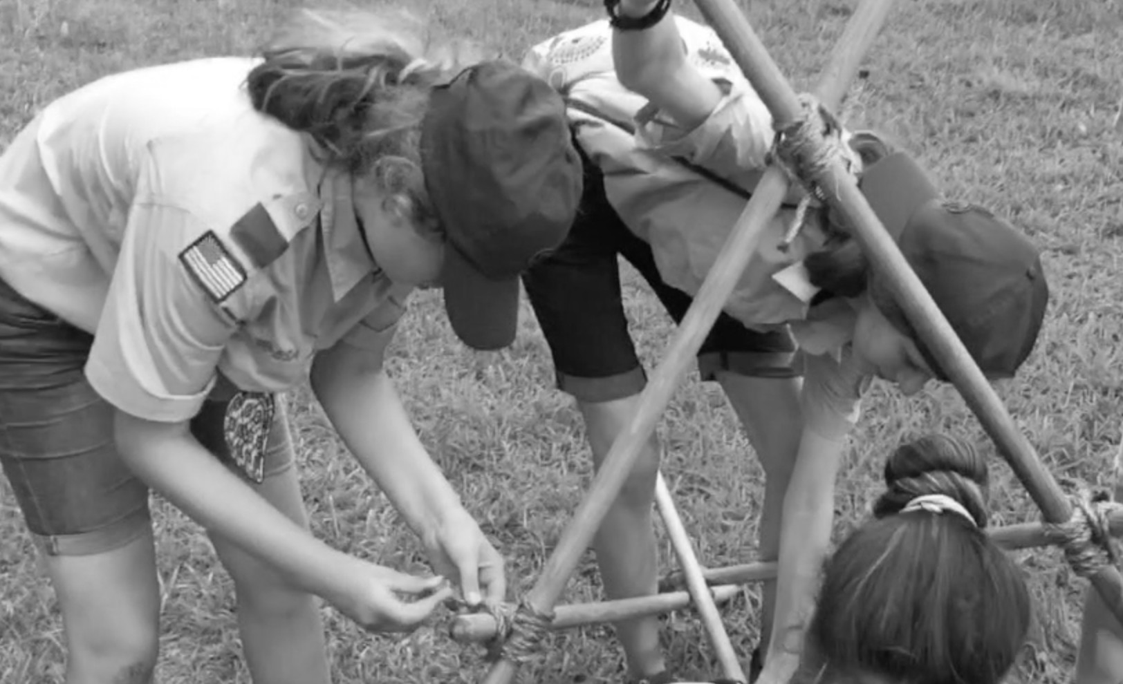
Scout Stave Launcher

CAMPING AND HIKING IN BEAR COUNTRY
(45 minutes - Inside)
Objective: Participants will review what to do in bear country, through discussion based on information from the Fieldbook and the National Park Service.
Discussion:
—> After receiving group responses for each of the following questions, as necessary, review the corresponding bullet points:
If a bear is sighted, simply stated, how can Scouts avoid an encounter with a bear?
  - By keeping their distance and not surprising them.
If a bear notices you and is paying attention to you, what should you do to prevent the situation from escalating?
  - Identify yourself by talking calmly so the bear knows you are a human and not a prey animal.
  - Remain still; stand your ground but slowly wave your arms. Help the bear further recognize you as a human.
  - Continue to talk to the bear in low tones. A scream or sudden movement may trigger an attack.
  - If the bear is stationary, move away slowly and sideways. Do NOT run.
  - If the bear follows, stop and hold your ground.
  - Do NOT climb a tree.
  - When you can, leave the area or take a detour. If this is impossible, wait until the bear moves away.
  - Be especially cautious if you see a female with cubs. Never place yourself between a mother and her cub.
What can a person do if they are attacked?
  - If you are attacked by a grizzly bear, leave your pack on and PLAY DEAD. Lay flat on your stomach with your hands clasped behind your neck. Spread your legs to make it harder for the bear to turn you over. Remain still until the bear leaves the area.
  - If the attack persists, fight back vigorously. Use whatever you have at hand to hit the bear in the face.
  - If you are attacked by a black bear, DO NOT PLAY DEAD. If escape is not possible, try to fight back using any object available. Concentrate your kicks and blows on the bear's face and muzzle.
  - If any bear attacks you in your tent, or stalks you and then attacks, do NOT play dead—fight back!
How can Scouts protect themselves at camp in bear country?
  - Avoid using scented lotions, soaps, deodorants, and shampoos while in bear habitat.

  - Wash early enough in the day so that residual product smells can dissipate before bedtime.
  - Before going to bed, change into clothes just worn for sleeping
  - Store day clothes and other equipment under a rain fly near the cook area and stow any clothing that smells of spilled food in a bear bag.
  - Avoid smelly food items.
  - Clean up any spilled food or crumbs and store with your trash.
  - Strain wash water and scatter over a wide area at least 200 feet from camp. Any bits of food strained out of the water should be placed in a plastic bag and stored with the trash.
  - Set up tents in a cluster at least 200 feet from the cooking area.
  - Take nothing into the tents except sleeping bags, sleeping pads, and flashlights.
  - Wash and rinse kitchenware thoroughly after meals.
How can Scouts prevent bear encounters on the trail?
  - While hiking, stay alert and on the lookout for bears or signs of bears.
  - Make noise like talking loudly, singing, whistling, or clapping your hands, so that bears can hear you coming and get out of your way.
  - If a bear approaches, make loud noises.
What should Scouts do if a bear enters their campsite?
  - Leave and stay away until the bear is gone.
What can be considered a smellable?
  - all food items
  - garbage
  - soap
  - toothbrushes and toothpaste
  - sunscreen
  - lip balm
  - insect repellent
  - feminine hygiene products
  - anything else with an odor
How are smellables stored in a bear bag?
  - on a bear cable
  - on a horizontal branch about 20 feet above the ground attached to a 50-foot length of cord thrown over the branch
  - attached to two 50-foot cords each thrown over a branch 20 feet high on trees spaced about 16 feet apart
  - at least 12 feet oﬀ the ground and 8 feet away from tree trunks
What are other ways smellable can be stored in bear country?
  - in a bear box
  - in a bear canister at least 200 feet from tents

— Day 4 - Block 3 —

SNAKE RACE
(30 minutes - Outdoors)
Objective: By using a lashing they reviewed earlier, and exercising teamwork, participants will meet a Scout skill challenge illustrating another use for that lashing.
Materials for each patrol
  - six Scout staves
  - five 6-foot lashing ropes Activity: Snake Race

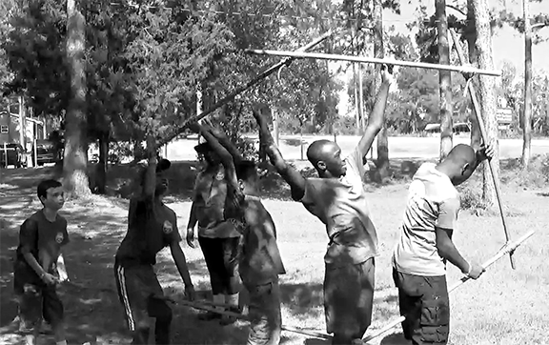
Scouts work together to meet a Snake Race Scout Skill Challenge.

LASSOING THE STEER
(30 minutes - Outdoors)
Objective: Through the EDGE method, participants will become comfortable with their ability to eﬀectively tie and present a bowline to form a small, fixed loop at the end of a line. They will then use the fixed loop to create a mechanical advantage and to form a lariat.
Materials for each participant
  - 20-foot x 1/4-inch braided nylon cord
Materials for class
  - 2-foot x 4 to 5-inch log with flat end
Participants will tie a small bowline at the end of their cord and reeve the other end through the loop to form a larger loop that can be used to create a strong pull, or used to form a lasso.
Activity: Lassoing the Steer
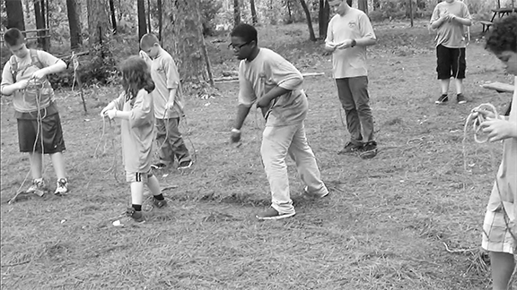
Lassoing the Steer is an involving Scout Skill Challenge.

CONSTRICTOR KNOT
(15 minutes - Inside)
Objective: Participants will become comfortable with their ability to eﬀectively tie and present a constrictor knot, through the EDGE method and continued practice.
Materials for every participant
  - 3-foot cord
  - Scout stave
Materials for class
  - projector
  - screen
(The following video can be used to explain and demonstrate the skill. As necessary, the process of guiding and enabling commences after it is viewed.)
—> View Video 43: How to Tie a Constrictor
Activity: Participants tie two constrictor knots around their Scout stave with their 3-foot cord.

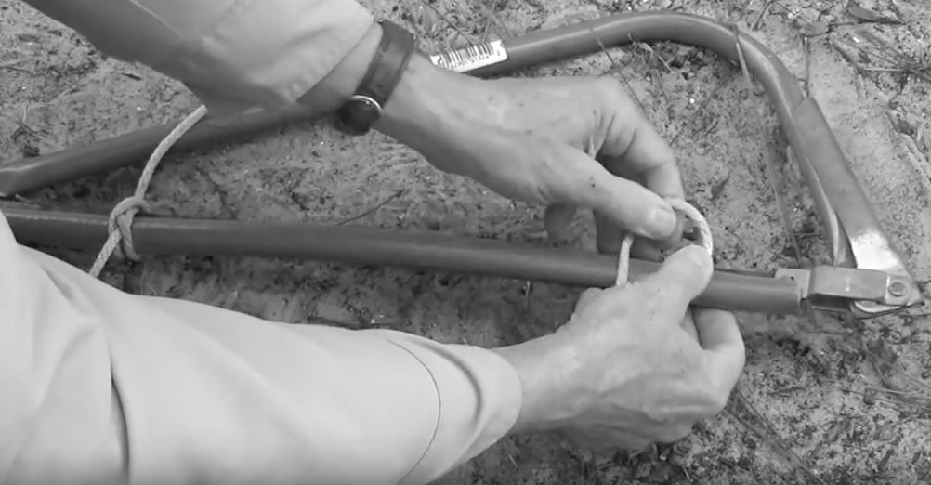
Like a clove hitch, constrictor knots can be applied from either side.

LARK’S HEAD
(15 minutes - Inside)
Objective: Through discussion, the EDGE method and application, participants will become comfortable with their ability to eﬀectively tie and present a lark’s head, and recognize it when mistakenly applied during the formation of two half hitches and taut- line.
Materials for each participant
  - 3-foot cord
  - Scout stave
Materials for class
  - projector
  - screen
(The following video can be used to explain and demonstrate the skill. As necessary, the process of guiding and enabling commences after it is viewed.)
—> View Video 44: How to Tie a Lark's Head Activity:
- Participants will simply apply a lark’s head to their Scout stave using their 3-foot cord.
- Participants will apply two half hitches to the stave with the second half hitch proceeding over around and through in the same direction as the first (clove hitch).
- Participants will start a clove hitch by crossing the line over itself around the pole for the first half hitch, and then reverse the direction for the second half hitch, forming a lark’s head.
Discussion: How often instead of seeing a double half hitch (referred to as two half hitches) do we see a cow knot? And how often do we see the lark’s head being formed inside what’s supposed to be a taut-line hitch? What’s the big deal? Why should we correct the mistake?
—> After receiving group responses, as necessary, review the following:
  - A larks head simply does not provide the same degree of friction as a clove hitch.

BACK SPLICE
(30 minutes - Inside)
Objective: Objective: Through application of the EDGE method, participants will become comfortable in their ability to eﬀectively tie and present the back splice.
Materials for each participant
  - three feet of manila rope (thicker diameter up to 1/2 inch is easier to work with)
Materials for class
  - scissors
  - whipping cord or tape
  - projector
  - screen
(The following video can be used to explain and demonstrate the skill. As necessary, the process of guiding and enabling commences after it is viewed.)
—> View Video 45: How to Tie a Back Splice
Action: Participants complete the demonstrated steps and tie a back splice in one end of their rope.
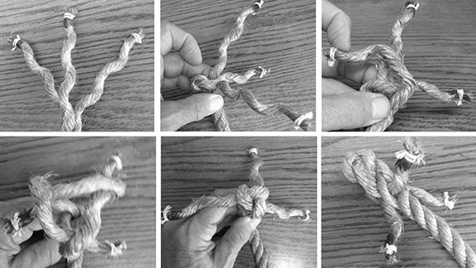
(Note: Some participants are apt to need a good deal of guidance in order to get the hang of this splicing process. Therefore, unless the instructor is already well-versed in splicing techniques, it’s advisable they prepare themselves to guide and enable the participants who might need more attention.)

DAY 5

— Day 5 - Block 1 —

Materials
  - 20-foot length of 1/4-inch nylon line
  - two platforms 6 to 8-inches tall (two halves of a cinder block or two cuts from a downed tree, 8-inches in diameter)
  - camp shovel or trowel
  - toilet paper in ziplock bag
  - straining screen
  - two 2-foot x 1-inch sticks
  - two 4-foot x 1-inch sticks
  - two Scout staves
  - six 6-foot lashing ropes
  - one 10-foot lashing rope
  - no. 10 tin can with bail
  - small towel
  - soap in a sock
  - two 3-foot cords Gathering Period: Hunker Down

FOOD ALLERGIES - SAFETY MOMENT

SUMMARY
According to Food Allergy Research & Education (FARE), one in every 13 children has a food allergy. Every 3 minutes, a food-allergy reaction sends someone to the emergency room. And while the responsibility for management of a food allergy lies with the individual or the individual’s parent or guardian, all of us need to be ready to assist in preventing — or helping in response to — a reaction.

A food-allergy reaction happens when the immune system overreacts to a food protein. A reaction can range from mild to severe. In the U.S., the most common food allergens are milk, eggs, peanuts, tree nuts, soy, wheat, fish, shellfish and sesame seeds.
However, any food might cause an allergic response, and many people are allergic to more than one food. Also, initial food-allergy reactions can occur at any time.
A food allergy should not be confused with a food intolerance. An intolerance is when someone cannot digest a component of a food, such as lactose, a sugar found in milk. An intolerance may cause abdominal cramping or diarrhea but is not life-threatening.

GENERAL INFORMATION
Food allergies can start in childhood or adulthood. Mild reactions might involve only a few hives or minor abdominal pain, though some reactions progress to severe anaphylaxis. The only way to avoid an allergic reaction is to avoid the foods that cause signs and symptoms. However, despite our best efforts, anyone at any time might encounter a food that causes a reaction.

For a minor allergic reaction, over-the-counter or prescribed antihistamines (such as Benadryl®) might help reduce symptoms. These medications can be taken after exposure to an allergy-causing food to help relieve itching or hives. Follow guidance from the person’s personal health care provider.

However, antihistamines can’t treat a severe allergic reaction. For a severe reaction, someone will likely need an emergency injection of epinephrine (such as from an EpiPen® or Auvi-Q®) and require a trip to the emergency room. Many people with allergies carry an epinephrine auto-injector. This device injects a single dose of medication when pressed against the thigh

WHAT TO DO IF SOMEONE HAS A FOOD ALLERGY
If someone has a food allergy, they must be diligent about avoiding allergens. They must always read all food labels before eating or drinking any food. Even tiny amounts of an allergen can cause an allergic response.

When preparing food, prepare food for people with allergies on a separate, clean surface to ensure there is no cross contamination. Start with clean hands and use separate and clean utensils and cooking tools, such as toasters.
For some people, bringing their own foods can be easier and safer when eating with a group. If you or someone in your unit has food allergies, be sure to review the Food Allergy Guidance and the other resources below before planning any event that includes food.

OUTDOOR HYGIENE AND SANITATION
(1 hour - Inside / Outdoors)
Objective: Through discussion based on information from the Fieldbook, participants will become acquainted with the range of considerations to guard against microscopic organisms that can make Scouts sick, both on the trail and in camp.
Discussion:
—> After receiving group responses for each of the following questions, as necessary, review the corresponding bullet points:

What is a bad germ
  - A protozoa, bacteria, or virus that make people sick. All are microscopic.
In camp and on the trail, what is the main way to ward oﬀ the possibility of getting sick?
  - Wash hands.
What are some ways to make hand washing more convenient?
  - Set out a basin or 8-quart pot of water and a small plastic bottle of biodegradable soap.
  - In the front country set up a hand washing station.
  - Set up a “piddilator.”
  - Keep small containers of waterless hand cleanser in convenient locations.
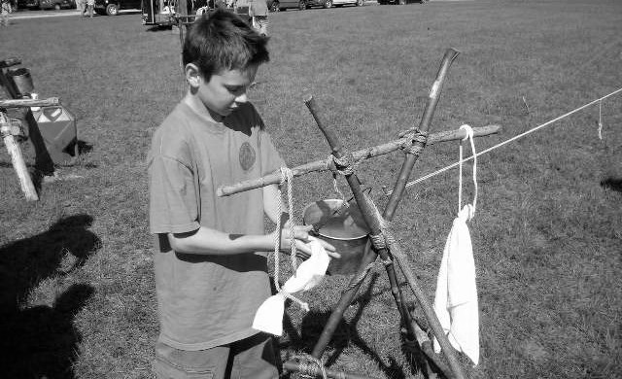
—> Turn attention to “Wash Station Diagram”
Demonstration: Following the diagram, participants build a wash station.

What are ways to purify all water in the wild before drinking?
- boiling
- chemical treatments
- filtering
- ultraviolet light
What are the advantages of bringing water to a rolling boil?
- 100% effective.
- Easy to do.
What are the disadvantages of boiling water?
- Requires a stove and fuel or a campfire and a pot.

Hand Wash Station

- The CDC recommends brining water to a rolling boil for one minute, due to people confusing simmering with boiling

What are the advantages of chemical treatment?
- Effective against viruses and bacteria.
- Simple to use.
- Inexpensive, lightweight, and convenient to pack.
- A good backup if other purification methods fail.
What are the disadvantages of chemical treatment?
- Not always effective against protozoa.
- Requires a waiting period before water is safe to drink.
- Can leave a chemical taste.
- Loses potency over time.
What are the advantages of filtering?
- Effective against protozoa and bacteria.
- Available in a range of capacities and designs.
What are the disadvantages of filtering?
- Filtering elements must be regularly cleaned or replaced, especially if the water is muddy or contains silt.
- Pump mechanisms sometimes malfunction.
- In temperatures below freezing, ice may clog a filter.
What are the advantages of ultraviolet light?
- Fast acting and simple to use.
- Effective against most waterborne organisms.
- Lightweight, compact, and easy to carry.
What are the disadvantages of ultraviolet light?
- Requires a supply of batteries.
- Requires a backup method in case batteries fail.
- Less effective with cloudy water.

What are some ways to handle and store foods safely?
- Plan meals around ingredients that need no refrigeration.
- Estimate portion sizes to avoid leftovers.
- Stow discarded leftovers in double plastic bags along with food particles from strained dishwater.
- Keep all foods out of the reach of animals.
How can dishwater and wash water be disposed of?
- Filter all food particles out of the dishwater with a strainer or sieve.
- Dispose of wash water by spreading over a wide area at least 200 feet from any water sources.
How should trash be disposed of?
- Pack out any and all trash or garbage that needs to be disposed of.
- Place flattened cans and food wrappers in a plastic bag.
- Place leftover food items like orange peels or leftover macaroni in a double plastic bag.

How should we dispose of human waste in ways that minimize contamination of the environment and limit the risk to wildlife and people?
- If toilet facilities are available, use them.
- Urinate away from campsites and trails and places where people gather.
- Use a cathole.
- Carry it out.
Where should a cathole be dug, how deep, and how is it to be used?
- At least 200 feet away from camps, trails and water sources.
- Dig the whole 6 to 8 inches deep with a trowel, a stick, or the heel of your boot.
- After you take care of your business, cover the hole with soil and camouflage with ground cover. The topsoil will breakdown the waste over time.
- In arid regions or higher elevations, pack out the toilet paper in a resealable plastic bag. (Burying toilet paper is more acceptable in regions where the soil is rich.)
- In certain areas, it is obligatory to use a Pack-it-out Kit.
Demonstration: Participants dig a cathole and determine the quality of the soil.

PREDICTING THE WEATHER
(30 minutes - Outdoors)
Objective: Through discussion based on information in the Scouts BSA Handbook and Fieldbook, participants will become familiar with traditional weather signs that can be used to help predict the weather.
Materials
- projector
- screen Discussion:
—> After receiving group responses for each of the following questions, as necessary, review the corresponding bullet points:
Why is it good to know how to predict the weather using natural signs?
- Your phone died.
- You’re in an area with no service.
What are the three basic forms of clouds?
- Cumulus (Latin for “Heap”)
- Cirrus (Latin for “Streak”)
- Stratus (Latin for “Layer”)
—> Turn attention to “Cloud Formations” reference page.
What does the label Nimbus or Nimbo describe?
- Any cloud from which precipitation might fall.
- Cumulonimbis = large, dark, towering clouds (thunderheads)
- Nimbostratus = dark layers of ragged clouds carrying rain
—> Read the following description:
Possible signs of an approaching storm might be:
- the appearance in a clear sky of high, feathery cirrus clouds known as mare’s tails.
- Over the course of hours or days, the clouds will thicken until the sun is hidden behind a thin cirrostratus veil. [Thats a combined formation of cirrus (streak) clouds and stratus (layer) clouds.]
- A curtain of altostratus clouds (layers that appear blue or gray) comes next.
- This might be followed by a moist blanket of stratus clouds rolling relatively close to the ground.
- Finally nimbostratus clouds—dark and threatening—bring the rain.
What is the prevailing wind?
  - The typical wind direction that a location has for a certain time of the year.
What does it mean when the wind shifts away from the prevailing direction?
  - It often indicates atypical or changing weather.
How does the direction of the wind and geography of a particular area correlate with predicting the weather?

  - Wind preceding from the direction of a large land mass generally means dryer weather.
  - Wind stemming from the direction of large bodies of water generally means wetter weather.
How can we determine how far away lightning is from our location?
  - Count the seconds between lightning and thunder and divide the result by 5 to determine how far away it was. For example, lightning strikes, ten seconds go by, and then thunder rolls; divide 10 by 5 and you’ll know the lightning was a mere 2 miles away.
What can birds contribute to forecasting changes in weather?
  - When birds, especially hawks, fly high in the air, it’s an indicator that the weather is fine and will be.
  - Birdsong during the rain is a solid promise that the clouds are breaking and the rain will be letting up soon.
  - “Swallows flying near to the ground mean a storm will come around.” The low air pressure that pulls in stormy weather causes insects to fly close to the ground. Swallows and other birds that feed on insects will follow.
  - “Swallows flying way up high mean there’s no rain in the sky.” In the high air pressure associated with fair weather, insects may be carried aloft by air currents.
What can pine cones tell us about the weather?
  - If the cone scales are open, the weather is likely to be pleasant and promising. However, if the cone scales are pulled down tight, it indicates stormy weather is on the horizon.
What can flowers tell us about the weather?
  - If their petals remained closed during the day it’s an indicator of rainy weather.
“Red sky at night, sailor’s delight.” Why is this an indicator of fair weather?
  - A red sunset usually means there is clear dry air to the west, the direction from which most storms come.
“Red sky in the morning, sailor take warning.” Why might this mean rain?
  - Dry dusty air is moving away from you towards the east. Clouds and moist air may be coming in from the west.
“If smoke goes high, no rain comes by.” How does this portend dry weather?
  - Still air is generally stable and won’t move moisture into the area.
“If smoke hangs low, watch out for a blow.” Why might this be true?
  - Low air pressure can prevent campfire smoke from rising very high.
“When the dew is on the grass, rain will never come to pass.” Why?
  - Cool, clear nights come with high pressure. Moisture condenses on cool leaves and grass.
“When grass is dry in the morning light, look for rain before the night.” How come this might be true?
  - On a cloudy night, grass might not be cool enough for dew to form.
—> View Video 46: Weather 101: A Tutorial on Cloud Types
Activity: Participants check the sky outdoors and observe the prevailing cloud types.

COOKING FIRE CONCEPTS AND CONFIGURATIONS
(30 minutes - Inside)
Objective: Through discussion and observation, participants will exchange ideas and review practical approaches pertaining to building fires for cooking.
Discussion:
—> After receiving group responses, as necessary, review the bullet points:
What are some simple cooking fire guidelines?
- Adherence to all fire safety measures is first and foremost.
- Cooking fires should only be large enough to match the size of what’s being cooked.
- Generally, cooking is done over coals, not flames.
—> After receiving group responses as necessary, review the bullet points while projecting the slide show presentation: “Cooking Fire Configurations” as a visual aid.
What are some approaches to setting up a cooking fire that accommodates pots and pans?
  - Hunters Fire - Pots and pans are supported by two parallel logs.
  - Keyhole Fireplace - A fire is built in a wider section, and as the wood burns down, the coals are transported to a section narrow enough to support pots and pans.
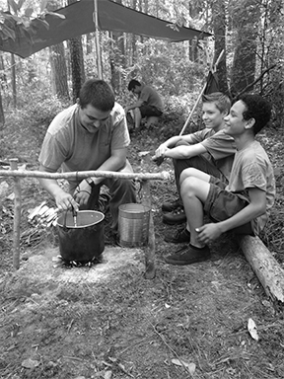
  - Tent Pin Configuration - Three tent tent pins are stuck in the ground forming an equilateral triangle the area of which is the right size to support a pot or pan.
  - Rock Fire Place - Non-porous rocks are positioned providing the right amount of surface and space to support pots and pans.
  - Tripod Pot Holder - A tripod is constructed around the cooking fire and a pot with a bail is hung down at the appropriate height.
  - Forked Sticks and Crossbar - Pots are suspended from a crossbar supported by two forked sticks.
  - One-Legged Fire Crane - a Dovetail notch is fashioned so a pot with a bail can be supported and positioned over a fire.

Using two forked sticks and a crossbar, Scouts cook their lunch.

ANCHORING
(30 minutes - Inside / Outdoors)
Objective: Participants will become familiar with the various types of anchoring equipment and configurations through observation and application.
Materials
  - six pioneering stakes 2 to 2-1/2-inches in diameter and 24 to 30 inches long
  - large wooden mallet
  - binders twine
  - two 12-inch stakes to form the tourniquets
  - rope grommet with ring(s)
—> View Video 47: Anchors for Pioneering Projects
Activity: Participants will build a 3-2-1 anchor in a designated spot where their monkey bridge will be constructed, taking turns driving in the pioneering stakes and applying the tourniquets. NOTE: Remember to lay the rope grommet over the three-stake set before applying the tourniquet.
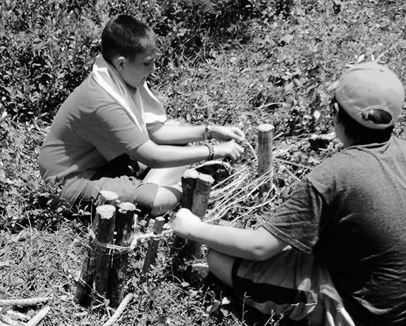
A Scout uses binder twine to connect the two-stake set to the single stake for their monkey bridge.

ROPE TACKLE
(45 minutes - Inside / Outdoors)
Objective: 1) Through the EDGE method participants will first become comfortable with their ability to eﬀectively tie and present the butterfly knot. 2) Through the EDGE method participants will become comfortable with their ability to configure a rope tackle followed by a hands on experience of how it yields a useful mechanical advantage.
Materials for class
  - Anchor point
  - Strop or rope grommet with ring
  - 50-foot x 1/2-inch manila rope
  - projector
  - screen
Materials for each participant
  - 3-foot cord
(The following videos can be used to explain and demonstrate the skills. As necessary, the process of guiding and enabling commences after each is viewed.)
—> View Video 48: How to Tie a Butterfly Knot Participants tie a butterfly knot using their 3-foot cord.
—> View Video 49: How to Tie a Rope Tackle
Activity: Participants proceed to where the outdoor materials are set up and take turns configuring a rope tackle on the 1/2-inch manila rope.

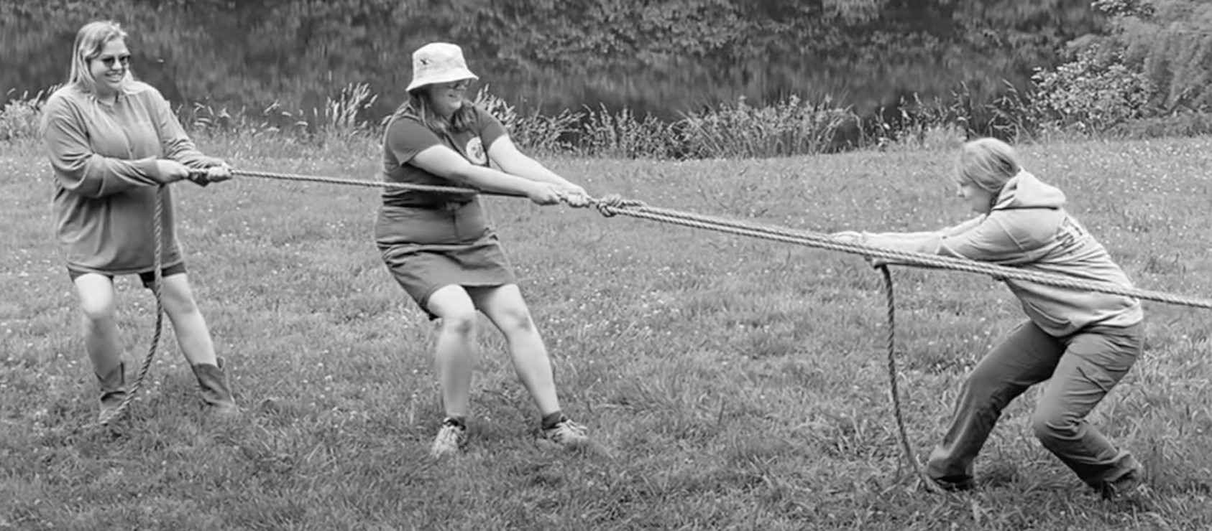

Activity: Rope Tackle Tug of War
National Camping School 148
Rope Tackle Tug of War

— Day 5 - Block 2 —

PLANNING AND BUILDING A PIONEERING PROJECT
(2 hours and 30 minutes - Inside and Outdoors)
Objective: Through group discussion participants will come to terms with the necessary steps they need to take in order to build a full-sized pioneering structure.
Materials
  - eight 8-foot x 4-inch A-frame legs
  - four 6-foot x 3-inch A-frame ledgers
  - fourteen 15-foot x 1/4-inch lashing ropes for square lashings
  - one 50-foot x 1/2-inch or 3/4-inch foot rope
  - two 50-foot x 1/2-inch hand ropes
  - five 8-foot x 1/4-inch stringer ropes
  - six 10-foot x 1/4-inch lashing ropes for strop lashings
  - six pioneering stakes for each 3-2-1 anchor
  - two 10-foot x 1/2-inch polypropylene or manila ropes with rings for rope grommets
  - two pieces of scrap canvas or burlap for foot rope saddles
  - binder twine for the back stays of anchor stakes
Building pioneering projects is an activity that captures and preserves Scouting’s timeless legacy. The projects themselves embody real Scouting ingenuity and teamwork. Whether they’re useful, just plain fun, or both, their construction invariably furnishes a joyful sense of accomplishment. Both planning and preparation play key roles in the success of any pioneering venture.
—> Turn attention to copies of “Double A-Frame Monkey Bridge” reference pages. Discussion:
—> After receiving group responses, review the following bullet points:
What questions should a Scout pioneering building crew answer before starting any pioneering project?
  - What type of project will we be building?
  - Do we have an established design – or – have we drawn up a plan?
  - How many people will be needed to build the project?
  - How much time will it take? (You’ll be given two hours, including time for playing and sharing.)
  - If you’ll be building a bridge, how wide and deep is the creek or ravine you’ll be spanning?

  - What size and amount of poles will be needed for the project?
  - What size and amount of lashing ropes, guylines, and other cordage will be needed?
  - What materials for anchors will we require?
  - What other materials will be needed?
  - Can the project be divided into subassemblies? If so, who will be working on, and who will be in charge of each subassembly?
  - Who will be the safety oﬃcer?
  - How will the materials be transported to the building site? (You’ll be taking apart your Chippewa kitchen to acquire the spars you’ll need.)

Activity: Using their reference pages, participants plan and build their bridge.

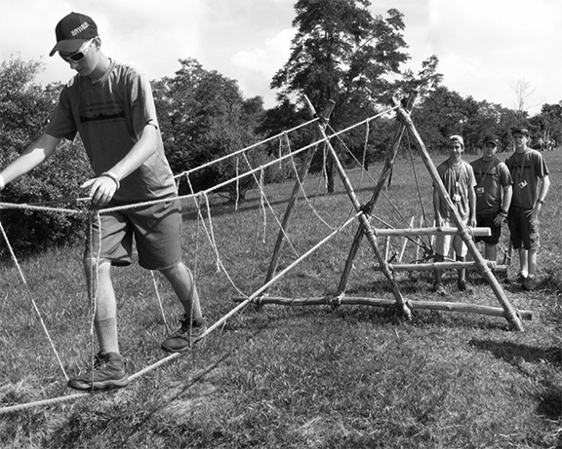
Double A-Frame Monkey Bridge

PATROL DUTY ROSTERS
(1 hour and 30 minutes - Inside and Outdoors)
Objective: Through discussion and some application, participants will understand the makeup and function of a patrol duty roster.
Materials

Ingredients Cooking Items
14.75-oz can salmon * | mixing bowl
one egg * | frying pan
one medium onion* | chef’s tool kit with potato peeler
1/2-cup seasoned bread crumbs* | charcoal
one medium-sized potato per person | charcoal chimneys
1-cup shredded Monterey Jack cheese * | tongs
raw string beans | cutting board
small container of olive oil | garbage receptacle
salt and pepper | spoons
minced garlic | measuring cup
scallions | heavy duty aluminum foil
- | paper towels
- | prepared fire ring or pit
- | filled fire buckets
- | plastic sheet
- | biodegradable soap and sanitizer
- | three 8-quart pots
- | Coleman 2 Burner Stove
- | propane
* every four persons

Discussion:
—> After receiving group responses for each question, as necessary, review the following bullet points:

What is a patrol duty roster?
- A schedule of tasks that need to be done with patrol member assignments for each.
What is its purpose?
- To define which patrol member or members will be responsible for what task and when.
- To assure everyone has an equal opportunity to share the responsibilities.
What three basic categories of responsibilities are notated on a patrol duty roster?
- Fire and Water Crew
- Cook Crew
- Cleanup Crew
What’s the job of the Fire and Water Crew?
- Maintains the water supply
- Maintains supplies of tinder, kindling, and fuel wood, or charcoal
- Keeps materials protected from the weather
- Makes sure cooking fires and/or stoves are ready to assure the cook crew has meals prepared on time.
What’s the job of the Cook Crew?
- Assembles food supply
- Follows menus and recipes exactly
- Serves meals on time
- Puts food away
- Prepares cook pots to soak, and has cleanup water set on the fire or stove before serving meals.
What’s the job of the Cleanup Crew?
- Sets up wash and rinse water for dishwashing
- Cleans cooking pots and utensils
- Cleans up camp kitchen and dining areas
- Stores all group equipment
- Disposes of garbage and trash
- As appropriate, puts out the cooking fire
—> Turn attention to “Duty Roster” reference page.
Patrols need to decide who will be responsible for the completion of the following tasks:—> Project the list on the screen.
- Set up the Coleman 2 burner stove.
- Prepare two charcoal chimneys full of charcoal briquettes and light them at the
appropriate time.
- Prepare a bed of coals in a fire pan or prebuilt fire pit.
- Take charge of preparing the salmon cakes.
- Take charge of preparing the campfire garlic potatoes.
- Take charge of preparing the green beans.
- Place 8-quart pot of water on the stove to boil

- Lead us in grace.
- Set up the dish washing assembly line.
- Wash frying pan and spoons.
- Dispose of the used aluminum foil.
—> Designated cooks refer to “Salmon Cakes,” “Campfire Garlic Potatoes,” and “Green Beans” reference pages.
Discussion: What is a standard way to set up a dish washing assembly line?
  - “Goop Scooping Station / Hot Water containing biodegradable soap / Hot Water for rinsing / “Room Temperature” Water containing sanitizing agent / Plastic sheet for air-drying cooking and eating utensils.)
What can be done to make it easier to clean the soot oﬀ a pot or pan that’s been used over an open fire?
  - Spread some liquid soap over the outside of the pot or pan.
Activity: Patrols will proceed to the cooking area and complete their assigned tasks.

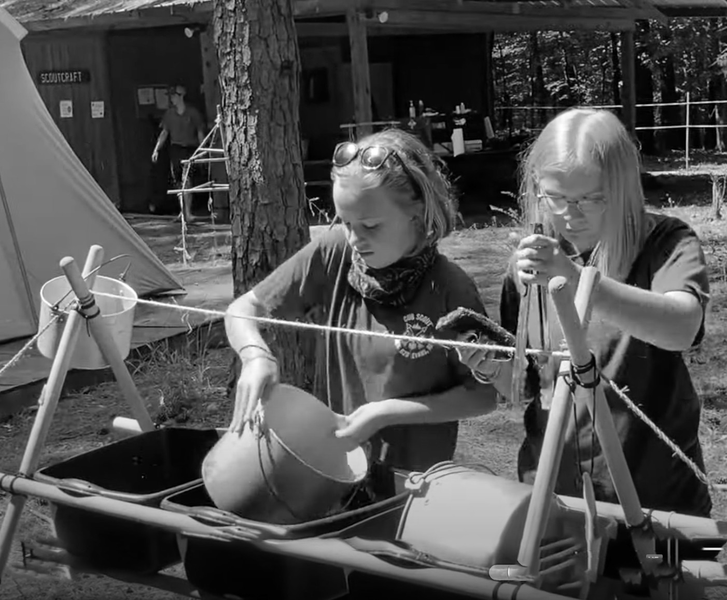
Scouts wash pots in the campsite’s dishwashing rack.

CUB SCOUT NEW ADVENTURE PROGRAM
(30 minutes - Inside or Outdoors)
Objective: Through discussion and the review of material in the relevant references, participants will become acquainted with the outdoor skill related adventures included in the new Cub Scout Adventure program starting June 1, 2024. Participants will be aware of how the Outdoor Skills staﬀ are to support the program for Cub Scouts to complete the Outdoor skills related adventures.
Discussion:
What is the purpose of resident Cub Scout camp?
—> After receiving group responses, as necessary, review each bullet point.
- Cubs have fun
- Cubs learn skills
- Provides opportunities for Cubs to participate in activities that their Pack may not be able to provide, such as shooting sports, swimming, and boating
- Provides opportunities for Cubs to go camping if their Pack does not go camping
- Provides opportunities for Cubs to participate in a wide variety of activities for growth and achievement
- Reinforce the ideals of Scouting in a camping atmosphere
Discussion:
What is the role of the outdoor skills staﬀ supporting the Cub Scout resident camp?
—> After receiving group responses, as necessary, review each bullet point.
- The staﬀ teaches the outdoor skills related to the Cub Scout Adventures.
- The staﬀ serves as a resource to the Pack leaders and assists them to improve their skills.
- The staﬀ provides a safe environment for Cubs to learn.
- The outdoor skills staﬀ is a source of physical equipment for outdoor skills.
—> Turn attention to the Cub Scout Adventure Program resource material, noting which ones are requirements and which are electives.
It is important that the camp focus on elective adventures since Cubs who complete required adventures may be repeating some or all of that adventure with their den when their den resumes meeting after the summer. Certainly the required adventures can be oﬀered as an option for Pack leaders to select for their Cubs.
These requirements take eﬀect on June 1, 2024.

AOL Outdoor Adventurer (Required)
- Learn about the Scout Basic Essentials. Note to Outdoor Skills staﬀ and Camp: Beginning in June 2024 with the updated Cub Scout program, Arrow of Lights will be learning the Scout 10 Essentials instead of the Cub Scout six essentials. Because part of the 10 essentials is matches/fire starters, Arrow of Light Scouts will be required to earn the Firem’n Chit before being able to use matches, fire starters, or light a fire. They will have to become “re-certified” when they join Scouts BSA. Camps who plan to incorporate this AOL program/adventure into their camp programs should be prepared to include the Firem’n Chit requirement.
- Determine what you will bring on an overnight campout — including a tent and sleeping bag/gear — and how you will carry your gear.
- Review the four points of the BSA SAFE Checklist and how you will apply them. on the campout.
- Locate the campsite where you will be camping on a map.
- With your patrol or a Scouts BSA troop, participate in a campout.
- Upon arrival at the campout determine where to set up your campsite: kitchen, eating area, tents, and firepit. Help the patrol set up the patrol gear before setting up your own tent.
- Explain how to keep food safe and the kitchen area sanitary at the campsite. Demonstrate your knowledge during the campout.
- After your campout, discuss with your patrol what went well and what you would do diﬀerently next time. Include how you followed the Outdoor Code and Leave Not Trace Principles for Kids.
AOL Knife Safety (Elective)
- Read, understand, and promise to follow the “Cub Scout Knife Safety Rules.”
- Demonstrate the knife safety circle.
- Demonstrate that you know how to care for and use a knife safely.
- Demonstrate the proper use of a pocketknife to make a useful object on a campout.
- Choose the correct cooking knife and demonstrate how to properly slice, chop, and mince.
Webelos Walkabout (Required)
- Prepare for a 2-mile walk outside. Gather your Cub Scout Six Essentials and weather appropriate clothing and shoes.
- Plan a 2-mile route for your walk.
- Check the weather forecast for the time of your planned 2-mile walk.
- Review the four points of BSA SAFE Checklist and how you will apply them on your 2-mile walk.
- Demonstrate first aid for each of the following events that could occur on your 2- mile walk: blister, sprained ankle, sun burn, dehydration and heat related illness

- With your den, pack, or family, go on your 2-mile walk while practicing the LeaveNo Trace Principles for Kids and Outdoor Code.
- After your 2-mile walk, discuss with your den what went well and what you would do diﬀerently next time.

Let's Camp Webelos (Elective)
- With your den, pack, or family, plan and participate in a campout.
- Upon arrival at the campground, determine where to set up a tent.
- Set up your tent without help from an adult.
- Identify a potential weather hazard that could occur in your area. Determine the action you will take if you experience the weather hazard during the campout.
- Show how to tie a bowline. Explain when this knot should be used and why.
- Know the fire safety rules. Using those rules, locate a safe area to build a campfire.
- Using tinder, kindling, and fuel wood, properly build a teepee fire lay. If circumstances permit, and there is no local restriction on fires, show how to safely light the fire while under adult supervision. After allowing the fire to burn safely, extinguish the flames with minimal impact to the fire site.
- Recite the Outdoor Code and Leave No Trace Principles for Kids from memory.
- After your campout, share the things you did to follow the Outdoor Code and Leave No Trace Principles for Kids with your den or family.

Bear Habitat (Required)
- Prepare for a one-mile walk by gathering the Cub Scout Six Essentials and weather-appropriate clothing and shoes.
- “Know Before You Go” Identify the location of your walk on a map and confirm your one-mile route.
- “Choose the Right Path” Learn about the path and surrounding area you will be walking on.
- “Trash your Trash” Make a plan for what you will do with your personal trash or trash you find along the trail.
- “Leave What You Find” Take pictures along your walk or bring a sketchbook to draw five things that you want to remember on your walk.
- “Be Careful with Fire” Determine the fire danger rating along your path.
- “Respect Wildlife” From a safe distance, identify as you look up, down, and around you, six signs of any mammals, birds, insects, reptiles.
- “Be Kind to Other Visitors” Identify what you need to do as a den to be kind to others on the path.
- With your den, pack, or family, go on your one-mile walk while practicing your Leave No Trace Principles for Kids.
Bear Whittling (Elective)
- Read, understand, and promise to abide by the “Cub Scout Knife Safety Rules.”

- Demonstrate the knife safety circle.
- Demonstrate that you know how to care for and use your pocketknife safely.
- Make two carvings with a pocketknife.

Let's Camp Bear (Elective)
- Review the buddy system and how it works in the outdoors.
- Pack your Cub Scout Six Essentials for the campout.
- In addition to your 6 Cub Scout Essentials, show the personal items you need for your campout.
- Help set up a tent. Determine a good spot for the tent. Explain why you picked the spot.
- Attend a council or district Cub Scout overnight camp or attend a campout with your pack.
Wolf Paws on the Path (Required)
- Identify the Cub Scout Six Essentials. Show what you do with each item.
- Learn about the buddy system and how it works in the outdoors. Pick a buddy for your walk.
- Identify appropriate clothes and shoes for your walk outside. Do your best to wear them on your walk.
- Learn about the Outdoor Code and Leave No Trace Principle for Kids.
- With your den, pack, or family, take a walk outside for at least 30 minutes to explore nature in your surroundings. Describe four diﬀerent animals, domestic or wild, that you could see on your walk.

Let’s Camp Wolf (Elective)
- Learn about the buddy system and how it works in the outdoors.
- Know the Cub Scout Six Essentials.
- In addition to your Cub Scout Six Essentials, list the personal items you need for your campout.
- Learn a camping skill.
- Attend a council or district Cub Scout overnight camp or attend a campout with your pack.

Tiger in the Wild (Required)
- Identify the Cub Scout Six Essentials. Show what you do with each item.
- With your den leader or Tiger adult partner, learn about the Outdoor Code.
- With your den, pack, or family, take a walk outside spending for at least 20 minutes exploring the outdoors with your Cub Scout Six Essentials. While outside, identify things that you see with your Tiger adult partner that are natural and things that are manmade.

- Identify common animals that are found where you live. Learn which of those animals is domesticated and which animal is wild. Draw a picture of your favorite animal.
- Look for a tree where you live. Describe how this tree is helpful.

Let’s Camp Tiger (Elective)
- Learn about the buddy system and how it works in the outdoors.
- Before going on the overnight campout, discuss what type of weather is expected and what type of clothes you should wear.
- Pack up your Cub Scout Six Essentials for the campout.
- Learn a camping skill.
- Attend a council or district Cub Scout overnight camp or attend a campout with your pack.

Mountain Lion (Required)
- Identify the Cub Scout Six Essentials. Show what you do with each item.
- With your den, pack, or family, take a walk outside spending for at least 20 minutes exploring the outdoors with your Cub Scout Six Essentials. While outside, identify things that you see with your Lion adult partner that are natural and things that are manmade.
- Discover what S.A.W. means.
- Identify common animals that are found where you live. Separate those animals into domesticated and wild.

Let’s Camp Lion (Elective)
- Learn about the buddy system and how it works in the outdoors.
- Before going on the overnight campout, discuss what type of weather is expected and what type of clothes you should wear.
- Pack up your Cub Scout Six Essentials for the campout.
- Attend a council or district Cub Scout overnight camp or attend a campout with your pack.
Discussion: During Cub Scout resident camp, a worthwhile goal is for a Cub Scout to complete an entire elective adventure. In what ways can staﬀ provide engaging activities that will make completing an elective fun?
—> Have participants develop a list of activities that are Cub Scout age appropriate and in line with the Guide to Safe Scouting that the Outdoor Skills Staﬀ can do at Cub Scout Resident camp. This can be done as one group or in smaller groups and then shared with the whole group:

—> Direct participants to resources available to them for the new Cub Scout Adventures.
Outdoor Skills staﬀ have a great opportunity to provide a successful program in camp that is fun and introduces Cub Scouts to outdoor skills and complete one or more of Adventure.

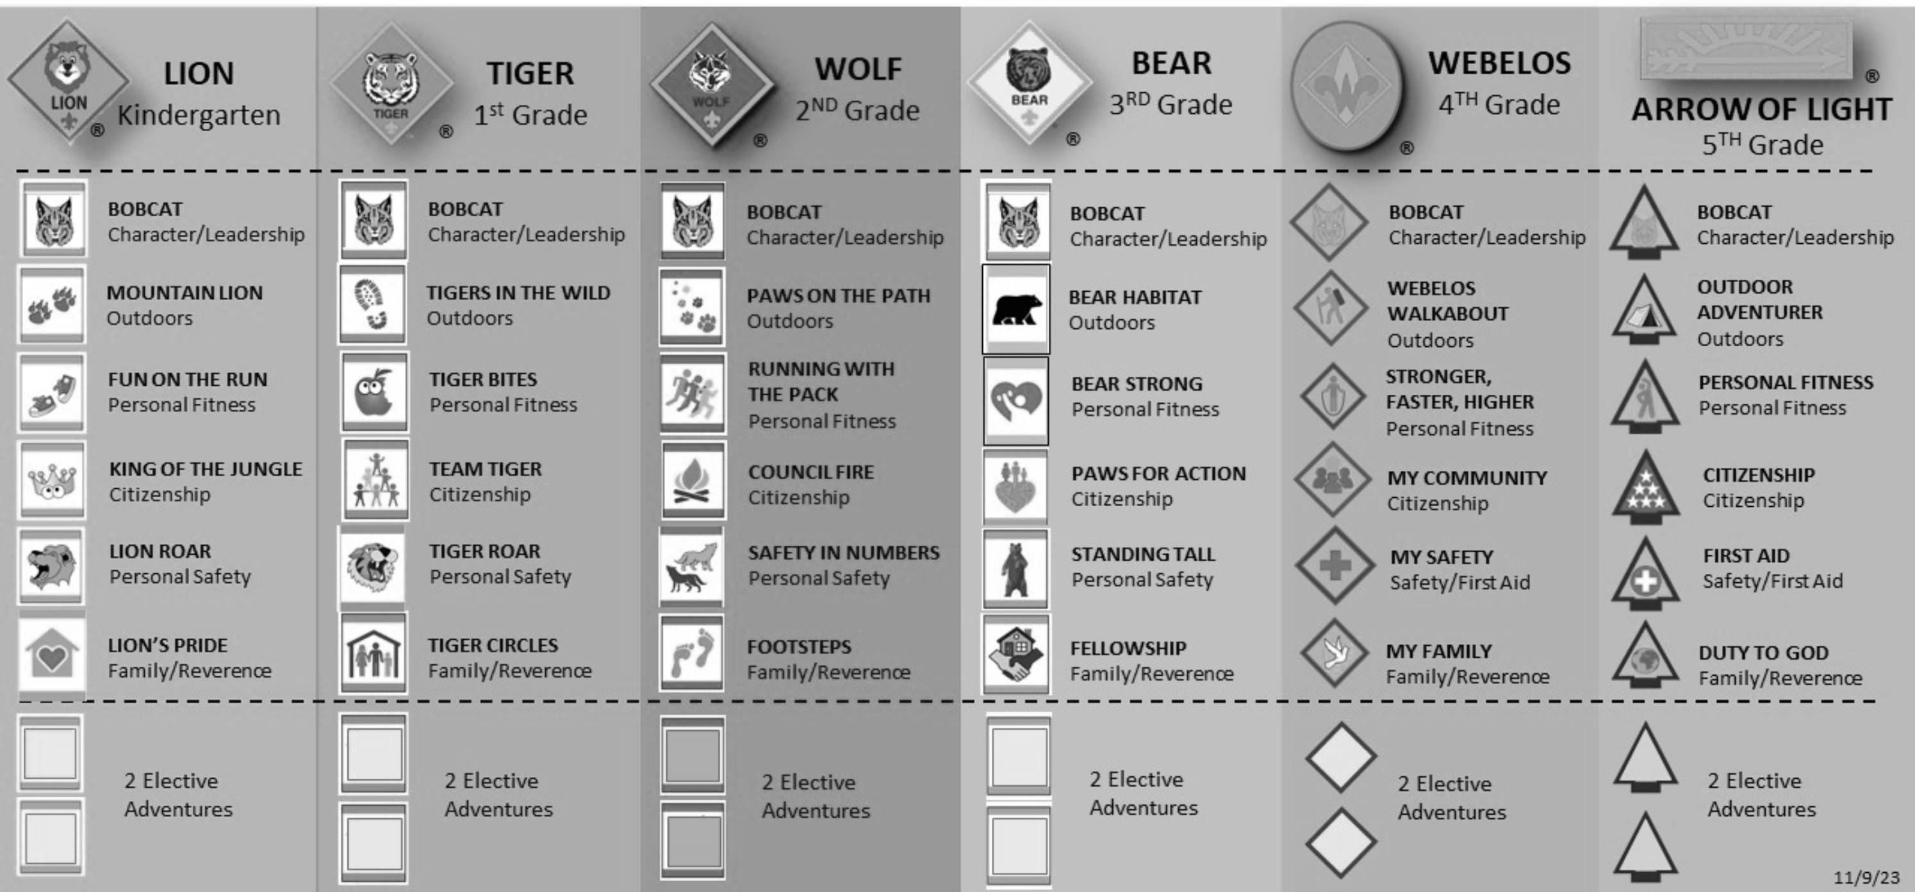

— Day 5 - Block 3 —

DOVETAIL NOTCH
(45 minutes - Outdoors)
Objective: Through an extended process, applying the EDGE method, participants will learn how to join two pieces of wood at right angles, without the addition of rope, wire, glue, nails, or screws.
Materials for every two participants
  - knife
  - bow or folding saw
  - leather gloves
Materials for class
  - 2-1/2-inch x 2-foot stick
  - 1-inch x 1-foot stick
Demonstration: The presenter demonstrates the process of forming a dovetail notch using the class materials. —>
Activity: Participants buddy up, retrieve some available wood, and proceed to produce their own Dovetail Notches.
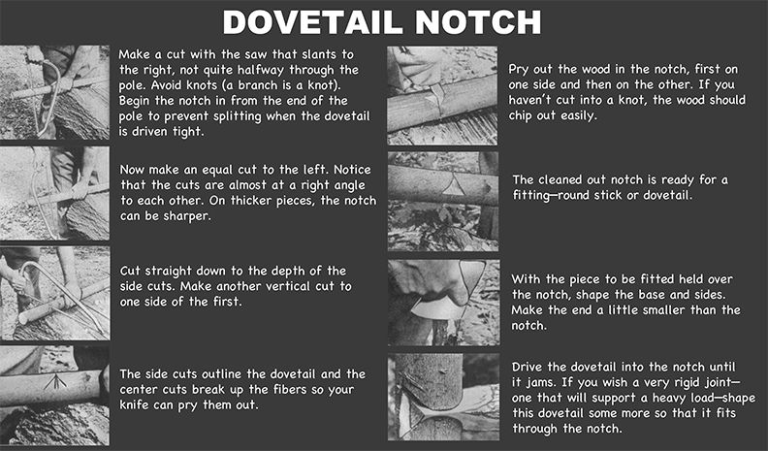

LOCKING A HITCH AND SEIZING THE END OF A LINE
(15 minutes - Inside)
Objective: Through discussion, demonstration, and application, participants will learn ways to keep a line secure, assuring knots won’t lose their integrity or come undone when under strain.
Materials for each participant
  - 12 inches of whipping cord
  - Scout stave
  - 3-foot cord
—> As an illustration, tie a rolling hitch to a Scout stave.
Discussion: You’ve attached a line to an object, and for reasons of safety, you want to make sure the hitch doesn’t loosen and fail. What can be done to further secure the line?
—> After receiving group responses, review and demonstrate the following:
  - Locking a Hitch - forming an extra half hitch around the standing part.
  - Seizing the End of a Line - using a whipping cord or smaller diameter line to apply tight wraps around both the end of a line extending from the knot and the standing part.
Activity: Participants use their 3-foot cord and Scout stave to apply a hitch and then “lock” it.
Activity: Participants use their 3-foot cord, and Scout stave to apply a hitch and then seize it using the whipping cord to apply a half knot whipping around both the end of the line extending from the knot, and the standing part.

SHORT SPLICE
(30 minutes - Inside)
Objective: Through application of the EDGE method, participants will become comfortable in their ability to eﬀectively tie and present the short splice.
Materials for each participant
  - three feet of manila rope (thicker diameter up to 1/2 inch is easier to work with)
  - the length of rope containing the back splice
Materials for class
  - scissors
  - whipping cord or tape
  - projector
  - screen
(The following video can be used to explain and demonstrate the skill. As necessary, the process of guiding and enabling commences after it is viewed.)
—> View Video 50: How to Tie a Short Splice
Action: Participants complete the demonstrated steps and tie a short splice, joining the rope containing their back splice from the previous splicing session, to one end of the new 3-foot length.
(Note: Some participants are apt to need a good deal of guidance in order to get the hang of this splicing process. Therefore, unless the instructor is already well-versed in splicing techniques, it’s advisable they prepare themselves to guide and enable the participants who might need more attention.)
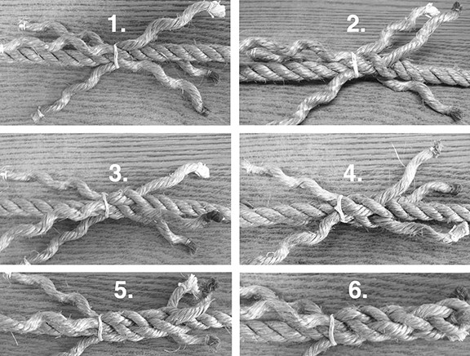

FINDING NORTH AT NIGHT
(30 minutes - Inside and Outdoors)
Objective: On a clear night, participants will face north by using the Big Dipper to find Polaris.
Materials for each two participants
  - Flashlight
  - Compass
Materials for class
  - projector
  - screen
Discussion: Who has used the North Star to find north? Does it work?
The image on this page is projected and used as a point of reference.

Which two stars are referred to as the “Pointer Stars?”
Activity: If the sky is clear enough, the class takes a night hike to where they can see the night sky and, conditions permitting, proceed to find north, confirming their findings with the compass.

DAY 6

— Day 6 - Block 1 —

Materials for each participant
  - whipping cord
  - usable lengths of 1/4-inch manila rope
  - pieces of flint, quartz or chert that will throw sparks
  - hardened steel fire strikers
  - charred cloth
  - tinder bundles
Materials for class
  - projector
  - screen
Gathering Period: As participants arrive, they are given an opportunity to retest their skill at catching a spark on some charred cloth and blowing the ember into a flame.

CHARCOAL SAFETY - SAFETY MOMENT

SUMMARY
The day has come to an end and now your next adventure is cooking a cobbler for your evening dessert. Soon, you’ll be ready to light a charcoal fire using your choice of approved Scouting equipment. However, when using charcoal, it is important to keep in mind that chemical fuels are not permitted for use in Scouting activities.

GENERAL INFORMATION
Lighting a charcoal fire without using a liquid or gel accelerant is possible. When you light charcoal in a chimney, it takes less time to prepare your briquettes and is a better way to control your fire output. Here are some tips for lighting your charcoal:
- Instant lighting charcoal (with or without a chimney)—This is probably the safest and most feasible for a Scout. Simply take a match to your charcoal assembly and watch it come ablaze.
- Starter cubes (with or without a chimney)—These are small blocks or cubes typically made of oil, wax, or quick-burning wood placed underneath your chimney or within your briquettes.
- Homemade fire starters (placed under chimney)
  - Cardboard egg cartons/toilet paper tubes/newspaper—Any of these will work as a fire starter. Place your briquettes or newspaper inside the carton slots where the eggs would sit or inside a toilet paper tube. Strike a match and light all corners or edges.
  - Processed corn chips—You read correctly. Processed corn chips are hydrocarbons (which burn) that are stored in fatty oil (which also burn).

Much like starter cubes, you place the chips within and around your charcoal for best results and then light.
  - When available, a double handful of dry pine straw stuﬀed under the chimney is often the go-to method.

Fire Safety Reminders
- Scouts can earn the Firem’n Chit while learning to safely light fires.
- Follow manufacturer’s product and safety instructions for chimneys.
- A knowledgeable adult should provide supervision when youth are starting or using fire.
- Start fires in a safe, outside area.
- Fires should never be left unattended.
- Thoroughly extinguish all fires after use.

SAILMAKER’S WHIPPING
(30 minutes - Outdoors and Inside)
Objective: Through the EDGE method, participants will eventually become comfortable with their ability to eﬀectively present how to apply a Sailmaker’s Whipping to lashing ropes.

(The following video can be used to explain and demonstrate the skill. As necessary, the process of guiding and enabling commences after it is viewed.)
—> View Video 51: How to Tie a Sailmaker's Whipping
Activity: Participants will try their hands at whipping the lengths of manila rope with the Sailmaker’s Whipping. Participants can take materials back to camp if more practice is required. (Note: This is one of those timeless skills that might require more preparation on the part of the instructors.)
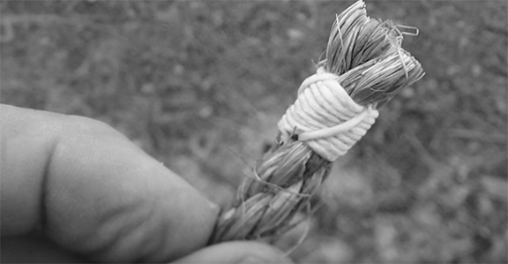

ROLLING HITCH
(1 hour - Inside and outdoors)
Objective: Through the EDGE method, participants will become comfortable with their ability to tie and present the rolling hitch. Participants will complete a challenge utilizing rolling hitches and requiring intense teamwork by successfully getting at least one patrol member across the alligator pit.
Materials for each participant
- 3-foot cord
- Scout stave
Materials for each patrol
- two 8-foot x 4-inch spars
- one 6-foot x 3-inch spar
- three 15-foot lashing ropes,
- six 20-foot x 1/4-inch lashing ropes (for guylines)
Materials for class
- projector
- screen
(The following video can be used to explain and demonstrate the skill. As necessary, the process of guiding and enabling commences after it is viewed.)
—> View Video 52: How to Tie a Rolling Hitch
Participants use the 3-foot cord and Scout stave to tie rolling hitches.
Activity: Keeping an A-frame intact for each patrol, participants disassemble the entire monkey bridge and store the materials in the appropriate place.
Activity: Crossing the Alligator Pit
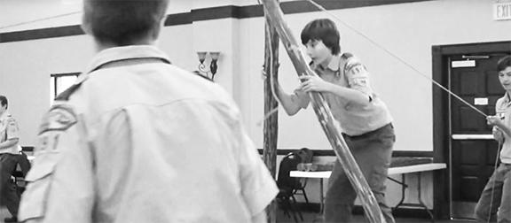
Crossing the Alligator Pit

NO POTS, PANS, OR FOIL
(1 hour, 30 minutes - Inside and Outdoors)
Objective: Through discussion and application, participants will become better acquainted with various approaches to cooking outdoors without utensils.
Materials
- 12-ounce chopped meat
- 8-ounce package of sliced cheese
- 16-ounce prepared biscuit dough
- 4 large eating oranges (thick skin)
- box of Duncan Hines Perfect Size for One cake in a cup
- charcoal
- charcoal chimneys
- trash receptacle
- prepared fire ring or pit
Discussion: What are some methods used to cook without utensils?
—> After receiving group responses, turn attention to “Cooking Without Utensils” reference page and review each recipe.
Bread on a stick - Remove the bark from “sweet wood” stick about 1 to 2 inches thick and about 2-1/2 feet long. Preheat stick. Roll a long sausage of biscuit dough and twist around heated stick. Bake over coals turning frequently.
Ash Cakes - Using biscuit dough, cook directly on coals or cabbage leaf etc. Trim oﬀ ashes when done. Biscuits may also be cooked on a smooth, hot rock or rock tilted toward fire.
Potato in Coals - Use potatoes no larger than a man’s fist. Cover completely with coals. Test for doneness after 1/2 hour by poking with thin wood sliver. If pieces of potato come out with sliver, potato is done.
Steak, chops, or fish - Impale on forked stick and roast over fire. May also be cooked directly on hot coals. Pork chops cook well on coals due to the extra fat!
Pig in a blanket - Slit center of hot dog. Fill with sliced cheese. Wrap outside with bacon and place on stick. Roast until done and then wrap the outside of the hot dog with biscuit dough and bake until dough is golden brown.
Onion Cups - Slice onion in half. Carefully remove small onion cups and fill with deviled ham, hamburger, or other filling. Roast over coals upside down. When onion turns transparent on bottom, flip over for a few more minutes. Eat onion cup and all! The large onion halves make great containers to cook eggs or meatloaf.
Baking in an Orange - Cut a "lid" oﬀ a thick-skinned orange and hollow it out. (Save the fruit.) Fill about 1/2 with prepared cake mix. Replace the lid, bury in coals and bake until done.

Egg in an Orange Cup - Cut a thick-skinned orange in half. Scoop out and eat the fruit. Crack an egg into the orange “cup” and place it on the coals. Cook until done. This can also be done the same way inside an onion “cup.”
Pepper Steak - Place hamburger (and anything else you can find laying around) in a hollowed out pepper and bake over coals. Stuﬃng can be any meatball or stuﬀed pepper recipe you like.
Shish-ka-bob - On green sticks or skewers roast any combination of meats, vegetables, fruits etc.
Bushman Monkey Meat Wrap ground beef around a stick and roast until done. Wrap hamburger with cheese and a thin layer of dough. Bake until bread is done.
Pizza Pocket - Cover two layers of prepared dough with tomato sauce, cheese, pepperoni or whatever. Fold in two and bake on coals or use a cabbage leaf, etc.
We’ll be baking cake in an orange and preparing “Bushman Monkey Meat.” What are some guidelines for selecting sticks used for cooking?
—> After receiving group responses, review the following:

Safe Not Safe
Most all hardwoods | Black Cherry
Dogwood | Buckeye
Ash | Horsechestnut
Maple | Rhododendron
Elm | Mountain Laurel
Birch (adds wintergreen flavor) | Yew
Willow | Black Locust
Sassafras | Viburnams
Bamboo

Activity: Participants decide who are going to attend to the following tasks and then proceed to prepare and cook without utensils:
- prepare coals for a cooking fire
- gather and prepare four cooking sticks
- make ready the required ingredients to cook up four “Bushman Monkey Meat” servings
- prepare the ingredients for four cakes baked in oranges
- monitor the cooking

—Day 6 - Block 2 —

OUTDOOR ETHICS
(4 hours, 30 minutes)
This session is to be conducted by a Leave No Trace Level 1 or Level 2 Instructor.
Objective: After participating in a Leave No Trace introductory session, participants will be provided a broader perspective and better understanding of outdoor ethics, its scope, and how to apply the principles of Leave No Trace.
Discussions / Activities Understanding Outdoor Ethics
- Plan Ahead and Prepare: Exploring Pre-Trip Planning
- Travel and Camp on Durable Surfaces: Exploring Campsite Selection
- Dispose of Waste Properly: Exploring Trash Disposal
- Leave What You Find: Exploring Natural Settings and Archaeological Areas
- Minimize Campfire Impacts: Exploring Fires and Stoves
- Respect Wildlife: Exploring Respect for Wildlife
- Be Considerate of Other Visitors: Exploring How to Be Considerate of Other Visitors

—> Turn attention to “Leave No Trace Principles” reference pages.

— Day 6 - Block 3 —

EYE SPLICE
(30 minutes - Inside)
Objective: Through application of the EDGE method, participants will become comfortable in their ability to eﬀectively present the eye splice.
Materials for each participant
- the ropes containing the back splice and short splice
Materials for class
- scissors
- whipping cord or tape
- projector
- screen
(The following video can be used to explain and demonstrate the skill. As necessary, the process of guiding and enabling commences after it is viewed.)
—> View Video 53: How to Tie an Eye Splice
Action: Participants complete the demonstrated steps and tie an eye splice in the end of the joined lengths of rope containing the back splice and short splice from previous sessions.
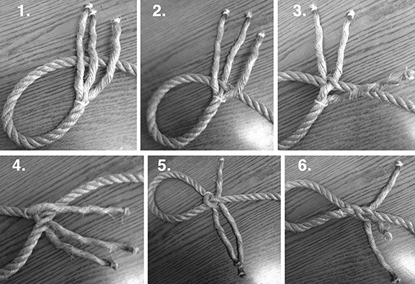
(Note: Some participants are apt to need a good deal of guidance in order to get the hang of this splicing process.
Therefore, unless the instructor is already well- versed in splicing techniques, it’s advisable they prepare themselves to guide and
enable the participants who might need more attention.)

S.A.F.E.
(30 minutes - Inside)
Objective: Through reading and group discussion, participants will become familiar with “S.A.F.E.”.
—> Turn attention to “S.A.F.E.” reference page.
Discussion: Participants take turns reading aloud the following safety standards, followed by open comments pertaining to each.
Scouts and their parents expect all Boy Scouts of America activities to be conducted safely. To ensure the safety of participants, the Boy Scouts of America expects leaders to use the four points of SAFE when delivering the Scouting program.

SUPERVISION

Youth are supervised by qualified and trustworthy adults who set the example for safety.
- Accepting responsibility for the well-being and safety of youth under their care.
- Ensuring that adults are adequately trained, experienced, and skilled to lead the activity, including the ability to prevent and respond to likely problems and potential emergencies.
- Knowing and delivering the program of the Boy Scouts of America with integrity.
- Using qualified instructors, guides, or safety personnel as needed to provide additional guidance.
- Maintaining engagement with participants during activities to ensure compliance with established rules and procedures.

ASSESSMENT

Activities are assessed for risks during planning. Leaders have reviewed applicable program guidance or standards and have verified the activity is not prohibited. Risk avoidance or mitigation is incorporated into the activity.
- Predetermining what guidance and standards are typically applied to the activity, including those specific to the Boy Scouts of America program.
- Planning for safe travel to and from the activity site.
- Validating the activity is age appropriate for the Boy Scouts of America program level.
- Determining whether the unit has suﬃcient training, resources, and experience to meet the identified standards, and if not, modifying the activity accordingly.
- Developing contingency plans for changes in weather and environment and arranging for communication with participants, parents, and emergency services.

FITNESS AND SKILL

Participants’ Annual Health and Medical Records are reviewed, and leaders have confirmed that prerequisite fitness and skill levels exist for participants to take part safely.
- Confirming the activity is right for the age, maturity, and physical abilities of participants.
- Considering as risk factors temporary or chronic health conditions of participants.
- Validating minimum skill requirements identified during planning and ensuring participants stay within the limits of their abilities.
- Providing training to participants with limited skills and assessing their skills before they attempt more advanced skills.

EQUIPMENT AND ENVIRONMENT

Safe and appropriately sized equipment, courses, camps, campsites, trails, or playing fields are used properly. Leaders periodically check gear use and the environment for changing conditions that could aﬀect safety.
- Confirming participants’ clothing is appropriate for expected temperatures, sun exposure, weather events, and terrain.
- Providing equipment that is appropriately sized for participants, is in good repair, and is used properly.
- Ensuring personal and group safety equipment is available, properly fitted, and used consistently and in accordance with training.
- Reviewing the activity area for suitability during planning and immediately before use, and monitoring the area during the activity through supervision.
- Adjusting the activity for changing conditions or ending it if safety cannot be maintained.

TIME BOMB AND WALL STREET
(15 minutes - Inside)
Objective: With the week’s training done and as a light-hearted change of pace, participants will enjoy the last few minutes leading up to the closing campfire by playing a couple of small-space troop-wide games.
Materials for Class
  - deck of playing cards Activity: Time Bomb Activity: Wall Street
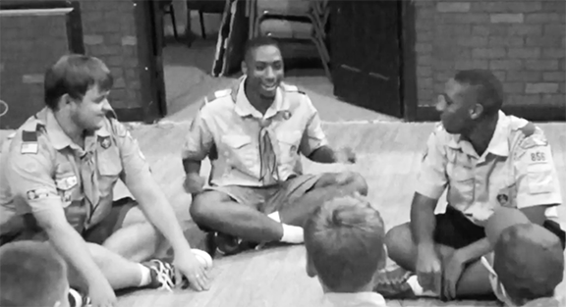
Scouts play Time Bomb.

APPENDIX: CATEGORIZED LIST OF MATERIALS

CORDAGE POLES
3-foot x 1/4-inch braided nylon cords (1 per participant) | twelve Scout staves + (1 more per participant)
3-foot unfused paracords (1 per participant) | eight 8-foot x 4-inch spars
15-foot x 3/16-inch braided nylon lines for guylines (4 per patrol) | six 6-foot x 3-inch spars
20-foot braided nylon lines for Lassoing the Steer (1 per participant) | twenty 3-foot x 2-inch floor spars
large roll of binder twine | two 4-foot x 3/4-inch poles
6-foot x 1/4-inch manila lashing ropes (7 per patrol) | two 2-foot x 3/4-inch poles
sixteen 15-foot x 1/4-inch manila lashing ropes | three 10-foot x 2-inch spars
20-foot x 1/4-inch manila lashing ropes (2 per patrol)
five 8-foot x 1/4-inch manila lashing ropes
10-foot x 1/4-inch manila lashing rope (1 per 2 participants)
three 50-foot x 1/2 manila ropes
one 50-foot x 3/8-inch manila rope per patrol
large supply of uncut 1/4-inch manila rope for splicing
MONKEY BRIDGE AND CHIPPEWA KITCHEN TARPS AND FLAGPOLES
twelve 30-inch x 2 to 2-1/2 inches pioneering stakes | 10 x 12-foot tarp with 50-foot nylon ridge line (1 per patrol)
one heavy wooden mallet | 12-inch stakes (6 per patrol)
two rope grommets with rings | tent stake mallet (1 per patrol)
two burlap or canvas saddles | 3 x 5-foot flag (not US, 1 per patrol)
2-foot x 5-foot piece of burlap or canvas
10 gallons of mineral soil

WOODS TOOLS AND WOOD SUNDRY ITEMS
good quality bow saw (1 per patrol) | playground ball
sharpened hatchet (1 per patrol) | lighter (1 per participant)
sharpened knife (2 per patrol) | small wood block for fusing (1 per participant)
leather gloves (1 pair per patrol) | small stick (1 per participant)
protective eyewear (1 per patrol) | sturdy 5-gallon bucket
3-foot x 3-inch soft wood log (1 per patrol) | 9-inch 2x4 board (1 per patrol)
chopping block (1 per patrol) | “hot spark kit,” (1 per patrol)
three 2 feet x 4 to 5-inch logs | cotton balls (2 per patrol)
9-inch x 1-inch dry stick (1 per participant) | ball of thin cotton string
2-foot x 2-1/2-inch stick for dovetail notch demo | biodegradable soap
1-foot x 1-inch stick for dovetail notch demo | dish washing sanitizer
SUNDRY ITEMS SUNDRY ITEMS
piece of flint that will throw sparks (1 per 3 participants) | Silva Starter Compass (1 per participant)
hardened steel fire striker (1 per 3 participants) | large paper bag (1 per participant)
charred cloth | large US map
cotton cloth for charring and prepared charring tin | trowel
two fire buckets | rat traps (2 per patrol)
one 2-person tent | 2-ounce fishing sinker (1 per patrol)
groundcloth | prepared shot holder (1 per patrol)
plastic sheet | several tennis balls
scissors | no. 10 tin can with bail
whipping cord | small towel
toilet paper in ziplock bag | soap in a sock
straining screen | deck of playing cards
two cinder blocks or 8-inch x 8-inch wood discs

COOKING ITEMS COOKING ITEMS
one well-seasoned 12-inch dutch oven | frying pan
one 8 or 10-inch dutch oven | measuring cup
dutch oven lid lifter | cutting board
tongs | paper bowls and spoons
2 charcoal chimneys | garbage bags
2 large bags of charcoal | mixing bowl
chef’s tool kit (with peeler) | heavy duty aluminum foil
paper towels | quart-sized ziplock bags
Coleman 2 Burner Stove | three 8-quart pots
propane
FOOD ITEMS FOOD ITEMS
2 whole Granny Smith Apples | 1 (15-ounce) can chopped fire-roasted tomatoes
4 bananas | 1 (14.75 ounce) can canned salmon (serves 4)
4 thick-skinned eating oranges | 1 (10-ounce) can red enchilada sauce
one medium-sized potato per person | 1 can (12-ounce) Mountain Dew soda
1 onion | box of cake mix
scallions | package of Rolos
1-pound of fresh green beans | package of mini marshmallows
12-ounce chopped meat | package of graham crackers
2 cans (8-ounce cans) Crescent Rolls | 1 bag tortilla chips
16-ounce can prepared biscuit dough | caramel sauce
8-ounce package of sliced American cheese | cinnamon
12-ounces shredded Monterey Jack | 1-1/2 cups sugar
12-ounces shredded cheddar | vanilla extract
1/2 dozen eggs | 1/2-cup seasoned dry bread crumbs
2 sticks butter | olive oil
small jar minced garlic | salt

FOOD ITEMS | FOOD ITEMS
1 can black beans | black pepper
16-ounces of canned white meat chicken

APPENDIX: MATERIALS AND VIDEOS PER BLOCK

— Day 1 - Block 1 —

MATERIALS | VIDEOS
Scout staves (1 per participant, at least 4) | Large Patrol Raft
15-foot braided nylon guylines (1 per participant) | How to Tie a Square Knot (Basic Approach)
3-foot x 1/4-inch nylon cords (1 per participant) | How to Always Tie a Square Knot Right
6-foot lashing ropes (1 per participant, at least 6) | How to Tie Two Half Hitches
tent stakes (1 per participant) | How to Tie a Taut-Line Hitch
3 x 5-foot flags (not U.S. flag) (1 per patrol) | How to Tie a Clove Hitch
mallet (1 per patrol) | How to Tie a Round Lashing
- | How to Tie Half Hitches to Finish Many Lashings

— Day 1 - Block 2 —

MATERIALS | VIDEOS
Scout staves (1 per participant) | Putting Skills Into Action
3-foot length of paracord (1 per participant) | How to Tie a Half Knot (West Country) Whipping
lighter (1 per participant) | -
small block of wood for fusing (1 per participant) | -
small stick (1 per participant) | -

— Day 2 - Block 1 —

MATERIALS | VIDEOS
sturdy 5-gallon bucket | How to Tie a Sheet Bend
playground ball | How to Tie a Bowline
Scout staves (1 per participant) | How to Tie a Timber Hitch
6-foot lashing ropes (1 per participant) | How to Tie a Sheep Shank
3-foot x 1/4-inch nylon cords (1 per participant) | -
three 10-foot x 2-inch spars | -
two 15-foot lashing ropes | -
four stakes | -
four 20-foot ropes for guylines | -
three 50-foot throwing lines (3/8-inch manila) | -
three large stakes | -
three 2-feet x 4 to 5-inch logs | -

— Day 2 - Block 2 —

MATERIALS | VIDEOS
bow saw (1 per patrol) | How to Use a Camp Saw
one pair of leather gloves (1 per patrol) | Preparing Tinder and Kindling
protective eyewear (1 per patrol) | Laying a Fire
log 3 feet long with 2 to 4-inch butt (1 per patrol) | How to Light and Feed a Fire
hatchet (1 per patrol) | How to Put Out a Fire
leather gloves (1 per patrol) | -
chopping block (1 per patrol) | -
knives (2 per patrol) | -
9-inch pine 2x4 (1 per patrol) | -
“hot spark kit” (1 per patrol) | -

MATERIALS | VIDEOS
cotton balls (2 per patrol) | -
string burning setup (1 per patrol) | -
9 inch x 1 inch dry stick (1 per participant) | -

— Day 2 - Block 3 —

MATERIALS | VIDEOS
- | Program Feature: Camping
- | Scouting’s Eight Methods
- | Scout Me In: Outdoor Skills!
- | Coleman Classic Propane Stove
- | How to Operate an MSR Whisperlite
- | JetBoil Flash Product Tour

— Day 3 - Block 1 —

MATERIALS | VIDEOS
100-foot pacing course set up | Tarps and Patrol Dining Fly
tarp with 50-foot ridge line (1 per patrol) | Dining Fly Race Demonstration
15-foot guylines (4 per patrol) | First Year Campers
Scout staves (1 per participant) | -
6-foot lashing ropes (6 per patrol) | -
stakes (6 per patrol) | -
mallet (1 per patrol) | -
— Day 3 - Block 2 —

MATERIALS | VIDEOS
6-foot x 1/4-inch lashing ropes (1 per participant) | How to Tie a Mark II Square Lashing
Scout staves (1 per participant) | How to Light a Fire by Friction
8-foot x 4-inch spars (2 per patrol) | Flint and Steel for Beginners
3-foot x 2-inch “rungs” (4 per patrol) | Making a Fire with Flint and Steel
15-foot lashing ropes (8 per patrol) | How to Make Char Cloth in Altoids Tin
piece of flint (1 per 3 participants) | How to Face a Bearing
hardened steel fire striker (1 per 3 participants) | How to Use a Map and Compass
charred cloth (1 piece per participant) | How to Measure Heights and Widths
quantity of binder twine for tinder bundles | Lashing Ropes and Pioneering Spars
covered, metal container with small hole | How to Tie a Draw Hitch
stove | -
tongs | -
Silva Starter Compass (1 per participant) | -
large paper bag (1 per participant) | -
large US map  (Block 3 materials continued on next page) | -

MATERIALS | VIDEOS
stakes (4 per patrol) | -
mallet (1 per participant) | -
treasure map | -
trowel | -
15-foot braided nylon guyline (1 per participant) | -
3-foot cord (1 per participant) | -
Color-coded coils of lashing ropes | -
— Day 3 - Block 3 —

MATERIALS VIDEOS
Scout Staves (6 per every 2 participants) | How to Tie a Double Floor Lashing
15-foot lashing ropes (2 per every 2 participants) | -
two 8-foot x 4-inch spars | -
3 foot x 2-inch floor spars (6 per patrol) | -
20-foot lashing ropes (2 per patrol) | -
COOKING SUPPLIES INGREDIENTS
one well-seasoned 12-inch dutch oven | 2 whole Granny Smith apples
one 8 or 10-inch dutch oven | 2 cans (8 oz. cans) crescent rolls
Dutch oven lid lifter, charcoal tongs | 2 sticks butter
1 charcoal chimney | 1-½ cup sugar
large bag of charcoal | 1 teaspoon vanilla
chef’s Tool Kit (with peeler) | cinnamon
paper bowls and spoons | 1 can (12 oz.) Mountain Dew soda
garbage receptacle | -
2 filled fire buckets | -
cutting board | -

- Day 4 - Block 1 —

MATERIALS VIDEOS
3-foot cord with 2 bowlines (1 per participant) | How to Tie a Tripod Lashing (with plain turns)
Scout staves (3 per 2 participants) | Chippewa Kitchen
10-foot lashing rope (1 per 2 participants) | -
eight 8-foot x 4-inch spars | -
six 6-foot x 3-inch spars | -
twenty 3-foot x 2-inch floor spars | -
sixteen 15-foot lashing ropes | -
two 20-foot lashing ropes | -
binder twine for floor lashing | -
piece(s) of burlap, terry cloth, or canvas | -
two 5-gallon buckets of mineral soil
COOKING SUPPLIES INGREDIENTS
mixing bowl | 1 bag tortilla chips
charcoal | 16-ounces of canned white meat chicken
charcoal chimneys | 1/2 cup red enchilada sauce
tongs | 1 (15-oz.) can chopped fire-roasted tomatoes, drained
chef’s tool kit | 1 cup canned black beans, drained
cutting board | 12-ounces shredded cheddar
garbage receptacle | 12-ounces shredded Monterey Jack
spoons | one banana per person
heavy duty aluminum foil | 1-cup chopped Rolos *
filled fire buckets | 1-cup mini marshmallows *
- | 1/4-cup crushed graham crackers *
- | caramel syrup
* every four persons

- Day 4 - Block 2 —

MATERIALS VIDEOS
Scout staves (2 per participant, 7 per patrol) | How to Tie a Shear Lashing
6-foot lashing ropes (1 per participant, 7 per patrol) | -
prepared shot holder (1 per parol) | -
tennis balls (8 per patrol) | -
3-foot cords (3 per patrol) | -
rat traps (2 per patrol) | -
2-ounce fishing sinker (1 per patrol) | -
FOR “SLOPPY CAMP” | -
tent | -
groundcloth | -
dining fly with poles, guylines, and stakes | -
firewood | -
plastic sheet | -
glass jar and other trash | -
axe | -
boots | -
trash | -
(Block 3 on Following Page)

- Day 4 - Block 3 —

MATERIALS VIDEOS
Scout staves (1 per participant, 6 per patrol) | How to Tie a Constrictor
6-foot lashing ropes (5 per patrol) | How to Tie a Lark's Head
3-foot cord (1 per participant) | How to Tie a Back Splice
20-foot x 1/4-inch nylon cord (1 per participant) | -
2-foot x 4 to 5-inch log with flat end | -
3 foot un-whipped manila rope (1 per participant) | -
scissors | -
whipping cord | -

- Day 5 - Block 1 —

MATERIALS VIDEOS
20-foot length of 1/4-inch nylon line | Weather 101: A Tutorial on Cloud Types
two platforms 6 to 8-inches tall | Anchors for Pioneering Projects
camp shovel or trowel | How to Tie a Butterfly Knot
toilet paper in ziplock bag | How to Tie a Rope Tackle
straining screen | Cooking Fire Configurations
two 2-foot x 1-inch sticks | -
two 4-foot x 1-inch sticks | -
two Scout staves | -
six 6-foot lashing ropes | -
one 10-foot lashing rope | -
no. 10 tin can with bail | -
small towel | -
soap in a sock | -
two 3-foot cords | -
strop or rope grommet with ring | -
50-foot x 1/2-inch manila rope | -
six pioneering stakes | -
large wooden mallet
binders twine
two 12-inch stakes to form the tourniquets
(Block 2 on Following Page)

- Day 5 - Block 2 —

MATERIALS VIDEOS
eight 8-foot x 4-inch A-frame legs | -
four 6-foot x 3-inch A-frame ledgers | -
fourteen 15-foot x 1/4-inch lashing ropes for square lashings | -
one 50-foot x 1/2-inch or 3/4-inch foot rope | -
two 50-foot x 1/2-inch hand ropes | -
five 8-foot x 1/4-inch stringer ropes | -
six 10-foot x 1/4-inch lashing ropes for strop lashings | -
six pioneering stakes for each 3-2-1 anchor | -
binder twine for the back stays of anchor stakes | -
four 12-inch stakes | -
large wooden mallet | -
two strops or rope grommets with rings | -
two pieces of scrap canvas or burlap for foot rope saddles | -
(Block 2 Cooking Supplies and Ingredients on Following Page)

— Day 5 - Block 2 (continued)—

COOKING SUPPLIES INGREDIENTS
charcoal | 14.75-oz can salmon *
charcoal chimneys | one egg *
tongs | one medium onion*
cutting board | 1/2-cup seasoned bread crumbs*
garbage receptacle | one medium-sized potato per person
spoons | 1-cup shredded Monterey Jack cheese *
measuring cup | raw string beans
heavy duty aluminum foil | small container of olive oil
paper towels | salt and pepper
filled fire buckets | minced garlic
plastic sheet | scallions
biodegradable soap and sanitizer | -
three 8-quart pots | -
Coleman 2 Burner Stove | -
propane | -
mixing bowl | -
frying pan | -
chef’s tool kit with potato peeler | -

(Block 3 on Following Page)

— Day 5 - Block 3 —

MATERIALS VIDEOS
knife (per 2 participants) | How to Tie a Short Splice
bow saw (per 2 participants) | -
leather gloves (per 2 participants) | -
12 inches of whipping cord (per participant) | -
Scout stave (1 per participant) | -
3-foot cord (1 per participant) | -
3 foot un-whipped manila rope (1 per participant) | -
the lengths of rope containing the back splice | -
scissors | -
whipping cord or tape | -
Compass (1 per participant) | -

— Day 6 - Block 1 —

MATERIALS VIDEOS
whipping cord | How to Tie a Sailmaker's Whipping
measured lengths of 1/4-inch manila rope | How to Tie an Eye Splice
pieces of flint, quartz or chert that will throw sparks | How to Tie a Rolling Hitch
hardened steel fire strikers | -
charred cloth | -
tinder bundles | -
3-foot cord (1 per participant) | -
Scout stave (1 per participant) | -
A-Frame from bridge (1 per patrol) | -
20-foot lashing ropes (6 per patrol) | -
COOKING SUPPLIES INGREDIENTS
charcoal | 12-ounce chopped meat
charcoal chimneys | 8-ounce package of sliced cheese
trash receptacle | 16-ounce prepared biscuit dough
prepared fire pit | 4 large eating oranges (thick skin)
- | box of Duncan Hines Perfect Size for One cake in a cup

— Day 6 - Block 3 —
MATERIALS VIDEOS
the ropes containing the back and short splices | -
scissors | -
whipping cord or tape | -
deck of playing cards | -

